**Levels B1.1- B2.1**

Send a photo or draw a picture of you dressed up in your scariest Halloween costume! Write a description of what you are wearing (approx. 40 words)

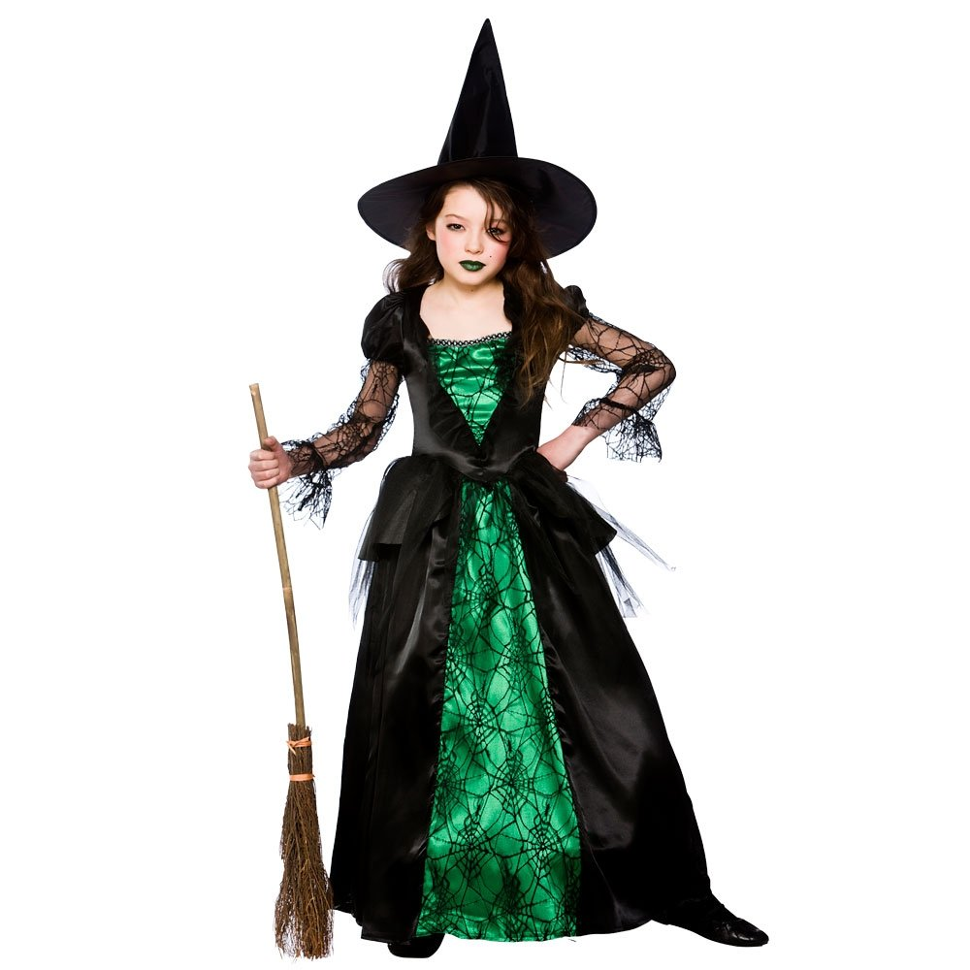

B1.1 – B2.1

I am wearing a green and black witch’s costume. The dress is decorated with spooky cobwebs. I’ve got a witch’s hat and a broom to fly on. I’m wearing green lipstick and I look very scary!

Write your name, your class and your school!