B2.2+
Send a photo or draw a picture of you dressed up in your scariest Halloween costume! Write a detailed description of what you are wearing, where you wore it and what you did (approx. 80 words)
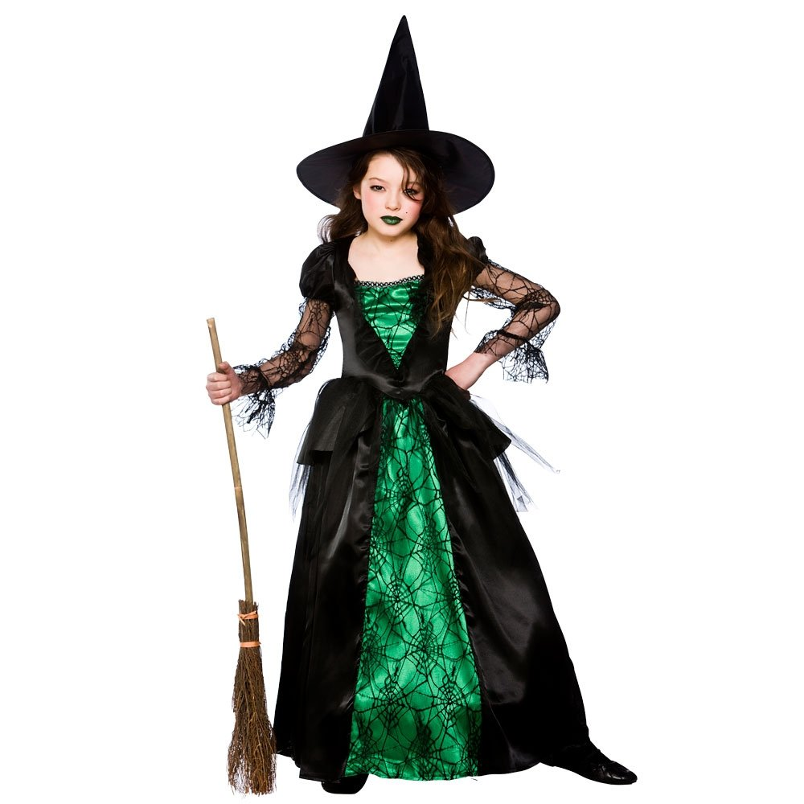

B2.2+
I wore this costume to a Halloween party 2 years ago. All of my friends got dressed up and we had a great time.
My mum made the costume. The dress is green and black and decorated with lacey cobwebs. This was the first time I wore make-up and I loved the green lips! The witch’s hat and broom finish off the outfit but unfortunately I didn’t have a black cat!

Write your name, your class and your school!

