Levels 2-5
Send a photo or draw a picture of you dressed up in your scariest Halloween costume! Label the clothes you are wearing and the scary things.
Example:

A witch!

An orange and black dress
A black hat

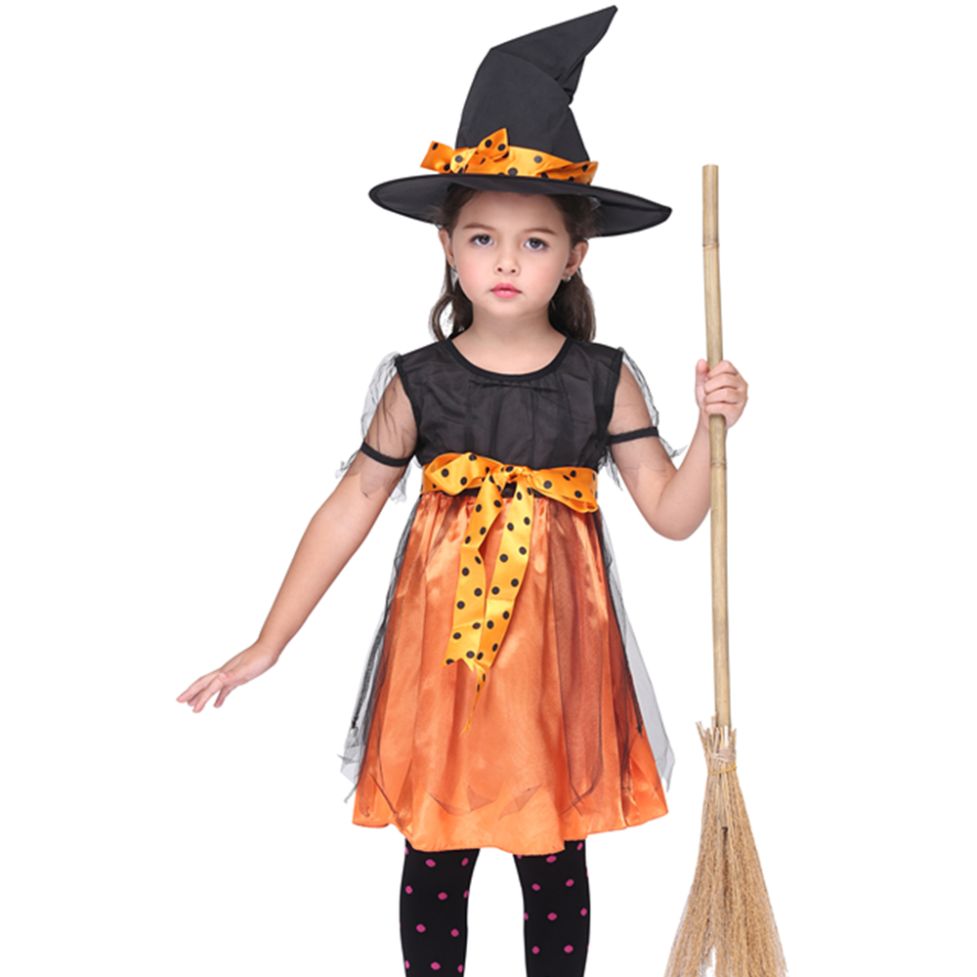
A broom
Write your name, your class and your school!

