enterprise-grade IT, technology and
[YOUR COMPANY’S logo]
infrastructure services

gigabit internet connectivity and infrastructure
The delivery and performance of services are backed by a highly resilient, geographically redundant, fully-secured, and always-on enterprise-grade private cloud network, owned and operated by essensys.

[YOUR COMPANY] is connected to the essensysCloud via diverse, high-speed, point-to-point fiber connections with built-in automatic failover, so your business is always on.
Your services are immediately available and instantly scalable with
the click of a button via essensys Connect IT management platform.

on-demand marketplace of products & services

network
- Managed LAN & WLAN
- Automatic Failover & Resilience
- Dedicated & Shared Bandwidth
- Public IP Addressing
- High Speed LAN Data Ports

wi-fi
- Enterprise-Grade Security
- Username-Based Wi-Fi
- Multi-Site & Secure Roaming
- Wi-Fi MAC For Devices Like
- Apple TV & Printers

voice
- Voice & Unified Communications
- PSTN Line for Peripheral Devices
- Call Recording
- Auto-Attendant
- Softphone Web & Mobile App

IT at your fingertips!
Powered by

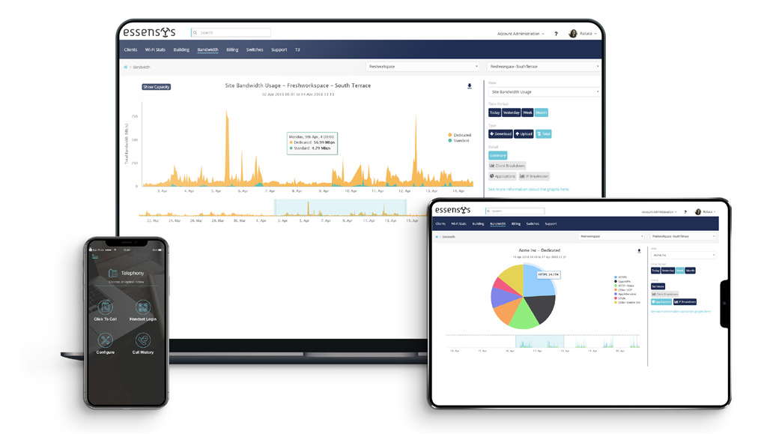
Your IT, technology and infrastructure services are delivered by Connect, web and mobile-based application for instant provisioning, management and monitoring of your services in line with your business requirements.

With Connect, [YOUR COMPANY]’s customers get real-time visibility and control over bandwidth consumption, Wi-Fi, voice configuration, and access to a marketplace of both essensys and third-party products and services.

