Call Conferencing
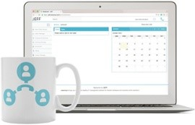
Your business depends upon the communication between multiple teams across multiple locations. Call conferencing enables you and your employees to access a dedicated conference facility to achieve more.

Benefits
- Enable your teams to communicate internally and externally.
- Bring the right people together at the right time.
- Be more productive and easily meet objectives.
- Communicate effortlessly with internal and external parties at any time.
- Build better customer relationships.
- Collaborate to finish projects quicker.
- Be proactive with user-friendly communication tools.
- Beat your competition to that next prospect enquiry.
- Improve your level of customer satisfaction.

How it Works
- Call Conferencing is easily enabled by your Site Manager.
- Once enabled, Call Conferencing functionality is accessible via your existing account in Occupie Connect.
- From the Telephone Manager choose users you want to assign conference IDs to.
- Add new users to any spare conference slots that have been purchased.
- To purchase more conference slots, contact your Site Manager.
- There is no limit to how many attendees can dial into a bridge.

Be in Control
- Create groups, assign Conference IDs and users.
- View the users that have conferencing accounts assigned to them.
- View the conference ID and conference PIN for the users.
- View Conference bridge number to dial.
- View the number of available conference IDs.
- Remove slots from users who no longer require the conferencing feature.

