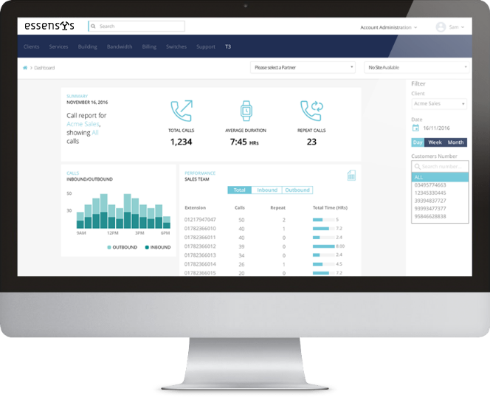
Advanced Call Reporting

- Access incoming and outgoing call data
- Apply filters to search call data
- Export reports as CSVs

Key Use Cases

Senior Management

Compare the performance of groups within your team (coming soon).
- How are different groups performing against objectives

Sales Manager

Asses how effective your team is in gaining and retaining business.
- How many calls are being made
- How long potential customers are being kept on the phone
- How many calls have been made to specific target/ priority customers
- How each of these metrics have improved or degraded over time
Assess the performance of individuals against their KPIs.
- Easily recognise which users are associated with a number
- Filter calls by individual team member
- Find out how these metrics have improved or degraded over time

Sales Team Member
- View the data that is being used to assess their performance
- View data relating to their own calls

Customer Services Manager

Assess your team’s efforts at responding to incoming support calls
- How many calls are being answered or missed
- How long calls are continuing for (i.e. are issues being resolved quickly?)
- How are individuals performing against their KPIs

