The softphone app allows you to make and receive calls from anywhere over 3G, 4G and Wi-Fi at local rates while using your existing landline number. Remain productive from wherever you are by staying connected from the convenience of your phone - a perfect solution for virtual users. Easy to use, flexible, and secure.

KEY FEATURES

Geographic flexibility and mobility 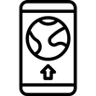 Stay connected from anywhere at any
time on any internet-enabled device

Cost-effective
Communicate globally and pay locally with local call rates

Best-in-class call quality
There's no need to worry about poor cellular signal when using Wi-Fi
Quick and easy set-up
Simply download from the Google Play & App Store and start using it straight away

Full contact integration
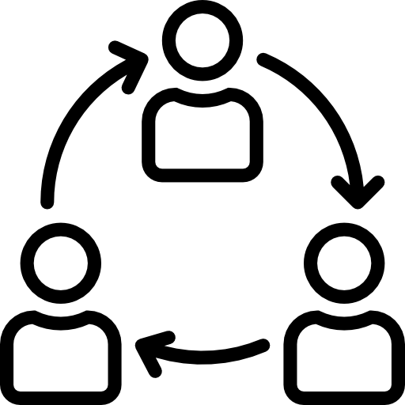 Save time and effort of manually inputting phone numbers by syncing contacts

All-in-one solution
Save the hassle of sourcing a separate supplier. We've got everything covered

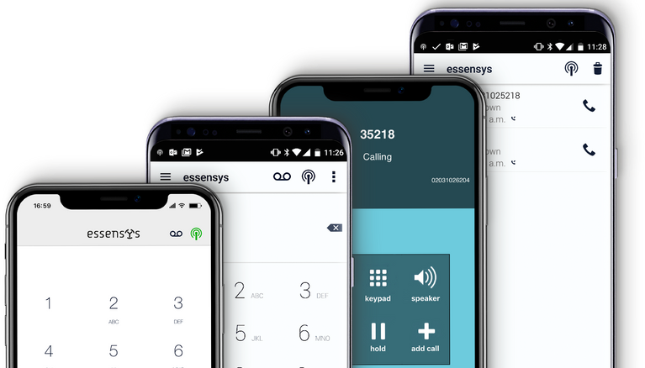

SOFTPHONE APP
Communicate globally, pay locally
Insert logo
Contact your centre manager for more information
Powered by

