September 9, 2019

Ms. Dana Woods
Watch Hill, Inc.
12 Broadway Suite 540
Columbus, OH 43086

Re: Service Proposal for Watch Hill
Services Proposed:
- Initial Company Assessment (Phase I) --complimentary
- Comprehensive Company Assessment (Phase II) --fee, includes
- Findings and Recommendations for Growth Strategy (Phase III)

Dear Ms. Woods:

This letter sets forth the terms and conditions of our agreement to serve as a business advisor to Watch Hill.

During our initial meeting, you described three goals for your business:

- Drive growth
- Improve profitability
- Improve operational efficiency: you want to delegate responsibility and accountability, freeing up personal time. Meaning, you’d like help growing the business while maintaining/improving your quality of life

Business Intelligence

Slow growth and operational inefficiency are caused by business bottlenecks. Based on our discussions, we are proposing a three-phase project which will give you a feel for working with us, after which you can decide to engage our firm to analyze and report on the operational health of your business. This business intelligence will be delivered as a Growth Strategy Report, identifying the bottlenecks preventing you from reaching your goals of growing and operating efficiently. These bottlenecks also impact the long-term equity value of your business.
Phase 1 – Initial Company Assessment – Confirming Goals
During this first meeting we will complete an initial assessment of Watch Hill’s operational strengths and weaknesses. The initial assessment of internal and external factors powers a detailed discussion of the top three bottlenecks to growth and operational efficiency. Your report will also analyze the impact of these bottlenecks on the equity value for your business (the value should you sell). This initial assessment requires twenty minutes of a one-hour meeting; the balance of time is devoted to discussing your results. We will also share a summary report benchmarking your company to other companies in your industry.
A copy of the initial report is yours to keep. Phase I is complimentary, allowing you and we to confirm goals, and to confirm your comfort with our methods and expertise.
Phase II – Comprehensive Company Analysis – CEO and (optional) Key Senior Staff
The Comprehensive Company Analysis takes approximately two hours. This meeting is a facilitated onsite mini-retreat, during which you and key senior staff will be led through a detailed analysis of Watch Hill’s operations. Think of this as a health scan of your entire business.
This comprehensive analysis will develop the understanding needed to create your Growth Strategy Report, as detailed in Phase III. We will deliver an agenda with the timing and resources needed for the onsite mini-retreat.
Phase III – Growth Strategy Report Presentation
From the Phase II analysis we will have detailed business intelligence about your company’s operational health, across the totality of your operations. Each area of your business is analyzed individually; you will also be able to see the relationship between related growth and equity value drivers. This analysis will be delivered to you as your Growth Strategy Report.
You will learn, in detail, what is preventing you from achieving sustained growth and operational efficiency. The Growth Strategy Report details the bottlenecks to reaching your stated goals, and includes recommended tasks to neutralize these bottlenecks.
The typical time for us to prepare the Growth Strategy Report is approximately ten days. We will then meet with you (and your senior team, if you choose) to deliver, present and discuss our findings. During this meeting, we will make prioritized recommendations to strengthen your growth and equity value drivers. When implemented, these recommendations are the key to creating sustained growth and an efficient operation. Companies that implement these recommendations have a proven track record of increasing Gross Revenues an average of 21.63% per year. The Growth Strategy Report can provide the basis for future strategic growth planning.

Schedule and Fees
Phase I – One hour, no fee; this is our mutual investment to confirm direction and comfort working together.
Please suggest two alternative one-hour meeting times, and we will confirm.
Phases II and III – If you choose to engage our firm after Phase I, we will facilitate the two hour mini-retreat and perform the comprehensive analysis. Based on this analysis we will prepare, deliver and present your Growth Strategy Report in a second two hour meeting. The total fee for this service is $8,000, including all relevant preparation and services, plus delivery of six copies of the Watch Hill Growth Strategy Report. Payment terms are half to begin, half due when we deliver your Growth Strategy Report.
[Optional] If, based on what you have learned through our work together, you decide to take action we can develop your Report into a separate Strategic Growth Plan. The Strategic Growth Plan will expand the Report's preliminary recommendations, making your Report actionable. We work collaboratively with our clients as on-demand, supplementary experts. Strategic Growth Planning is optional and not included in this proposal. Planning fees are project-based; consulting is by monthly retainer. We are committed to equitable fees, based on the value you will receive from our work together.
Watch Hill Will Provide
In order to maximize the effectiveness of our meetings and your return on investment, please plan to provide:
- Access to a conference room in which to hold the Phase II and III meetings, with high-speed internet access and a large monitor allowing all participants to clearly see the analysis questions and presentation.
- You and any invited senior staff will block two hours, plus a one hour buffer, for the meetings; please limit interruptions to emergencies only. Mobile phones will be turned off; there will be a 10 minute break each hour.
- Reasonable access to operational and financial information, under our mutual non-disclosure agreement, plus reasonable access to you and your staff for follow-on questions between the Comprehensive Analysis meeting and delivery of the Growth Strategy Report.

Engagement
Should you decide to move forward, please accept the description of services, deliverables and terms by signing below. This proposal is accepted when signed by you; this proposal expires 30 days from the date above.

Sincerely,
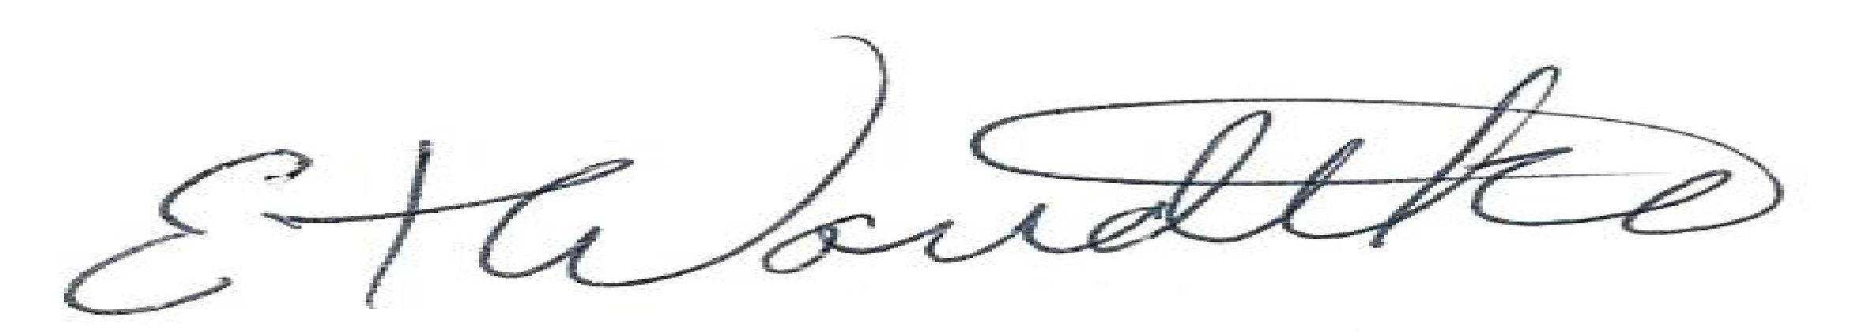

Managing Director

ACCEPTED:
Ms. Dana Woods, President

By: ________________________________ ________________
Title Date

