Multi-node Hardware-in-the-Loop system with Hybrid Vehicle simulation for testing Battery Management Systems
Dharshan Medonza
A&D Technology Inc.

Abstract
To properly operate a high voltage battery, it is critical to have a Battery Management System (BMS) to operate it in an optimum range. It is therefore necessary to fully test the BMS for all scenarios before deployment. A Hardware-in-the-loop system (HiL) for simulating a battery pack to the BMS under test is ideal as it reduces the development cycle time. In addition, it also makes BMS testing more flexible, traceable, easier to reproduce and safer when testing beyond the normal range of battery operation. This paper describes a system that not only simulates a battery to the BMS, but it also provides simulations of an Electric Motor, Electric Motor Control Unit and Vehicle Dynamics. Thus, the system will provide a full Hybrid Vehicle Simulation to the BMS under test. This is done via a multi-node high performance HIL system with separate nodes for each of the components described above. These nodes work as one system by communicating with each other via a high-speed interface. The node simulating the battery contains a battery model and a vehicle dynamics simulation model. The nodes simulating the Electric Motor and Electric Motor Control Unit has a Motor model and Control Model running on FPGA’s at high cycle speed.

Introduction
Testing ECU’s with HIL simulators has become standard procedure. This is the case with BMS testing as well. Most BMS HIL simulators on the market have a standard Battery Model computing the individual cell voltages and then outputting them to the BMS under test. Very few if not none at all have the ability to simulate a full Hybrid Vehicle to the BMS. This paper will introduce a multi-node system that does exactly this. This system consists of 3 nodes working together. The solution is centered on high performance real-time controllers, which can run high fidelity simulation models and perform various control functions. By integrating high fidelity real-time models of all components of a hybrid vehicle in the solution and emulating components that are not physically present in the setup, such a testing platform can be structured and used for testing specific hybrid powertrain configurations to the BMS under test.

This paper will describe the setup of the system and provide some performance results of the BMS under test when it is subject to the Battery cell voltages it would see from a fully simulated Hybrid Vehicle Model. The Hybrid Vehicle Model simulated is a series hybrid in this case. All the models are developed in Simulink and runs in Real-Time on Real-Time Linux Operating systems.

A major advantage of a system such as this is that not only can you develop the BMS logic, but the user can also prototype a Motor Model and Motor Control Unit (MCU) Model at the same time. Since the system is modular, the user can choose to use these nodes individually for testing purposes. For instance, a user may want only the node for Battery Simulation and not the Motor/MCU simulation system to test and prototype a real BMS. Or the user may want only the Motor Simulation system to prototype and test a real MCU. Or the user may want only MCU simulation system to test a real Motor/Invertor system.

The hardware and software mentioned here was all developed by A&D Technology with the exception of the Vehicle Simulation software CarSim which is developed by Mechanical Simulation Corporation. Also, the BMS under test is from Linear Technology.

1.1 System overview

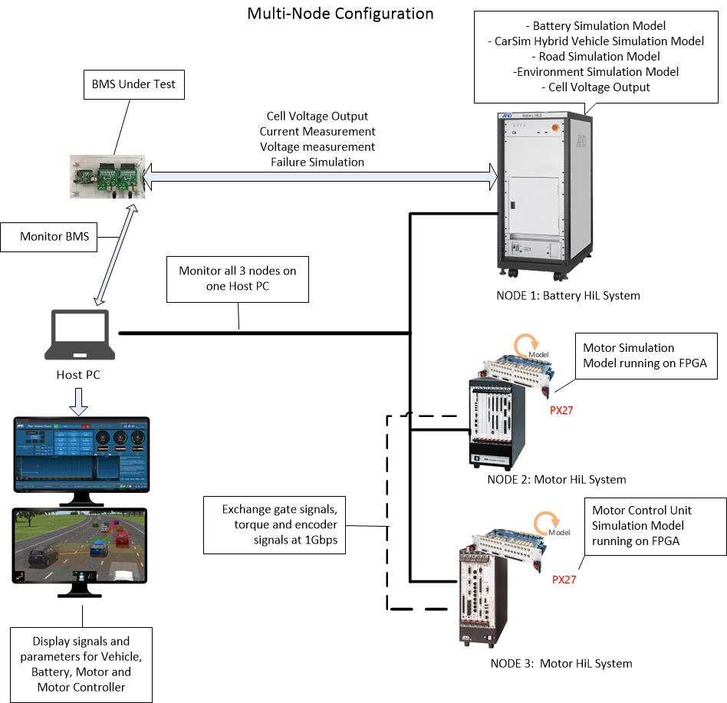

Figure 1 - System Overview

Figure 1 gives an overview of the system. The system consists of 3 nodes as mentioned previously.

Figure 2 shows a more detailed description of the signal flow between the 3 nodes.

Node 1: The Battery HiL System
This is the system that simulates the battery cells to the BMS under test. This system contains the following software and hardware components:

- Battery Simulation model
- CarSim Series Hybrid Vehicle Simulation Model
- Voltage output unit that can simulate up to 192 battery cells in the 0-5V range. This unit can also measure the charge/discharge current from the BMS. This current feedback is needed for the Battery Model running on this system to determine the SOC of the individual cells.

The Battery Model can simulate up to 192 cells connected in series. The CarSim Vehicle Model provides the load for the Motor Model. The Vehicle Model has the entire vehicle dynamics, road profile and environment modeled in it.

Node 2: Motor HiL System
This system contains the Motor Model running on the FPGA of the Motor Simulation HiL Board. Since this model is running on the FPGA it is running at a cycle time of 125Mhz which is needed for a Motor Simulation system. The simulated motor is a Permanent Magnet Synchronous Motor which is widely used in hybrid vehicles. It is also communicating to Node 3 which is the MCU HiL system and sending and receiving signals over a 1Gbps high speed interface.

Node 3: MCU HiL System
This system contains the MCU model running on the FPGA of the Motor Simulation HiL board. This model is also running at a 125Mhz cycle time and communicating to Motor Model running on Node 2 over the 1Gbps high speed interface.

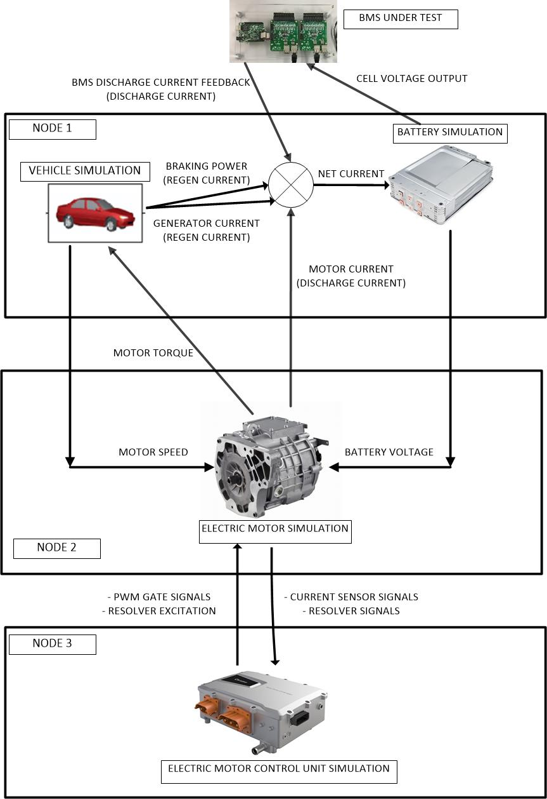

Figure 2 - Signal Flow Overview

1.2 System Setup for Battery HiL system (Node 1)
To properly simulate the behavior of HEV or EV vehicle battery several cell simulation modules are needed. Figure 3 below shows an overview of the A&D Technology Battery HiL system which is Node 1. The Battery Simulator used for Node 1 uses the VS1100 to simulate up to 12 battery cells. This can be expanded by adding 16 of these VS1100 units to simulate up to 192 cells simultaneously in one HiL system.

The heart of the HiL system is the VS2000 HELIOS unit which contains the Intel Xeon 3.5 Ghz processor and the real-time operating system. This unit runs the physical models in real time and communicates to the VS1100 voltage output units via a high-speed fiber optic interface. Since the fiber optic interface has a high data rate, values between the model running on the real time CPU and the voltage output board can be done with very low latency. It also contains any other I/O boards that maybe needed for the system such as analog input/output, digital input/output, PWM input/output etc… . It also contains any other communication protocols that maybe needed such as CAN, CAN-FD, LIN, Ethernet etc… .

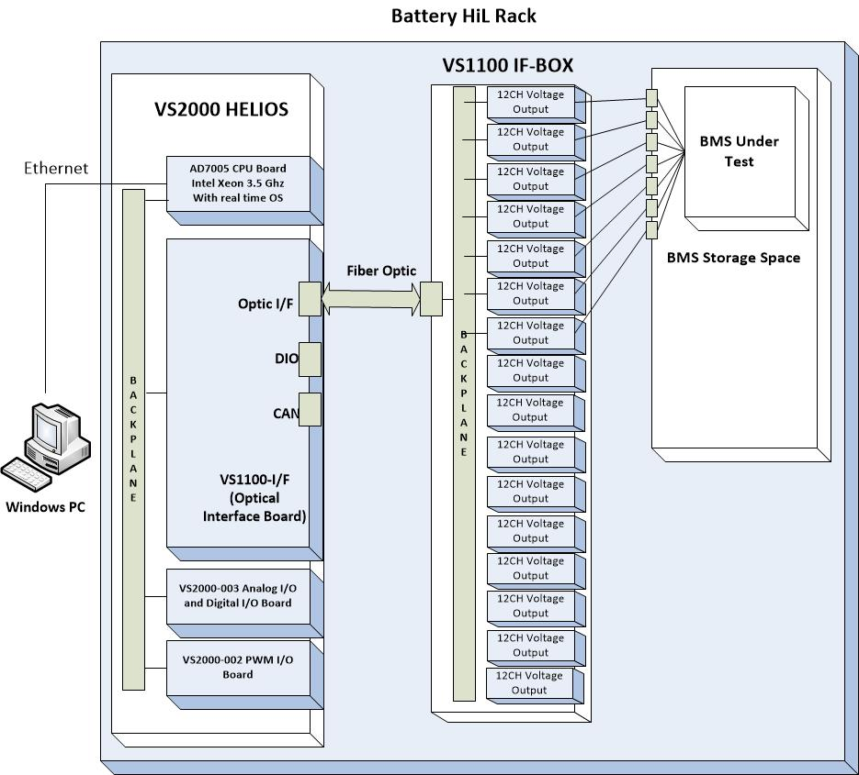

Figure 3 – Overview of Battery HiL System

This system provides the following electrical features that is needed to simulate a battery to a BMS.
- Voltage precision of up to 5mV
- High current output for individual cells up to several hundred mA.
- Measurement of BMS balancing current and voltage that is needed for the battery model to calculate SOC.
- Failure simulation for individual cells.
- Noise contamination function for individual cells.

1.3 System Setup for Motor HiL and MCU HiL system (Node 2 and Node 3)

Figure 4 below shows an overview of the A&D Technology Motor HiL and MCU HiL systems and how they work together. The A&D Technology Procyon systems are used for this purpose. Each of these units contains 2 main components.

- The AD7005 CPU board with a 3.5 Ghz Intel CPU and Linux real time operating system.
- The AD5440-PX27 FPGA Board

The heart of these systems is the AD7005 CPU board which runs a Simulink model which captures signals of the Motor and MCU model running on the AD5440-PX27 FPGA board. The Motor and MCU models running on the FPGA board is running at a cycle time of 125Mhz and thus providing a very accurate and high speed simulation of a Motor and MCU.

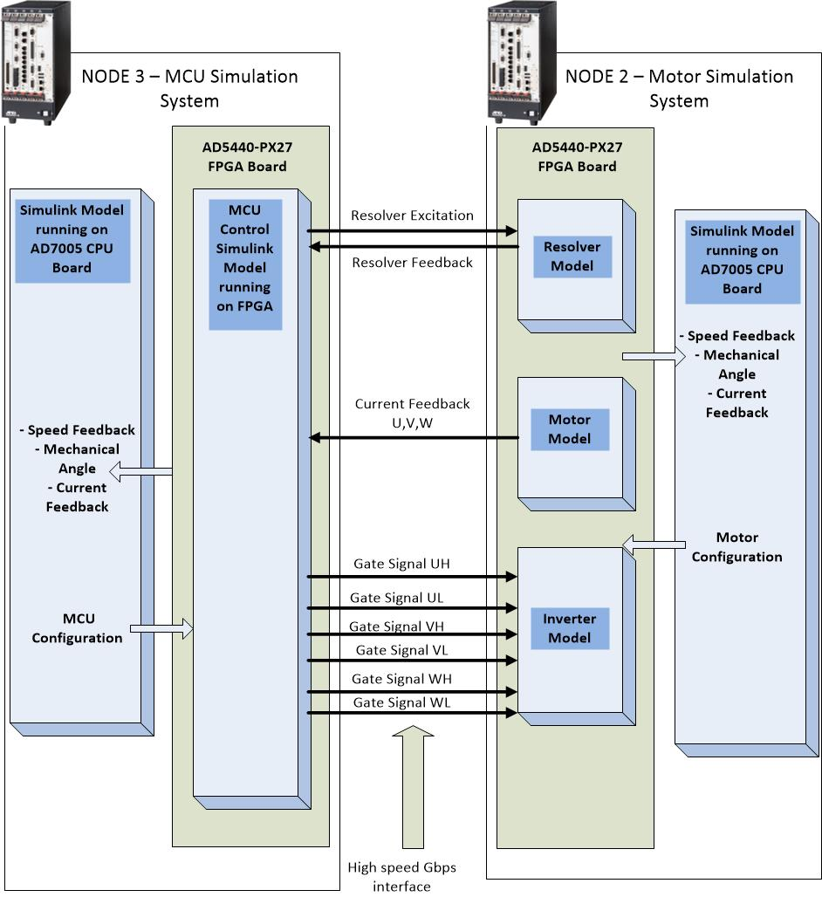
Figure 4 – Overview of MCU and Motor HiL systems

Experimental results
Experimental results of the interaction of the BMS with the HIL Simulated Battery, Vehicle and Motor are shown in this section. The Vehicle Model runs an FTP-75 cycle with the built in driver model following the trace. Figure 5 below shows a window of the vehicle speed running the vehicle speed trace.

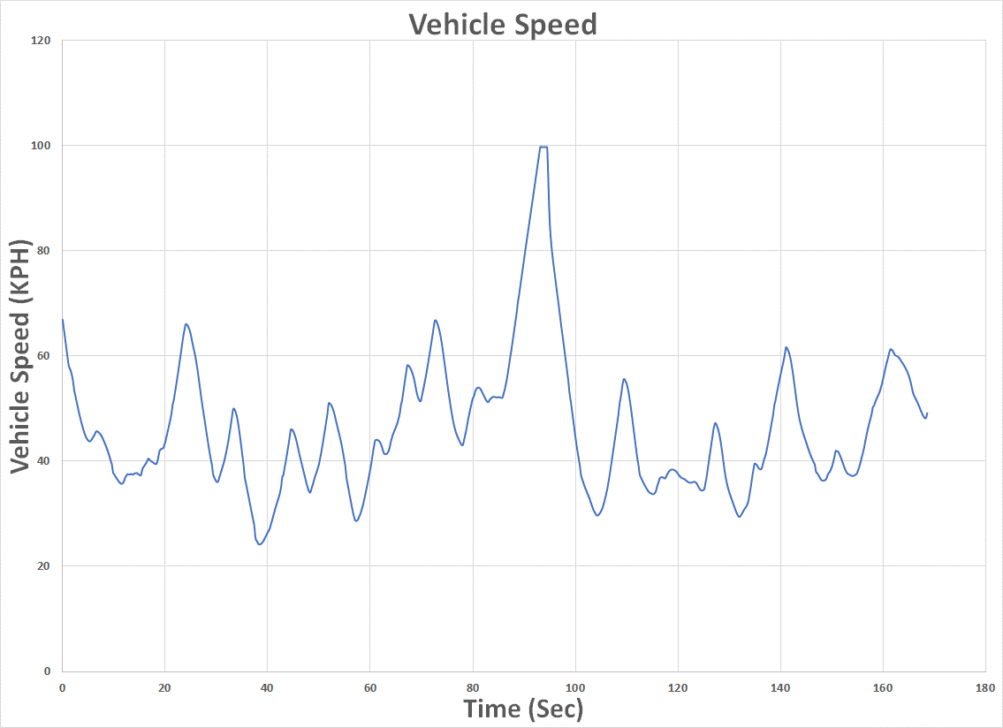
Figure 5 – Vehicle speed trace

The SOC computed by the Battery Model in Node #1 is shown in Figure 6 below.

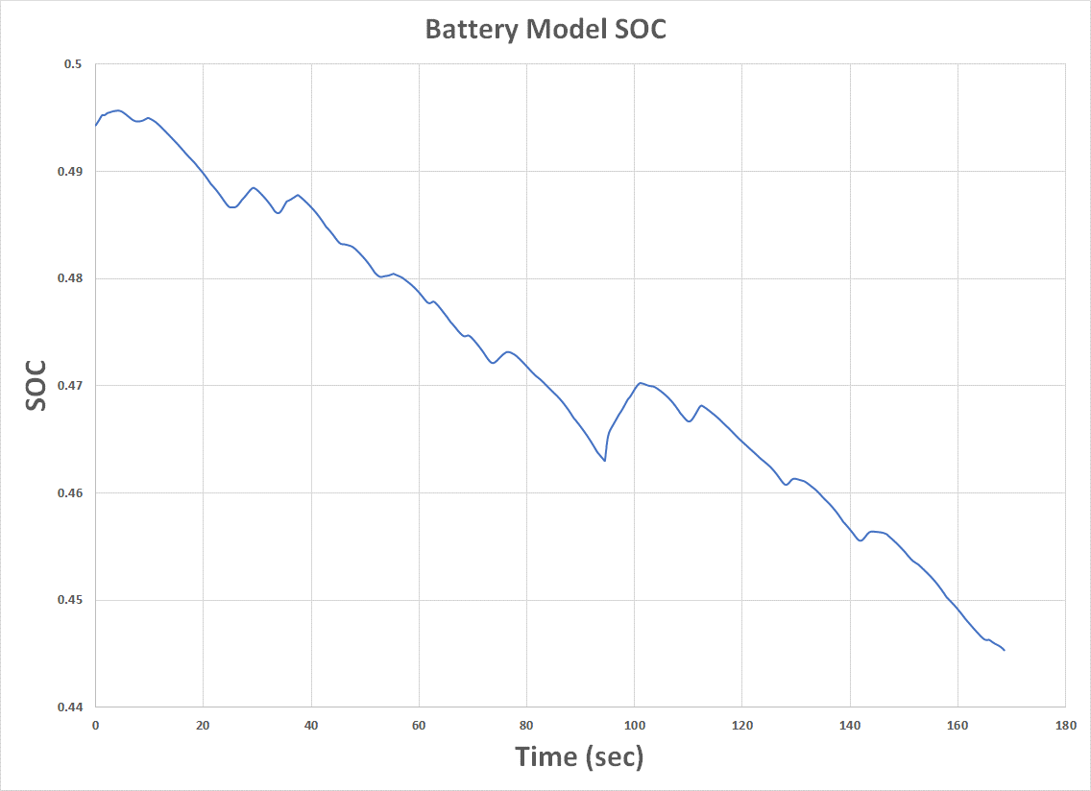
Figure 6 – Battery SOC

Figures 7 below shows the charging and discharging currents of the battery. The figures 7,8 and 9 show results for 1 battery cell. The Net Current into the Battery Model is used by the Battery Model to calculate the State of Charge (SOC) and the individual cell voltages. This is computed as follows:

$$Net Current =+ charging Generator current \left(from vehicle simulation in Node 1\right)+ charging braking regen current \left(from vehicle simulation in Node 1\right)- discharging Motor current \left(from Motor simulation in Node 2\right)-discharging BMS balancing current (measured)$$

Figure 7 shows the discharging Motor current and the Braking regen and Generator regen current.
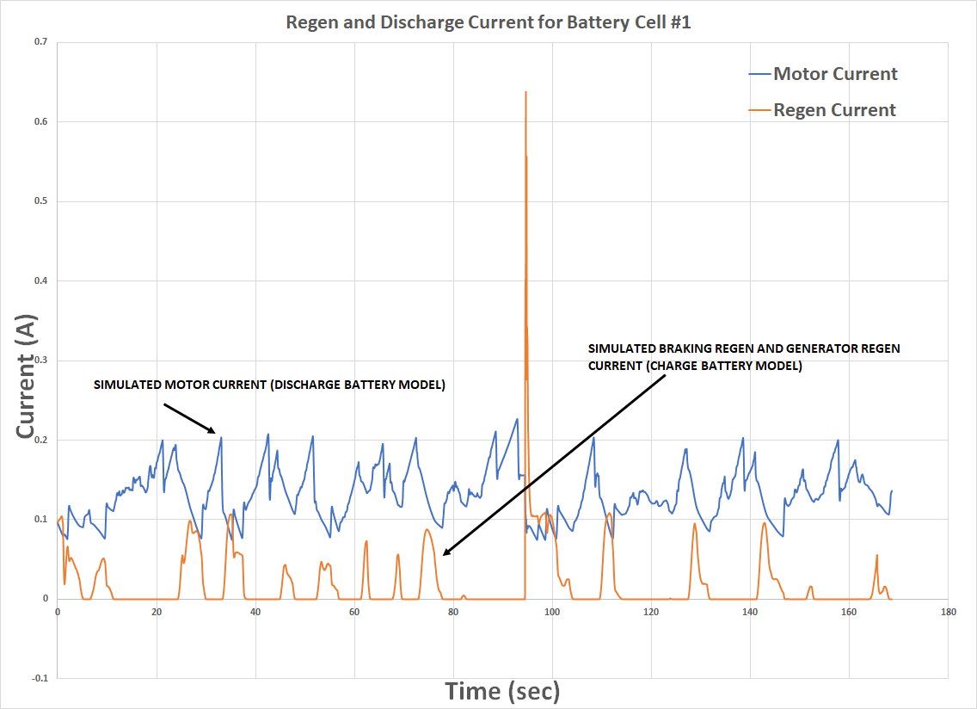
Figure 7 – Charging and discharging current of Battery Model

Figure 8 shows the resulting battery voltage due to the net current. Note that every time there is a regen event, the battery voltage goes up. The BMS under test responds to this and then tries to balance the cell by discharging the cell. The BMS is programmed to maintain the cells at a voltage maximum of 3.5V. Every time the simulated battery voltage goes above this threshold, the discharge current from the BMS goes high to balance out this voltage spike. This is shown in Figure 9. This current measurement is measured by the BMS HIL system. A clear correlation between the vehicle acceleration and deceleration, battery voltage and BMS behavior can be seen.

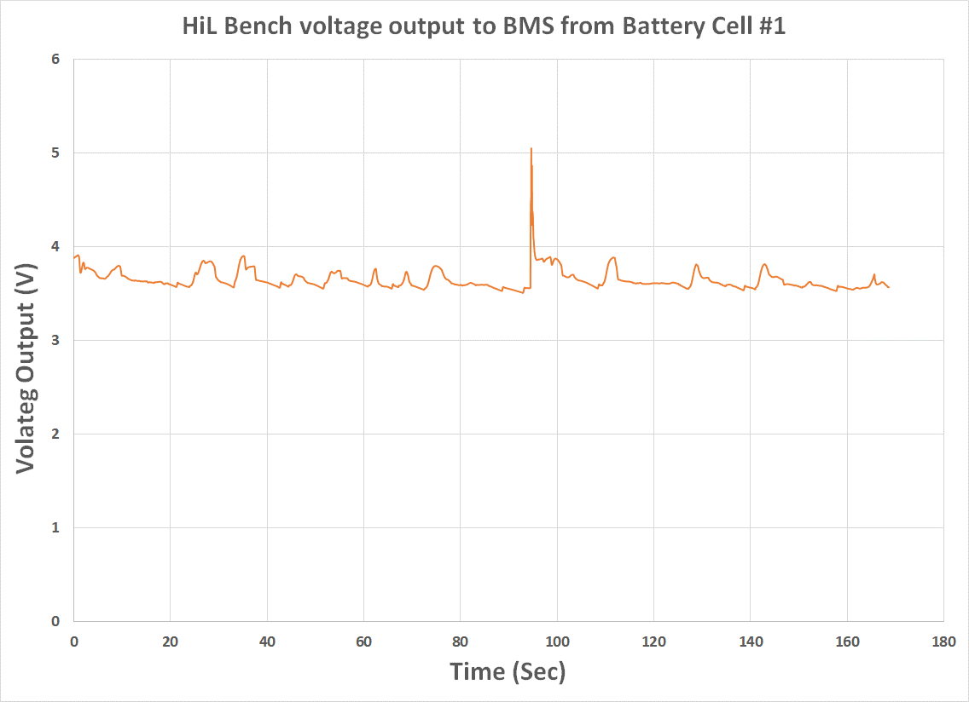
Figure 8 – Voltage output from battery model to BMS

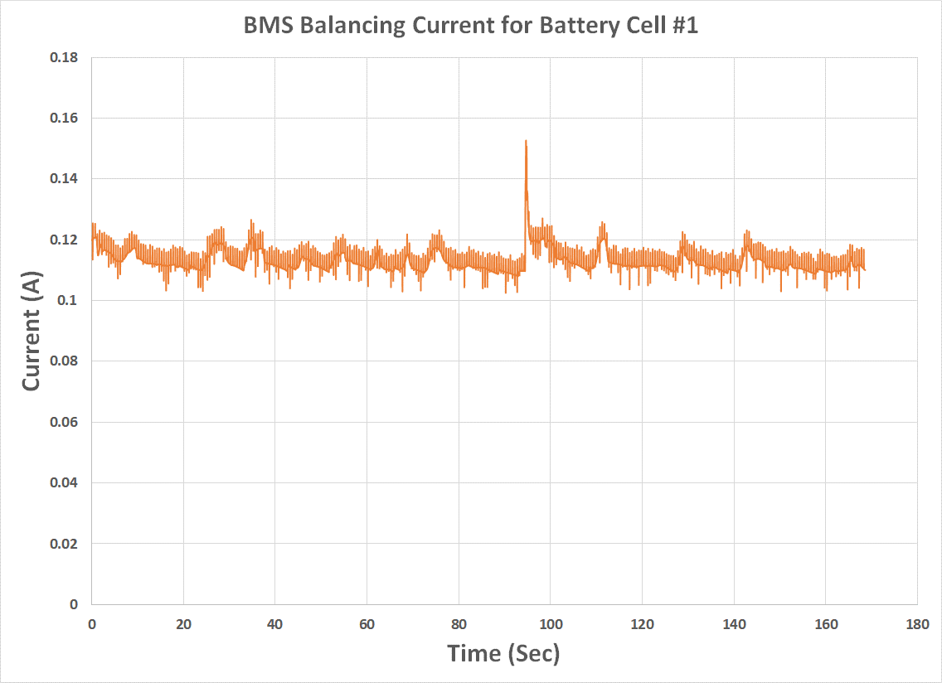
Figure 9 – Measured BMS balancing current

