Top 4 Things to Understand about Changes in Business Applications

In the last decade enterprise applications have moved from being locally hosted in corporate data centers to being multi-tenanted in the cloud. CRM applications, read salesforce.com, led the charge, and more recently interactive communication solutions such as IP telephony and videoconferencing have jumped onto the SaaS bandwagon.
“Within the next 3 years 78% of firms are planning to expand SaaS usage”, The State of SaaS in 2016, BetterBuys.
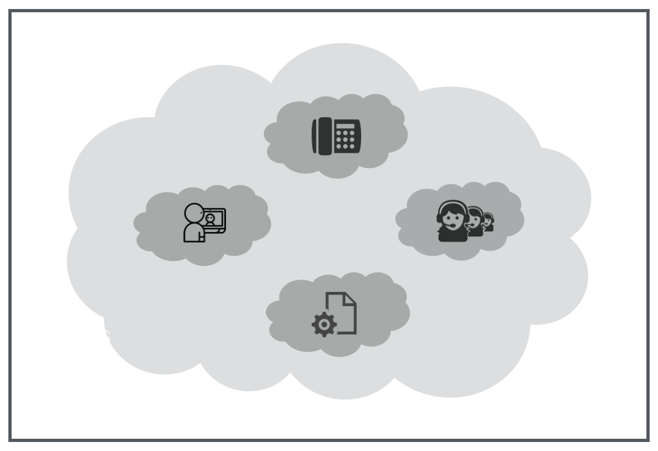

As more and more business applications move to the cloud, reliability of network connections becomes more important. It’s now not uncommon to be hit with the spinning wait cursor/pinwheel/beach ball when accessing hosted applications. With the proliferation of sales, marketing, HR, supply chain and financial SaaS solutions, a business’ productivity can be seriously affected by hung applications.
“By 2020, 78% of small businesses will be fully adapted to the cloud, up from 34% in 2014,” Small Business Success in the Cloud, Emergent Research & Intuit.
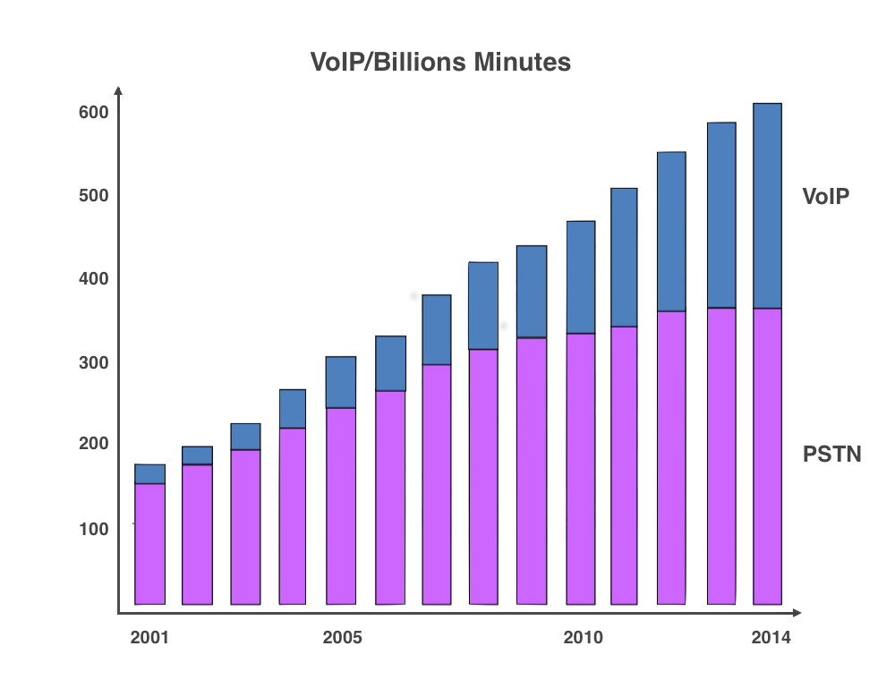
Email and text-based communications remain important, but business still depends on telephony. And today, business telephony means VoIP. While VoIP technology continues to improve, it’s still not good enough to provide a clear and reliable experience over any connection, all of the time. Too often, conversations with prospects, customers, and colleagues are interrupted by jitter and latency, resulting in garbled speech or echoes. Time is lost, productivity lags, and brand reputation is tarnished.
“Use of traditional carrier-switched phone services has leveled off, whilst VoIP traffic has roughly quintupled over the past decade,” The future of global telecommunications: expected impacts on usage and prices,” SCF Associates, April 2015.
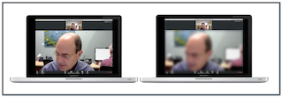
Web conferencing, including interactive videoconferencing, has become essential for today’s distributed and mobile workforce. Videoconferencing can suffer from quality problems similar to those affecting VoIP. In the middle of a video call, frames might freeze, audio might become out of sync with video, and other problems might occur. There’s nothing worse then trying to carry out an online business meeting when the other side is distracted by imperfect visuals and audio.

Streamlining the Internet fixes network reliability problems once and for all, enabling VoIP, videoconferencing and business applications to work as promised over every connection, all the time. Clear voice calls, reliable videoconferencing, and responsive applications become routine after deploying InSpeed Quality Service™, the first networking solution developed to address interactive communications.
“The global videoconferencing market, including SaaS and on-premises services, is growing at 9.8% year-on-year.” 2016 Global Web Conferencing Market Forecast, Frost & Sullivan.

If you’d like to find out more information on how we can help you benefit from Streamlining the Internet, please don’t hesitate to contact us at KTS at:
hclark@ktsnetworks.com or call 800-397-1201

