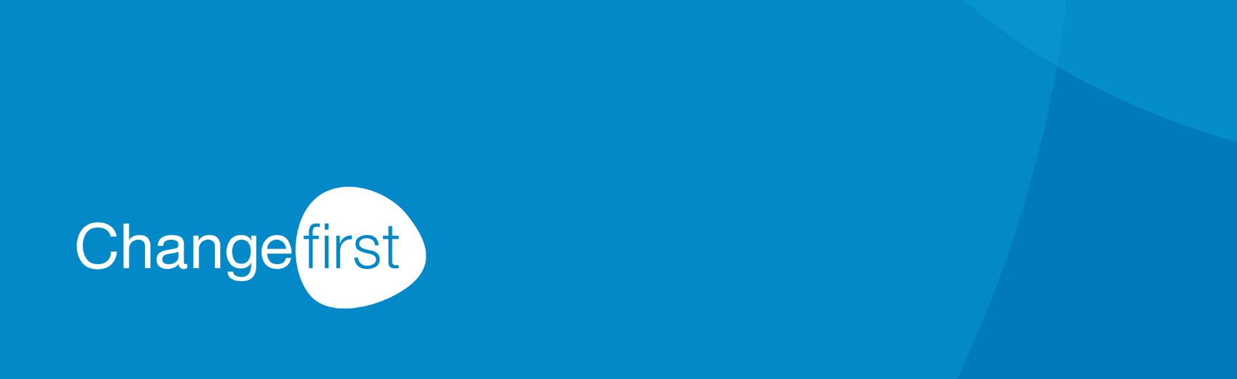

**7 ways Roadmap Pro will help you implement your agile organizational change management capabilities and significantly improve your ROI**

As an organization it is important for you to focus on full implementation, not just installation, which is at the heart of the ROI of effective change management.  Here at Changefirst, we are seeing an increasing amount of organizations move towards agile ways of working where you will need more, not less change management for your business because of the iterative nature of the agile approach.

To meet this need we have developed a completely new digital platform called Roadmap Pro for organizations that must deliver their change projects quickly, comprehensively and cost-effectively. Here are seven ways in which Roadmap Pro can help you achieve this:

1. **Lower Costs**

Highly competitive enterprise-wide pricing means organizations can drive up their change capabilities at a fraction of the cost of more traditional offline and workshop programs.

1. **Rapid program support**

Organizations can start working quickly, virtually and collaboratively on major change programs.

1. **Consistent change planning**

The step-by-step planner functionality in Roadmap Pro can guide users, often in different locations, quickly and easily through a standardized approach to building change plans.

1. **Quick and effect change-skill building**

Contextual on-demand learning and proven tips on specific topics provide support to inexperienced change managers, making learning more accessible and convenient without the disruption of lengthy workshops.

1. **Powerful analytics to deliver critical data**

Roadmap Pro provides just-in-time information, at the right time to people who need it and can act on it in an agile way to measure, track and mitigate program risks.

1. **Easier and effective Collaboration**

Roadmap Pro also features collaboration channels, creating direct connections and building engagement among people across the organization. Single click sharing means that geographically dispersed change teams can share, collaborate on and deliver programs more effectively and quickly.

1. **Increased Productivity**

The intuitive nature, the ability to keep data, plans and key deliverables in one place, the ease of sharing plans and learning from past implementations means that both teams and organizations are far more productive with Roadmap Pro.

Our work is entirely shaped by research and our learnings from over 600,000 data points across 75 clients in 45 countries for over 20+ years. Our PCI methodology underpins Roadmap Pro and has been rated by Forester as one of the top three methodologies globally.

Get in touch to schedule a personalized demo to see how we can help your team or organization build and implement your change management capabilities and significantly improve your ROI.

Get in touch to schedule a personalized demo to see how we can help your team or organization build and implement your change management capabilities and significantly improve your ROI.

[Request a demo](https://info.changefirst.com/changefirst-roadmappro-demorequest-form-0)

A close up of a sign

Description generated with high confidence

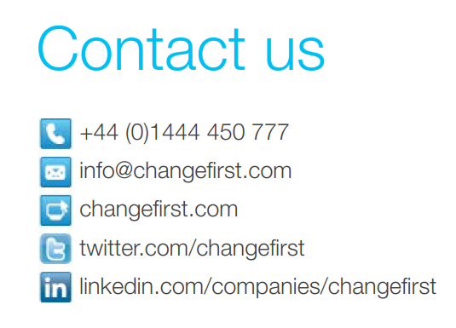

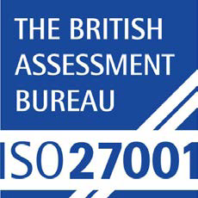

**Main Office**

Delmon House, 36-38 Church Rd, Burgess Hill, RH15 9AE

**T** +44 (0) 1444 450 777

**F** +44 (0) 1444 450 745

**E** info@changefirst.com

**Australia/New Zealand**

PO Box 3042

Eltham Victoria

Australia 3095

**T** +61 3 9459 4110

**M** +61 4 1739 9358

**E** info@changefirst.com.au

**Latin America**

**Dextera Consultoria**

Alameda Jaú, 72 conj. 121

Cerqueira César 01420-000

São Paulo-SP Brasil

**T** +55 11 3062 8486

**F** +55 11 3062 8809

**E** info@dextera.com.br

About Changefirst

Changefirst has been working with organizations for over 20 years with a clear goal - to enable organizations to deliver on their change agenda. In that time, we have worked with over 300 organizations in over 45 countries, training more than 30,000 people to use our tools and processes.

In the last 5 years, the accelerating pace of change and wholesale disruption of business models has seen client requirements changing significantly – with a need for solutions that are cost effective, scalable and available 24/7. To meet those needs we have developed Roadmap Pro for organizations that must deliver their change projects quickly, comprehensively and cost-effectively.

In 2018, Changefirst was assessed and certified as meeting the requirements of ISO 27001:2013 for providing Change Management services.

Changefirst’s PCI® is a licensed product and is protected by copyright laws. Copyright © Changefirst Limited 2018. All rights reserved.