FOR IMMEDIATE RELEASE

Media Contact:
Jessica Schneider
214-206-3047
jschneider@dma-solutions.com

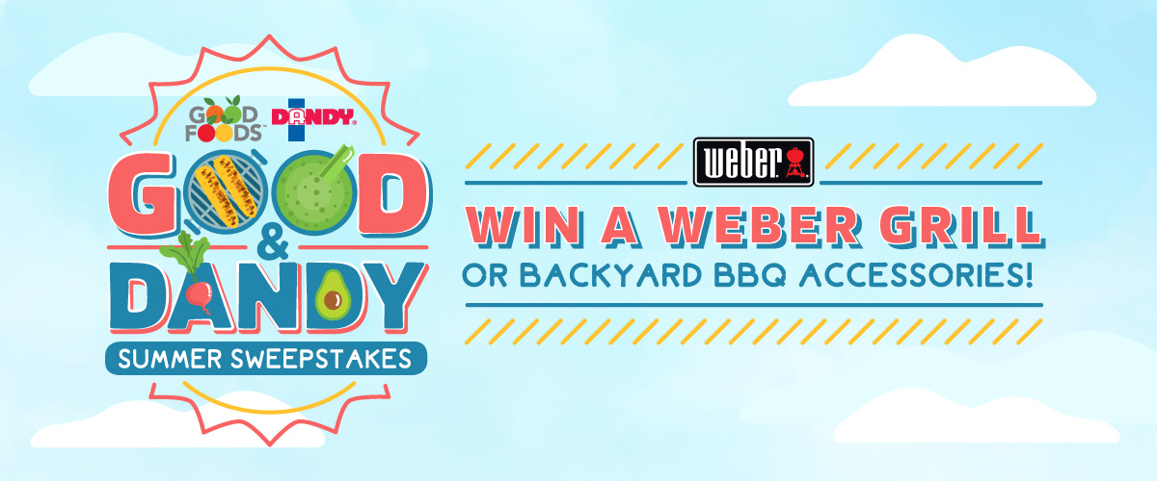

Good FOODS™ PARTNERS WITH Dandy® TO BRING FANS THE ultimate summer sweepstakes
The Limited Time Giveaway of Fresh Products & Brand New Weber Grill Ends July 31

DALLAS, TEXAS (JULY 9, 2019) – Good Foods™ and Duda Farm Fresh Foods, growers of consumer brand Dandy®, have partnered to give one lucky winner of their Good & Dandy Sweepstakes a Weber Spirit® E-330TM Gas Grill and an assortment of fresh dips and vegetables across both brands. Runners-up from each brand’s social media pages will score backyard barbecue accessories to host the hottest summer get-togethers.

To enter the sweepstakes, participants must visit either the Dandy or Good Foods websites and choose their favorite summer products and pairings. Choices include everything from the best fresh dips and burger toppings to bright and summery drinks and desserts.

“Our brands are a natural fit for one another, so we wanted to take advantage of pooling our collective earned consumer data to determine how to best serve our fans with recipe inspiration and future products,” said Danyel O’Connor, executive vice president of sales and marketing at Good Foods. “Depending on what we learn, we believe there could be some incredible product partnerships in the future as well.”

The Good & Dandy Sweepstakes encourages participants to choose their ultimate grilling lineup from a list of Good Foods and Dandy recipes and products. With the results from both personalized quizzes, the brands will determine what future products and recipes make sense for their most actively engaged consumers.

“We are devoted to our consumers and are constantly looking for ways to better their experience with our products through research like this,” said Nichole Towell, senior director of marketing at Duda Farm Fresh Foods. “We’re thrilled to be partnering with Good Foods and hope that shoppers will naturally pair our complementary brands together while in the fresh produce aisle.”

For more “Good & Dandy” inspiration, visit both websites at goodfoods.com and dudafresh.com.

# # #

About Duda Farm Fresh Foods
Duda Farm Fresh Foods, the parent company for Dandy® Celery, is a leading grower of a wide range of fresh vegetables and citrus with primary locations in Florida, California, Arizona, Georgia and Michigan. The company is a wholly owned subsidiary of A. Duda & Sons, Inc., a family-owned, diversified land company headquartered in Oviedo, Fla. For more information, please visit http://www.dudafresh.com.

About Good Foods
Good Foods, LLC is a leader in providing healthy, all-natural products such as guacamoles, dips, salads, and dressings. Good Foods creates convenient snacks and meal options that are made with real ingredients, free of preservatives and artificial flavors. The brand’s products are packaged using high pressure processing that uses cold water pressure, keeping foods safe and at their peak freshness. For more information, please visit http://goodfoods.com/.

