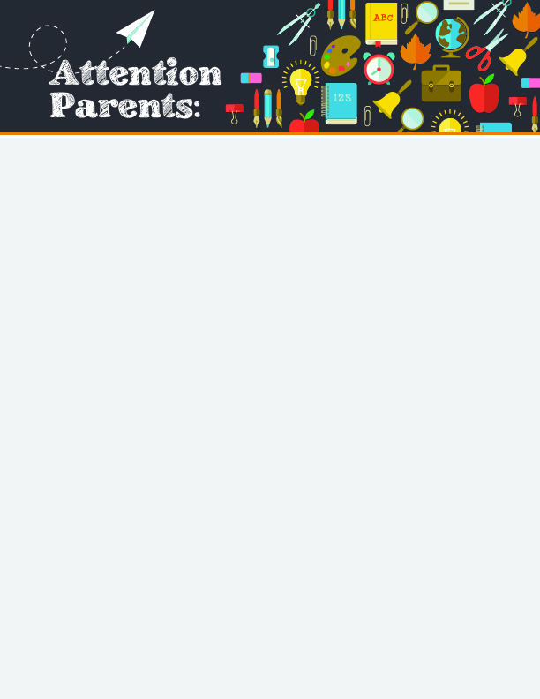

Info Request: Our school needs an email address for each student’s custodial parent/guardian to send school information electronically.

Please support this effort by *confidentially* sharing your email address.

Please fill out the information below and return it to school if you do not already have parent/guardian email addresses on file.

Student’s Name: Grade:

Parents’ or Guardian’s Email Address(es):

Email #1: for ­

Parent/Guardian Name

Email #2: for ­

Parent/Guardian Name

Email #3: for ­

Parent/Guardian Name

**Our School Needs Your Email Address**