IDP Self-Assessment Worksheets

These worksheets will help you formulate some initial thoughts which you can use to have your IDP conversation with your supervisor. Use them to generate ideas which can feed into agreed on specific goals and actions for your IDP plan for the year.

Three Key Ingredients for Professional Development

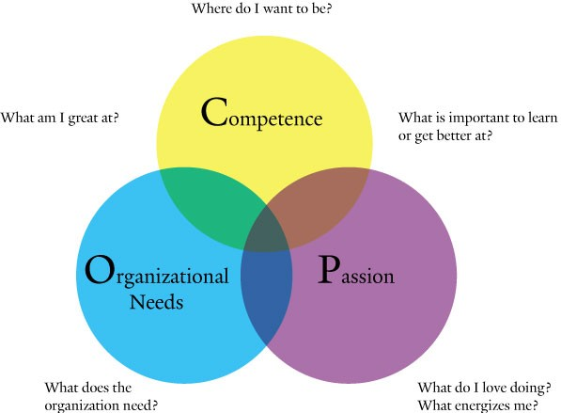
What are my current challenges / areas for improvement?

Part 1Professional Goals and Aspirations –
As a first step, it can be helpful to identify where you are in relation to where you may want to move on your professional path.

• Are you new in your role, or new to the College, and needing to master essential competencies critical for your success?

• Are you thinking about preparing for a different role, which may require different skills, or developing existing skills into significant strengths?

• Are you experienced in your role, and looking to maintain full engagement and enthusiasm through taking on additional challenge, or building competencies that are needed to meet changing work demands, or using strengths more fully, or mentoring others?

Use the following questions to further refine your professional goals.

1. What gives me the greatest sense of satisfaction and reward?

2. What do I want to do that I am not currently doing?

3. What do I care most about in my work and life?

4. How will these goals and motives help me deliver results at Hocking College?

5. What is now, or will be of greatest need to Hocking College, or to my department, in the future? What are the necessary competencies I’ll need to contribute?

6. Do I see myself changing roles? If so, when, and what does that next role look like?

7. How might my current role change in the future? What competencies will I need to be ready?

8. What work experiences do I need to have to develop professionally to improve performance and to stay engaged?

9. Where do my professional goals and aspirations overlap and align most with the needs of Hocking College?

Part 2Strengths – Development Opportunities –

Now think about your current strengths and development opportunities. You will not necessarily have a strength and development opportunity in every category below, but you may. The idea is to go with “top-of-mind” responses at this stage of planning. As you continue to plan each year, you will find your areas of strengths and development opportunities will change, so there is no need to identify or accomplish everything at once.

TECHNICAL KNOWLEDGE or EXPERTISE SKILL AREAS – Examples: Classroom management, using technology to improve teaching, inspiring students, finance, process improvement, project management, computer applications, strategic planning, etc.

Strength –

Development opportunity –

PERSONAL SKILL AREAS – Examples: Managing time, taking initiative, planning and organizing work, problem solving, providing customer service, etc.

Strength –

Development opportunity –

INTERPERSONAL SKILL AREAS – Examples: Attitude, Collaborating, working on teams, listening, resolving conflict, etc.

Strength –

Development opportunity –

MANAGEMENT AND LEADERSHIP SKILL AREAS – Inspiring others, delegating, coaching, giving feedback, setting clear goals and expectations, strategic planning, communicating well, getting participation from others, etc.

Strength –

Development opportunity –

Part 3 Passions –

In our rational, pragmatic minds, we don’t often spend time thinking about what we simply love about working at – our passions. However, if we would analyze when it seems that “time just flies,” or when we experience a healthy dose of satisfaction, we would probably discover that we are applying skills or abilities that we love using. These are automatic motivators for us, and we can leverage them to achieve great results, to build skills into strengths, and to keep us fresh and focused at work.

Check the areas below that fit the description of passions so you can factor them in when you are ready to create your IDP.

CONTRIBUTING EXPERTISE AND RESULTS

Providing information and expertise to others in the organization

_Producing work based on my own technical expertise

_Working with others on a team as an individual contributor

Solving technical problems

Teaching others the skills and knowledge in my area(s) of expertise

Working directly with customers to resolve issues

___ Other

SUPPORTING PEOPLE

Communicating goals and expectations

_Recognizing others for high performance

_Overseeing team and individual efforts and providing timely feedback

_Delegating tasks to provide growth opportunities for others

Discussing career development with direct reports

Intervening and facilitating with teams and individuals to work through issues and problems

_Other

DESIGNING and ASSISTING with HOW WORK GETS DONE

Establishing procedures for problem solving and decision making

_Designing and implementing systems and practices to support organizational objectives

Cultivating relationships and networks to procure key resources and improve work flow

Overseeing processes and metrics to ensure quality and identify targets for improvement

Developing project plans and delivering project status updates

Leading or facilitating teams to accomplish work

_Other

DEVELOPING the FUTURE VISION, CULTURE and ARCHITECTURE OF THE ORGANIZATION

Translating organizational goals and strategies into goals for my department and myself

Communicating change and strategy to others

Holding strategic discussions to establish work priorities

Developing a vision for the future for my part of the College

Scanning the environment for trends and assessing organizational challenges and opportunities

Analyzing my attitude and impact on creating a positive work environment for myself and others

Other

Part 4 Alignment –

ALIGNMENT – YOUR PROFESSIONAL GOALS AND THE COLLEGE’S GOALS

Now you’ve developed a clearer sense of yourself in terms of what you have to offer professionally, and what you want to have to offer, now and in the future. It’s time to think about how this feeds into your current role and the directions you may have in mind going forward. It’s also important to consider where your department is going and where the college is going, so that you can connect with opportunities to grow and develop, both in your role now, and with an eye to the future. Answer the items below to focus your thinking.

- What will be important for me to perform at the maximum level in my current job?

- Where is my department going and what do I need to grow with it?

- What future roles or positions are exciting to me?

- What skills and capabilities will be important to prepare for future roles and changes in my current role?

YOU’RE READY TO PLAN!!

Use the information you’ve compiled here to zero in on two to three areas of importance for this year’s individual development plan, and make some notes on the IDP Conversation Tool to prepare for your meeting.

