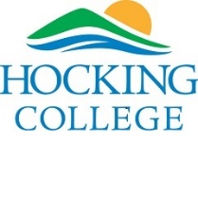

Hocking College
Dental Hygiene Program

Application Spring 2020

Name of Applicant __________________________________

For Department Use ONLY:

Date/Time Received ________________________ By: _____________________________
Signature
Welcome
Congratulations! You have just taken your first step to success in one of the fastest growing and highest paying professions. The Hocking College Dental Hygiene Program takes pride in recognizing and supporting the idea of “Achievement Matters”. This packet will take you through a step-by-step process to complete the Dental Hygiene Program application. Please Carefully Read and Complete.

Admission to the Hocking College Dental Hygiene Program is selective and competitive. Selection is based on a formula of specific criteria. The twenty (20) highest ranking candidates will be offered program admission.

Applications are accepted beginning September 12, 2019. Students applying for the program must complete the application packet prior to December 1, 2019. Admission acceptance decisions will be finalized by December 15, 2019.
If you have any questions regarding the application process, please do not hesitate to contact:
Contact Information:
Dental Hygiene Program Manager Misti Malfe
malfem@hocking.edu
(740) 342-5197
Perry Campus, Office 103

Allied Health Office Manager: Leanna Grey
Grey132771@hocking.edu
(740) 753-6376
Davidson Hall – DVD 217

Please take a moment and tell us how you heard about the Hocking College Dental Hygiene Program:
- Internet Search
- Word of Mouth
- Dentist/Dental Hygienist
- Brochure
- Advisor
- Other ___________________________________
Content

Guidelines …………………………………………………………. 4
Section A: Program Requirements ………………………………... 5
Section B: Dental Hygiene Program Outcomes ………................... 5-6
Section C: Scope of Practice ……………………...………………. 6
Section D: Employment Opportunities……………………... ……. 7
Section E: Dental Hygiene Curriculum Schedule ………………… 7
Section F: Transferability of Dental Hygiene Program Courses …. 8
Section G: Application and Admissions ………………………….. 8-9
Section H: Application Procedure …………………………………10-11
Section I: TEAS Test Information ………………………………... 11-12
Section J: Student Personal Information ………………………….. 13-14
Section K: Educational Information ……………………………… 14-15
Section L: Educational Courses …………………………………... 16-18
Forms Observation Experience …………………………………... 20
In Progress Grade Report Form ………………………………….. 21-22
TEAS Test Assessment Registration Directions ………………… 23-31

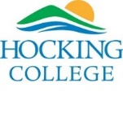
Guidelines
Please utilize the following guidelines to ensure that you have completed all of the required steps necessary for applying to the Hocking College Dental Hygiene Program.

- If you have previously applied to the Hocking College Program and would like to reapply, you are required to fill out a new Hocking College Dental Hygiene Program application.
- Before you apply, please make sure you meet all the minimum eligibility requirements listed on the Hocking College website: www.hocking.edu
- Before you apply to the Hocking College Dental Hygiene Program, you must apply to and be accepted to Hocking College.
  - This is not the same as applying to and being accepted to the Hocking College Dental Hygiene Program. By applying to Hocking College, we are able to properly determine which prerequisite and general education courses you have taken will transfer. This is the first step, and without it, we are unable to determine the eligibility of the courses you have completed.
  - To apply to Hocking College, go to www.hocking.edu/future-students and use the “Apply” button in the upper-right hand area. When you apply to Hocking College please be sure to mark, Associate of Science – Dental Hygiene.
- If you have attended institutions other than Hocking College, have ALL official transcripts sent directly to Hocking College Office of Admissions, regardless of whether you did well or not. Failure to disclose ALL colleges attended may affect financial aid eligibility (Not sent directly to the HC Dental Hygiene Program) Only transcripts mailed directly to Hocking College Admissions from the Institution will be accepted. Students may not hand-carry scaled transcripts to the Admissions Office.
- Please have your transcripts sent well before the application closing date. It may take up to 4 weeks to receive and log transcripts.
- Complete all of the Prerequisite and General Education Courses:
- Courses “IN PROGRESS” at the time of application process must be completed by December 15, 2019, prior to acceptance into the Dental Hygiene Program. Please use the in progress guide report form to have the course instructor report any “in progress grades”. This form should be sent directly to Misti Malfe Dental Hygiene Program Manager. (malfem@hocking.edu)

- Please Send Completed Applications too: Hocking College
Attn: Misti Malfe
3301 Hocking Parkway
Nelsonville, OH 45764

**Application Deadline: December 1, 2019

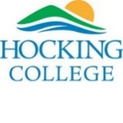
Section A: Program Requirement Information/Technical Standarts:
In order to accomplish the objectives of the Hocking College Dental Hygiene Program, students must be able to meet the following performance requirements:
- Professional Attitude: It is important for a dental hygienist to interact professionally with patients, coworkers, employers, and other health care professionals. Therefore, if at any time during the application process it is determined that your attitude or actions are unprofessional, your application may not be considered for acceptance.
- Physical ability to sit for prolonged periods of time, perform repetitive wrist motion for instrumentation, and move from room to room or maneuver in limited spaces.
- Written and verbal communication skills to concisely describe patient conditions, document findings in a patient record, and implement oral health teachings.
- Manual dexterity to use a variety of instruments in the small, confined space of the oral cavity.
- Function safely under stressful conditions with the ability to adapt to an ever changing environment inherent in clinic situations involving patient care.

Health Requirements:

- Tetanus, Diphtheria, Pertussis (Tdap)
- Varicella (Chicken pox) immunizations (must have a negative titer)
- Measles, Mumps, Rubella (MMR)
- Hepatitis B Vaccination required (if a hepatitis series has been completed a titer test must be completed to insure adequate hepatitis B surface antibody levels (HBsAG), indicating protection against hepatitis B antigen)
- CPR Certification (will be offered through Hocking College, after acceptance into the program)
Dental patients and dental hygienist may be exposed to a variety of microorganisms via blood, oral or respiratory secretions that carry the hepatitis B virus (HBV), hepatitis C virus (HBC), herpes simplex virus type 1 & 2, human immunodeficiency virus (HIV), mycobacterium tuberculosis, staphylococci, streptococci, and other viruses and bacteria. Infections may be transmitted in the dental operatory through contact with contaminated instruments, operatory equipment, or environmental surfaces. Airborne contaminants through droplet spatter or aerosols of oral or respiratory fluids may also be transmitted in the dental environment. Protective immunizations, stringent infection control processes and proper training programs are in place to insure the protection of the patient and the dental hygienist.

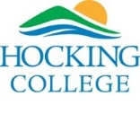
Section B: Dental Hygiene Program Outcomes:
Upon successful completion of the Dental Hygiene Program, the graduate will be able to:
- Apply theoretical principles and perform procedures relevant to the dental hygiene practice, routinely self-assessing performance abilities to ensure a high standard of care.
- Determine the need and extent of patient-centered treatment utilizing critical thinking skills, including radiographic exposure, routine preventative procedures, periodontal therapy procedures, referral for additional assessment and/or treatment, response to medical/dental emergencies, and all other treatment needs.
- Utilize the dental hygiene process of care in the prevention and/or treatment of oral diseases: assessment, dental hygiene diagnosis, planning, implementation, evaluation, and documentation.
- Apply oral health literacy utilizing analysis of current research literature to provide oral and overall health promotion to individual patients and the community using evidence-based information.
- Utilize standard precautions for infection control during all phases of appointment planning, patient interaction, and treatment.
- Discern and manage ethical issues, using Dental Hygiene Code of Ethics and federal and state laws, exercise sound clinical judgement, and collaborate with diverse populations of professionals and patients.

Section C: Scope of Practice for Dental Hygienist:
Ohio dental hygienists provide the following oral health services as permitted by the Ohio State Dental Board’s Dental Practice Act:
- Administration of local anesthesia
- Administration of nitrous oxide-oxygen minimal sedation
- Monitoring nitrous oxide-oxygen minimal sedation
- Removal of calcareous deposits or accretions from the crowns and roots of teeth
- Periodontal scaling, root planing, and soft tissue curettage
- Sulcular placement of prescribed materials
- Bleaching of teeth
- Pit and fissure sealants
- Radiologic procedures
- Taking dental impressions
- Fluoride application.
- Nutritional counseling as it relates to dental health
- Oral hygiene instruction
- Other patient treatment and documentation procedures within guidelines
Section D: Employment Opportunities For Dental Hygienist
According to the US Department of Labor, the job opportunities for dental hygienists are expected to grow much faster than average through the year 2024. An estimated 17% increase in employment is expected in Ohio and 19% increase throughout the United States.
Dental Hygienists are typically employed:
- In private dental practices
- In community clinics
- In college/university dental clinics
- In prison facilities
- In school sealant programs
- To work with underserved populations such as nursing homes

Section E: Dental Hygiene Curriculum Schedule:

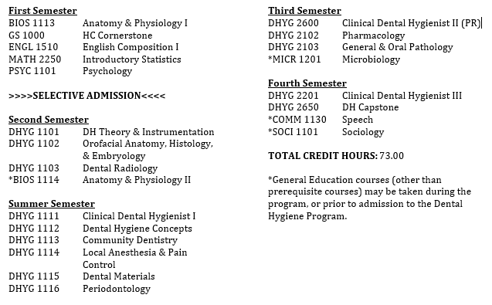

Section F: Transferability of Dental Hygiene Program Courses:
Due to the technical nature of the dental hygiene courses, it is unlikely that they will transfer to other dental hygiene program institutions. Hocking College Dental Hygiene Program does not accept transfer credits for dental hygiene program courses taken at other institutions in place of the required courses at Hocking College. However, the Hocking College courses generally will transfer into a Dental Hygiene Bachelor Completion Program once the student has completed the Associate of Applied Science – Dental Hygiene here at Hocking College.

Section G: Application and Admission to the Dental Hygiene Program:

Application and admission to the Dental Hygiene Program is a separate procedure from application and admission to Hocking College. Admission to Hocking College does not ensure admission into the Dental Hygiene Program. Any Hocking College student may declare Dental Hygiene as a major, enroll, and complete general education courses required for a program degree without having been specifically admitted to that program. However, only those students who have been admitted to the Dental Hygiene Program may enroll in the dental hygiene (DHYG) courses. There is no waiting list. If a student is not accepted, they must reapply for a later year. The candidates receiving the most points in the admissions process will be offered entrance into program. Students will be notified by email or mail of their admission status: ‘Accepted or Not Accepted’. All statements related to admission criteria or announcements of present policies are subject to revision as needed. Any advice given by the dental hygiene department regarding coursework does not ensure acceptance into the program.

Admissions are determined on an objective basis using a quantified point scale. The scale is designed to accurately predict a student’s successful completion of the program and passage of external board exams.

Admissions ranking criteria include:

Minimum requirements for consideration of admission to the Hocking College Dental Hygiene Program include:
- Minimum cumulative college GPA of 2.6
- BIOS 1113: Anatomy & Physiology I (must achieve a ‘C’ 73% or better)
- GS 1010: Pathway to Prosperity (must achieve a ‘C’ 73% or better)
- ENGL 1510: English Composition I (must achieve a ‘C’ 73% or better)
- MATH 2250: Introductory Statistics (must achieve a ‘C’ 73% or better)
- PSYC 1101: General Psychology (must achieve a ‘C’ 73% or better)
- Minimum of 18 observation hours in dental offices
- TEAS entrance exam, three attempts allowed: total score of 55% or better, Reading content area score of 65% or better, English & Language Usage content area score of
65 % or better

All applicants will be scored using the following system. Admission is granted to the applicants with the highest scores using this system.

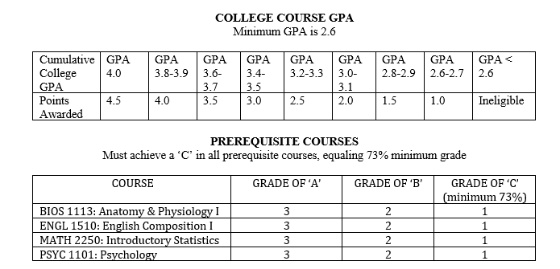
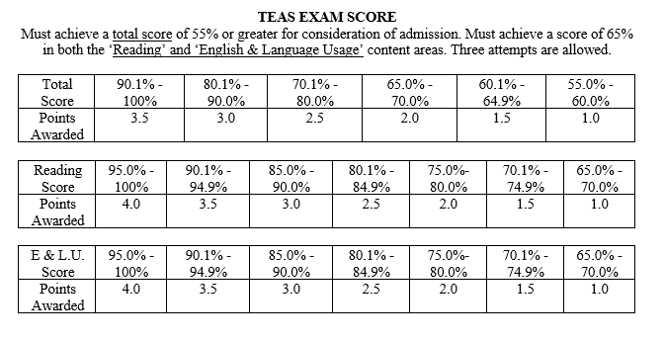
__ Additional Point awarded for previous completion of dental assisting courses or dental assisting career
**DO NOT INCORPORATE THE FOLLOWING DATA IN TOTAL CANDIDATE POINTS**

Section H: Application Procedure:

The following application procedure must be followed for your application to be considered complete:
- Complete application to Hocking College.
- Order 1 official transcripts from every college or university attended forward to Hocking College Admissions Department.
- Students must maintain a minimum cumulative grade point average in college level courses of 2.6 or better.
- One official transcript from other colleges or universities will be sent to the Hocking College admissions office and one will be turned in with your dental hygiene program application in the original sealed envelope.
- Complete the TEAS exam, attaining at least the minimum scores. Three attempts are allowed.
- Complete application to the Hocking College Dental Hygiene Program.
- Criminal history form provided to Hocking College Police Department or other applicable organization. Form is found on website: www.hocking.edu/dental-hygiene. Results will be returned to Hocking College.

Hocking College does not discriminate against qualified applicants with disabilities in any of its programs including the Dental Hygiene Program as long as the candidates are able to meet the technical standards described earlier in this document. The Access Center/Office of Disabilities Services in DVD 114 is dedicated to serving the various needs of individuals with documented disabilities and to promoting their full participation in college life. They will assist persons interested in seeking admission to any program to understand the program requirements and determine whether and how their disability can be accommodated in the program.
In addition, a person with disabilities who is interested in pursuing a career in dental hygiene might wish to consult with a dental professional concerning whether the nature of the disability may be an impediment to hiring in the specific office settings in which there is interest before commencing the program.

HOCKING COLLEGE
DENTAL HYGIENE PROGRAM
Program Application Checklist

Apply for general admission to Hocking College at: www.hocking.edu/apply-to-hocking -Choose Dental Hygiene as program/major
Submit official transcript(s) from all college(s)/university(ies) attended to Hocking College registrar: www.hocking.edu/registrar
SUBMIT TO DENTAL HYGIENE PROGRAM PERSONNEL:
Dental Hygiene Program application
Office observation forms (minimum of 18 hours, forms are included in this packet)
TEAS scores will be accessed by Hocking College faculty and staff (three attempts allowed, see required scores listed above)
Official transcript(s) from all college(s)/university(ies) attended – must be sent by the
College directly to Hocking College. Transcripts hand-carried by students will not be
accepted.
Criminal background results will be received from police department or other office

DO NOT SUBMIT APPLICATION UNTIL ALL REQUIREMENTS AND PAPERWORK ARE COMPLETED; DEADLINE FOR APPLICATION SUBMISSION IS DECEMBER 1, 2019.

All information must be included for your application to be complete. Any piece of missing documentation will result in the application not being considered for admission. It is recommended to retain copies of the application submitted.

Information is not accepted via FAX. All Forms must be delivered in person or by postal mail to the Allied Health Office Manager Leanna Grey or Dental Hygiene Program Manager Misti Malfe.

Please notify Hocking College regarding any change of address, phone number, or email address as soon as possible.

Section I: TEAS Test Information:

TEAS INFORMATION
Last date to take TEAS entrance exam as part of application for Spring 2020: November 30, 2019
The ATI TEAS has four content areas (Reading, Mathematics, Science, and English and Language Usage) each of which is comprised of several sub content areas (e.g., Key Ideas and Details, Craft and Structure). Adjusted percentile correct scores that range from 0.0 to 100th percentile are provided for each of the content areas. These scores are equated scores, meaning they are adjusted to account for possible differences in difficulty across questions. The percentile of questions answered correctly in each sub content area is also provided. A total score is also provided and indicates one’s overall preparedness for early success in a health sciences program. The total score is an adjusted percentile correct score which ranges from 0.0 to 100th percentile. It is an equated score generated by the information from the entire set of 150 scored questions.
Registration for the TEAS Exam is done at: www.atitesting.com/teas
The TEAS Exam must be taken at the Hocking College testing center on the main campus in Nelsonville, OH. An applicant may take the TEAS exam up to three (3) times in association with application to the Hocking College Dental Hygiene Program. The testing center is located on the first floor of Davidson Hall. Make sure to select ‘Hocking College AH’ as your institution when setting up an account. The testing schedule allows for four (4) hours to complete the exam. Attached is information on registering to take the TEAS Exam.

Section J: Hocking College Dental Hygiene Program:

Student Application for Selective Admission
APPLICATION DEADLINE: December 1, 2019

- Name of Applicant | Last MI First

- Hocking College ID#

- Physical Address | Street Name & Number Apt# City State Zip

- Mailing Address | Street Name & Number Apt# City State Zip

- Email Address
- Home Phone Number | ( )
- Work Phone Number | ( )
- Cell Phone Number | ( )

- I have previously attended Hocking College. | Last term attended:
- Are you a citizen or permanent resident of the U.S? | Yes or No

- Emergency Contact | Name Street City State Phone Number

** If ‘No’ the Ohio State Dental Board will not allow licensure for employment. Please consult the Ohio State Dental Board if you have questions or concerns: (614) 466-2580
(Please supply a copy of your permanent resident card, if applicable)

Section K: Educational Information:
Please list all Educational Institutions, High School and above, and Health Related Programs you have attended. Please list them in the order you attended them.
1) Name of Institution:__________________________________________________________________ Address: ___________________________________________________________________________ Phone Number: ______________________________ Health Related Program: Yes No Degree(s) and/or Certificate(s) Accomplished: ___________________________________________ ____________________________________________________________________________________
2) Name of Institution:__________________________________________________________________ Address: ___________________________________________________________________________ Phone Number: ______________________________ Health Related Program: Yes No Degree(s) and/or Certificate(s) Accomplished: ___________________________________________ ____________________________________________________________________________________
3) Name of Institution:__________________________________________________________________ Address: ___________________________________________________________________________ Phone Number: ______________________________ Health Related Program: Yes No Degree(s) and/or Certificate(s) Accomplished: ___________________________________________ ____________________________________________________________________________________
4) Name of Institution:__________________________________________________________________ Address: ___________________________________________________________________________ Phone Number: ______________________________ Health Related Program: Yes No Degree(s) and/or Certificate(s) Accomplished: ___________________________________________ ____________________________________________________________________________________
**Omitting any information will result in a student’s application being rejected and dismissal from the dental hygiene program.**

Have you ever been dismissed from a professional program or academically withdrawn from a profession program? Yes or No
If yes, complete the following information:
School Name and Location: _________________________________________________
Dates of Attendance: _______________ to _______________
Type of Program:
_________________________________________________________________________
Are you in good standing and eligible to return to the program? Yes or No
If no, please explain: ____________________________________________________________________________________
____________________________________________________________________________________

Section L: Educational Courses:
Please fill out the Prerequisite Courses you have completed in the chart below. Send all official transcripts from institutions other than Hocking College to the Hocking College Office of Admissions. (Not directly to the HC Dental Hygiene Program). This process may take 3-4 weeks. Please be sure to have your transcripts sent in well ahead of the application deadline!

PREREQUISITE  COURSES | COURSE ID#  (EX: BIOS1114) | COURSE TITLE | FINAL  GRADE | Date Completed  &  semester or quarter | COURSE  STATUS  C –COMPLETED  I – IN PROGRESS  NT – NOT TAKEN | Institution  Where Course Was  Taken
Anatomy & Physiology 1

BIOS 1113
Pathways to Prosperity

GS
English Composition 1

ENGL 1510
Introduction to Statistics

Math 2250
General Psychology

PSYC 1101

Please fill out the General Education Courses you have completed in the chart below. Send all official transcripts from institutions other than Hocking College to the Hocking College Office of Admissions. (Not directly to the SJC Dental Hygiene Program). This process may take 3-4 weeks. Please be sure to have your transcripts sent in well ahead of the application deadline!

Section L: Educational Courses (continued)
General  Education  Courses | Course ID | Course Title | Final  Grade | Date  Completed  &  Semester or Quarter | Course  Status  C – Completed  I – Incomplete  NT – Not Taken | Institution  Where Course Was Taken
Anatomy &
Physiology 2

BIOS 1114
Microbiology

MICR 1201
Speech

COMM 1130
Sociology

SOCI 1101

Students with felony convictions may not be licensed by the State of Ohio or allowed in the dental clinic to practice dental hygiene. Please consult the Ohio State Dental Board (614) 466-2580 if you have questions or concerns.

Acceptance is contingent upon a negative criminal background check.

I certify that information provided in this application is correct and complete. I understand that omission or falsification of information is grounds for exclusion or dismissal. If accepted into the program, I agree to meet all entrance requirements and to confirm and abide by the rules, regulations, and procedures of Hocking College and this program.

Signature: ______________________________________ Date: ______________________

Please return the completed Dental Hygiene Program Application: including certifications and any other necessary documentation to:

Hocking College
Dental Hygiene Program, DVD 309
3301 Hocking Parkway
Nelsonville, OH 47564

Transcripts:

Hocking College
Admissions Office
3301 Hocking Parkway
Nelsonville, OH 47564

OBSERVATION EXPERIENCE IN THE DENTAL OFFICE

Requirement for Application for Admission into Hocking College’s Dental Hygiene Program

Applicant’s Name: __________________________________ HC Student ID: ____________

Dear Dental Professionals,

Thank you for taking the time to allow a prospective Hocking College Dental Hygiene student observe you in your daily work. This student is expected to observe in a minimum of two offices for a total of 18 hours with no limit on number of days utilized.

The student is encouraged to observe multiple procedures common in a dental practice. Preferred experiences include:
- Prophylaxis provided by a dental hygienist: scaling, polishing, application of fluoride
- Radiographic exposure and review of images
- Administration of local anesthesia
- Infection control and sterilization procedures
As a potential student in the dental hygiene program at Hocking College, proper attire is required during observation in all dental settings. During observation, please adhere to the following dress code:
- Hair should be away from face and shoulder and prevented from falling forward if leaning over.
- Scrubs, dress slacks, or khakis. No Jeans. No excessive amount of body exposed.
- Lab coat, if possible.
- No visible piercings or body art.
- Closed toe shoes.

Observation Hours Form:
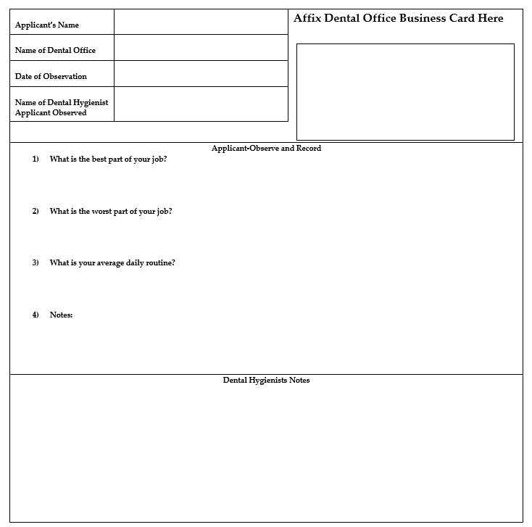
In Progress Grade Report Form:
Dear Professor,
Your student is applying for the Hocking College Dental Hygiene Program and has asked you to forward his or her in progress grade in your course as part of the Application Process. Please fill out the form below and submit this letter directly to the Hocking College Dental Hygiene Program by Dec 1, 2019. Please include the Course ID, Section Number, Course Title, and the Number of Credits.
Thank you very much for your assistance.

________________________________________________________________________ (Student Name)

is currently enrolled in

__________________________________________________ (Course ID and Section)

__________________________________________________ (Course Title)

_________________________ (# of Credits) at

________________________________________________________________________ (Name of Institution)

His/Her current grade is: ______________________________

Instructor’s Name: ________________________________________________________________________

Instructor’s Signature: _____________________________________________________________________

Date: _______________________________________

This form must be submitted by the instructor directly to the Hocking College Dental Hygiene Program. Please email to: Misti Malfe Dental Hygiene Program Manager: malfem@hocking.edu

How to Register for the TEAS® Assessment
Find more information at the testing organization’s website: www.atitesting.com

Create a New Account
If you are not a current user on www.atitesting.com, you must create a new account to access the student portal or to make a purchase from ATI's online store. Follow the steps below to create a new account.

