 | ESCUELA COMERCIAL CAMARA DE COMERCIO, S. C.  Extensión de Estudios Profesionales

English Class

T700 / T500

Teacher: Juan David Macías Sánchez.

To the students:

Read carefully the instructions in order to perform all the following activities properlly.

Due to the past events that we went throught our English classes were suspended until new orders to get back to classes. In the mean time we start again, we have to do some activities to re-enforce what we had learnt at the beginning. These activities will be done per day until we get back to classes.

You have to print the activities given and answer them. These activities will be delivered the day we restart again classes. If you happen to have any question you can be in touch
at my e-mail j.david.ms@hotmail.com

ACT1 September 25, 2017

Irregular Verbs: Change the verb into the past simple

1) She _________________ (bring) some chocolates to the party. _____________
2) I _______________ (hear) a new song on the radio. _____________
3) I _______________ (read) three books last week. ______________
4) They ______________(speak) French to the waitress. ______________
5) He ______________(understand) during the class, but now he doesn't understand. ________________
6) I ___________(forget) to buy some milk. _______________
7) She _______________(have) a baby in June. ________________
8) You ______________(lose) your keys last week. ______________
9) They ________________(swim) 500m. _________________
10) I _____________(give) my mother a CD for Christmas. ______________
11) At the age of 23, she _________________ (become) a doctor. _______________
12) I ______________ (know) the answer yesterday. _________________
13) He ______________ (tell) me that he lived in Toronto. ________________
14) We _______________(lend) John £200.________________
15) She _______________ (drink) too much coffee yesterday. _________________

Look at the pictures and complete with the right past tense of the verbs:

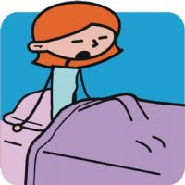 |  |  |  |  | 
wake | find | make | sleep | read | sing

 |  | 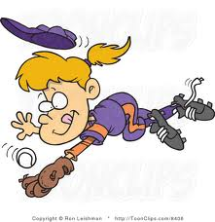 | 
write | write | catch | see | speak | think

ACT2

Regular Verbs: Rewrite the sentences into the Simple Past Tense. Then write the number in the square that describe the action of the verb.

1) | John cleans the car.
2) | Mr Black climbs on the big mountain.
3) | Mandy cooks the lunch. | 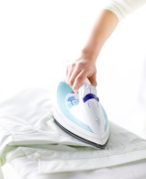
4) | The baby cries.
5) | Tom and Mary dance. | 
6) | Frank fishes next to the lake.
7) | Ms Green hoovers the carpets. | 
8) | She dreams about flying.
9) | Mrs Brown irons the clothes. | 
10) | She laughs at something. | 

Regular Verbs: Put the verbs in the brackets into Simple Past Tense.

1) He _________ (knock) at the door. __________
2) Tom __________ (lie) to his mum. __________
3) Mum __________ (lift) her bags. __________
4) They __________ (like) this programme. __________
5) You ___________ (listen) to the radio in June. __________
6) We ___________ (live) in Cambridge. ___________
7) He ___________ (lock) the gate. _____________
8) I __________ (look) at the photos. ____________
9) Mike __________ (love) dancing. ____________
10) I ___________ (believe) her. ____________
11) She __________ (visit) her parents in London. ___________
12) They __________ (paint) a beautiful picture. ____________
13) My mum _________ (ask) me. __________
14) Dogs _______ (hate) cats. __________
15) John ___________ (marry) Susan. ____________

