Contents

Tutorials 1

How to Create Your Free Personal Profile: 1

How to Acquire a Course Using Your Recert Subscription: 1

Using Recert to Track Your Recertification Progress 1

Viewing Your Recert Dashboard 1

Adding Your Nassau County Recertification Model 3

Adding Your Nassau County Online Courses 3

Taking a Recert Course 14

Accessing CAPCE Certificates 15

# Tutorials

Please view our tutorials by clicking the following two links.

## How to Create Your Free Personal Profile:

[**https://www.recert.com/video-lp-how-to-create-your-free-personal-profile-nassau**](https://www.recert.com/video-lp-how-to-create-your-free-personal-profile-nassau)

## How to Acquire a Course Using Your Recert Subscription:

[**https://www.recert.com/video-lp-nassau-acquire-course**](https://www.recert.com/video-lp-nassau-acquire-course)

# Using Recert to Track Your Recertification Progress

Prehospital recertification requirements are constantly evolving and can be difficult to track. **Recert** is an online continuing education service designed to make meeting prehospital recertification requirements more efficient. **Recert** offers engaging courseware mapped to a personalized recertification roadmap. User-friendly dashboards help you manage your professional portfolio, while keeping you focused on what’s important—your training.

## Viewing Your Recert Dashboard

1. After you log in via psglearning.com or jblearning.com, click the **RECERT** tab on the My Account page to view the **Recert** Dashboard.

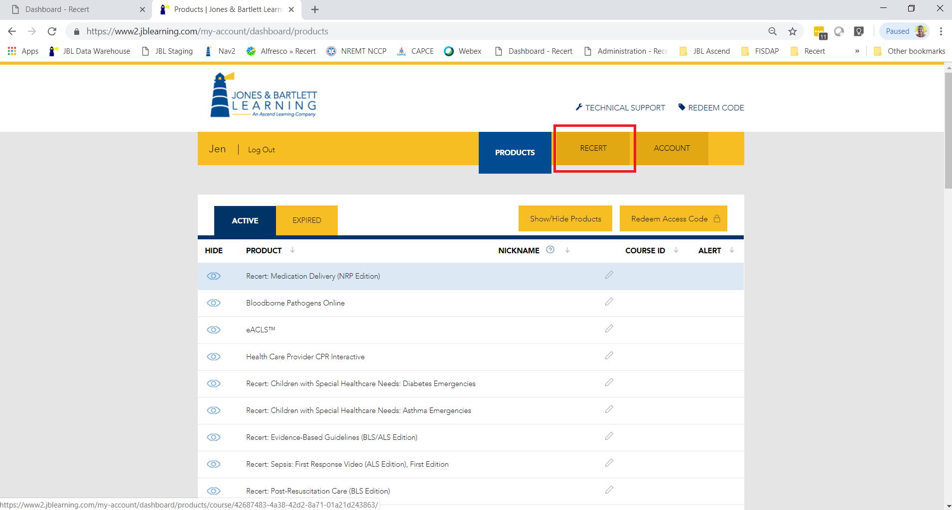

Once you have added a recertification model, the **Recert** Dashboard will display your progress towards recertification.

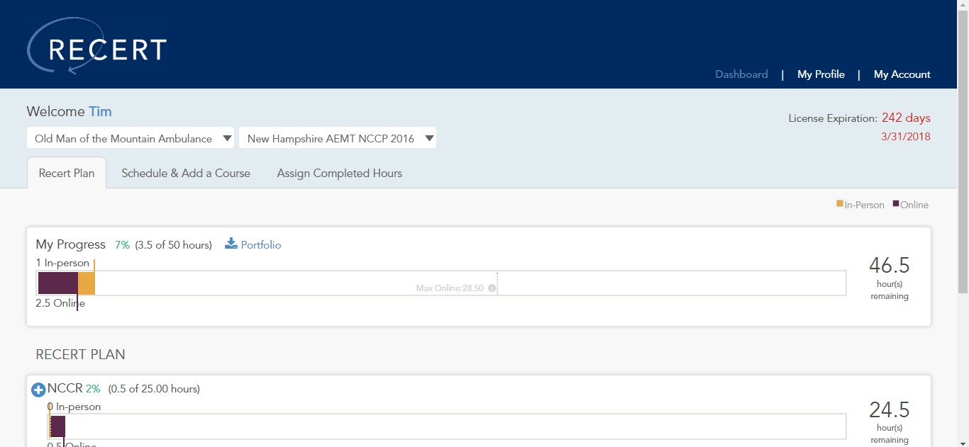

A maximum of

28.5

hours online

In the example above, “Tim” has completed 7% of his required hours, or 3.5 out of 50 hours required for his New Hampshire AEMT recertification. Note that hours can be fulfilled either online or in-person, although there is a limit to how many hours you can receive from online training. For example, 28.50 of Tim’s 50 recertification hours can be completed online.

**Note** It is up to the user to find and complete the training necessary for recertification. Courses are available via the Jones & Bartlett Learning Public Safety Group’s **Recert** course library, but you can also schedule a “non-Recert” course, which is any course or activity that helps to fulfill your recertification requirements.

# Adding Your Nassau County Recertification Model

Your first step is to add your Nassau County recertification model to your Recert profile. This will enable you to view your progress on your dashboard, as seen above. It will also allow you to add the required courses to your schedule and acquire them.

1. Click “My Profile.”
2. Click “Add New Certification” and enter your license and recertification information.
   1. For “Provider Level”, select Paramedic
   2. For “NREMT Certification,” select “No.”
   3. For “Recertification Model,” select “Nassau County EMS Academy (NY) Paramedic 2019 Refresher.”
   4. For Employer ID
      1. Enter 14438.
      2. Cick the “Add” button.
      3. Click the “Save” button.

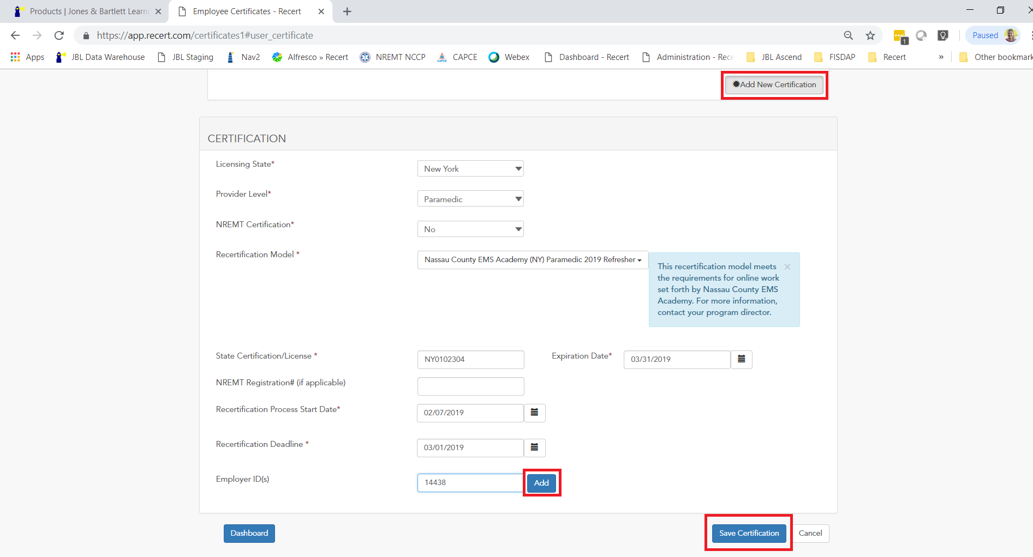

Click on “Dashboard” to return to the previous screen. Click “Schedule & Add a Course” to add the online courses required by Nassau County EMS Academy. That is the Dashboard, where you will track your course completions against your requirements.

# Adding Your Nassau County Online Courses

To add your courses, you will need to navigate to the “Schedule & Add a Course tab

1. In the right-hand column, you will see a dropdown list of topics. In the Category dropdown menu, select “Preparatory (Medical Legal, Safety, BSI). You will also want to change the click “Show Details” to collapse the view.

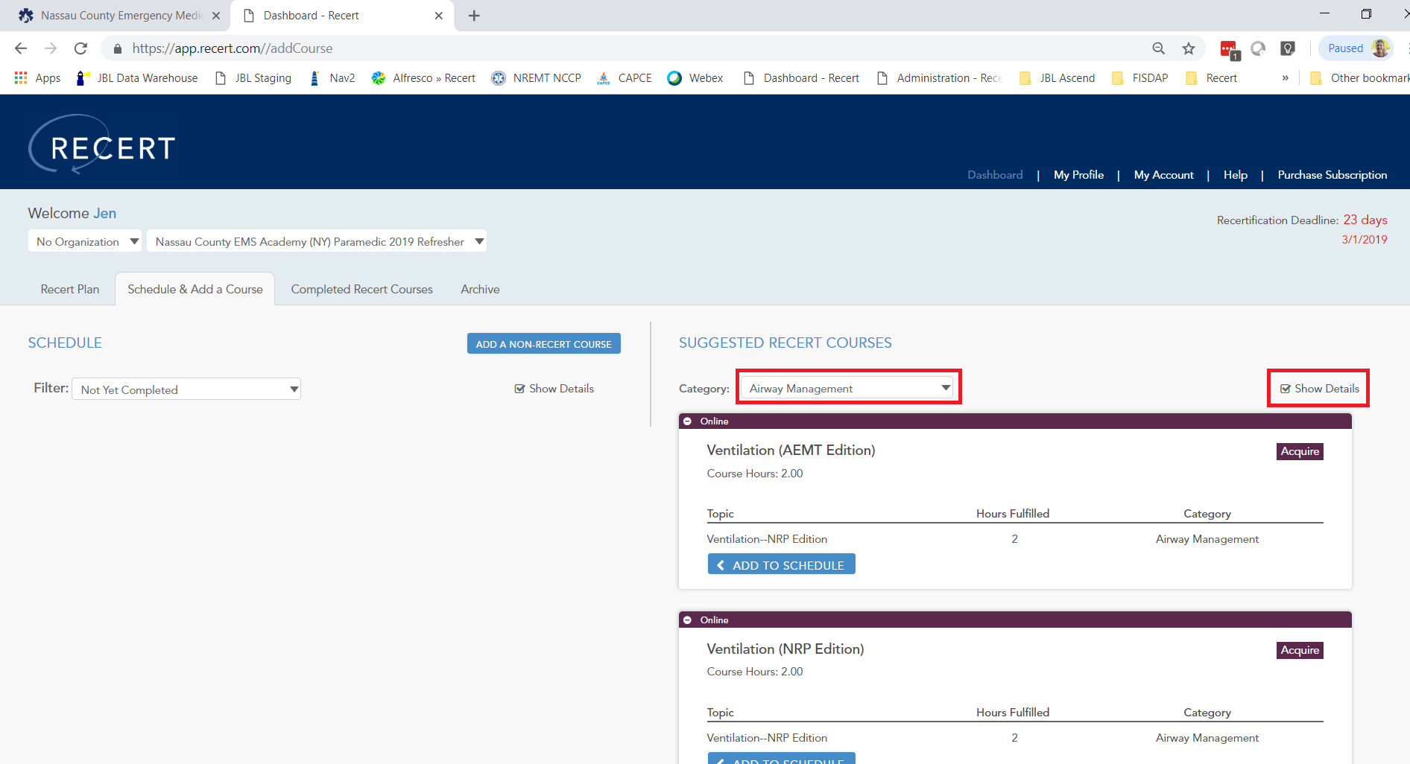

1. Locate “Medication Delivery (NRP Edition)” and click “Add to Schedule.”

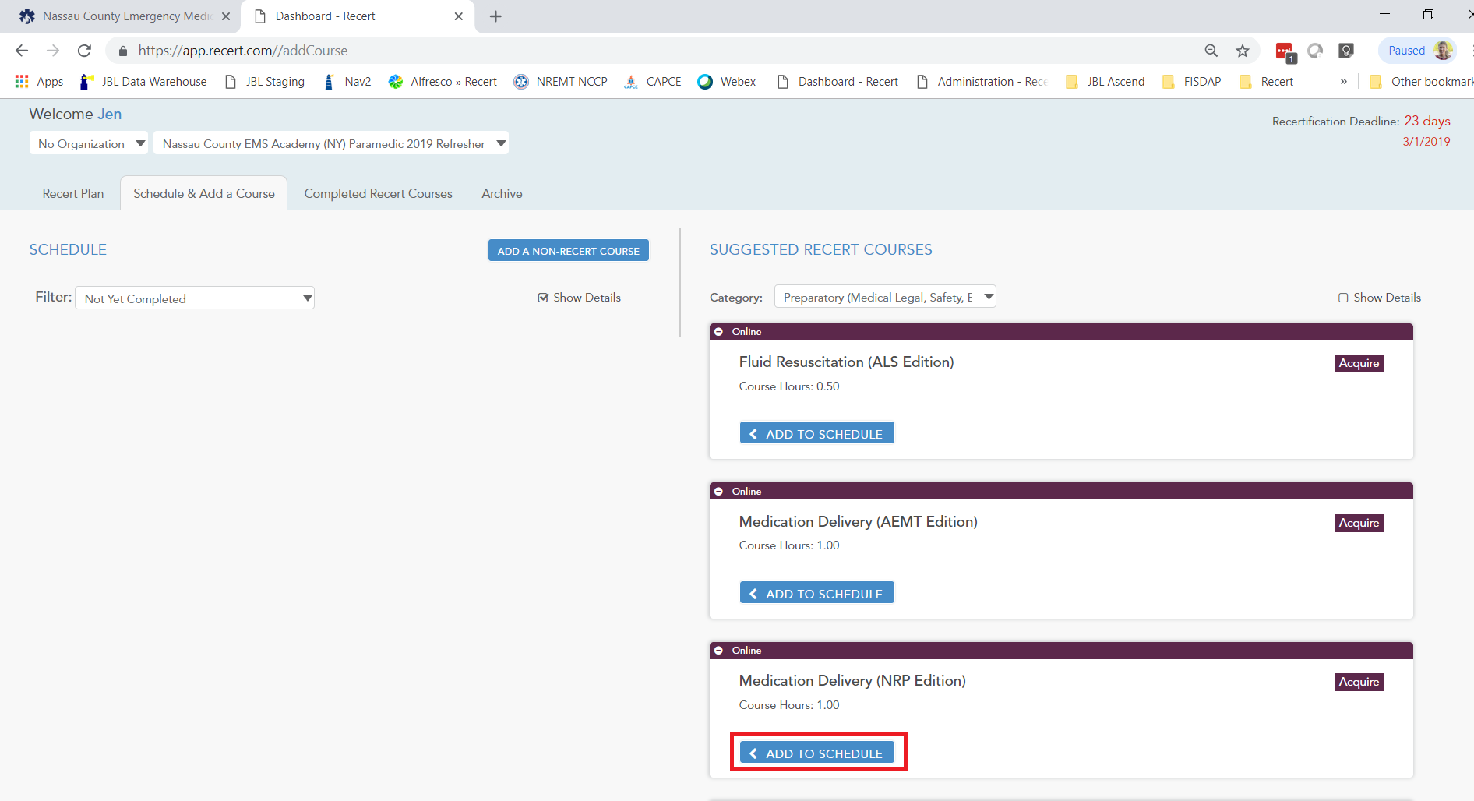

1. Locate “Fluid Resuscitation (ALS Edition)” and click “Add to Schedule.”

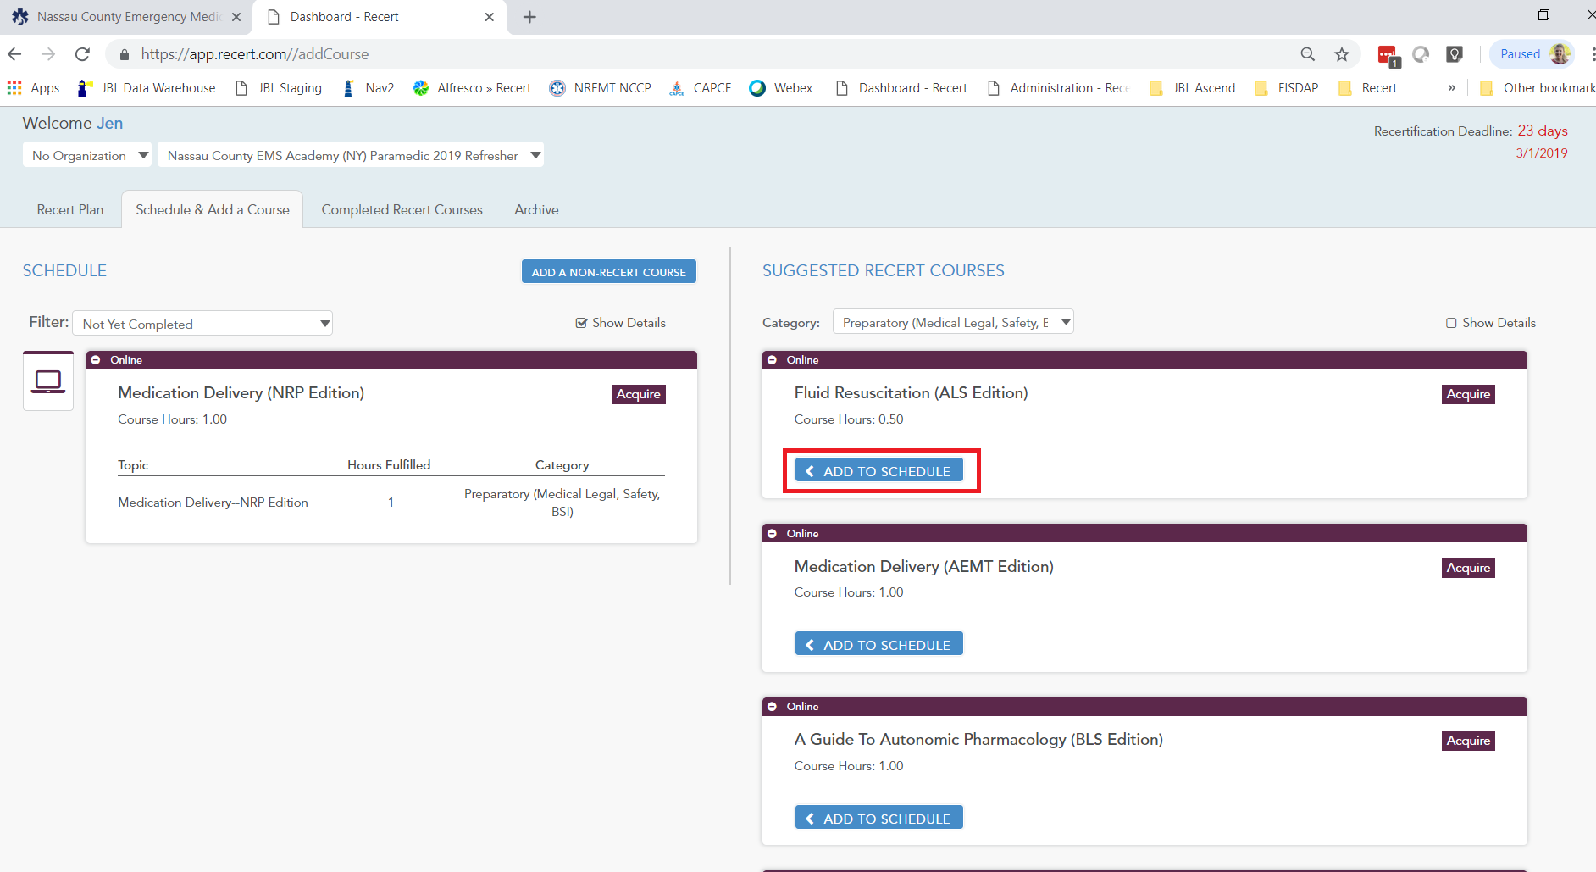

1. Locate “A Guide to Autonomic Pharmacology (ALS Edition)” and click “Add to Schedule.”

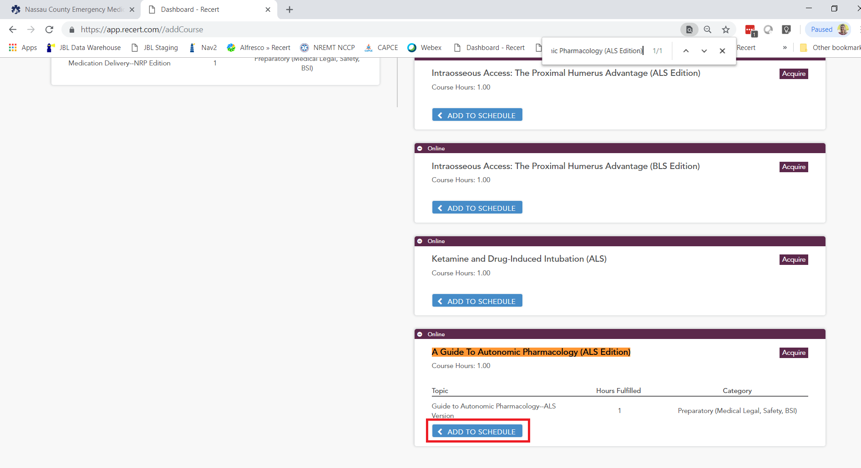

You have now added all required Preparatory courses to your Recert schedule.

1. In the Category dropdown menu, select “Airway Management.” Locate “Oxygenation (ALS Edition)” and click “Add to Schedule.”

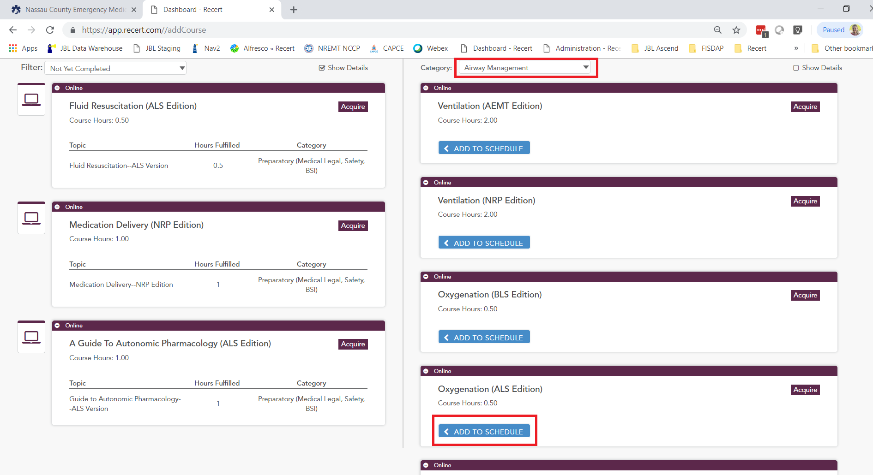

1. Locate “Ventilation (NRP Edition)” and click “Add to Schedule.”

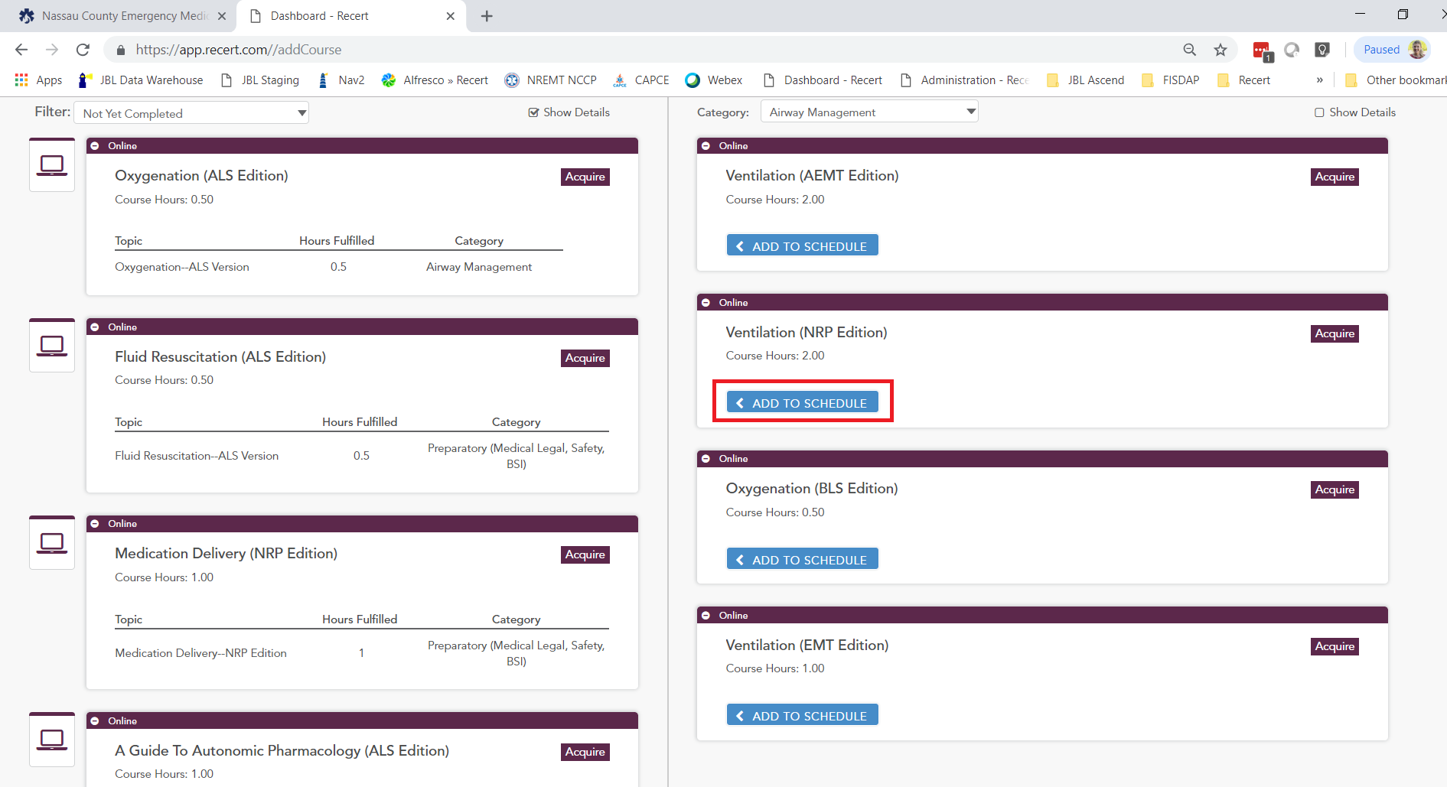

You have now added all required Airway Management courses to your Recert schedule.

1. In the Category dropdown menu, select “Respiratory and Cardiac Emergencies.” Locate “Adult Cardiac Arrest (ALS Edition)” and click “Add to Schedule.” Locate “Congestive Heart Failure (ALS Edition)” and click “Add to Schedule.”

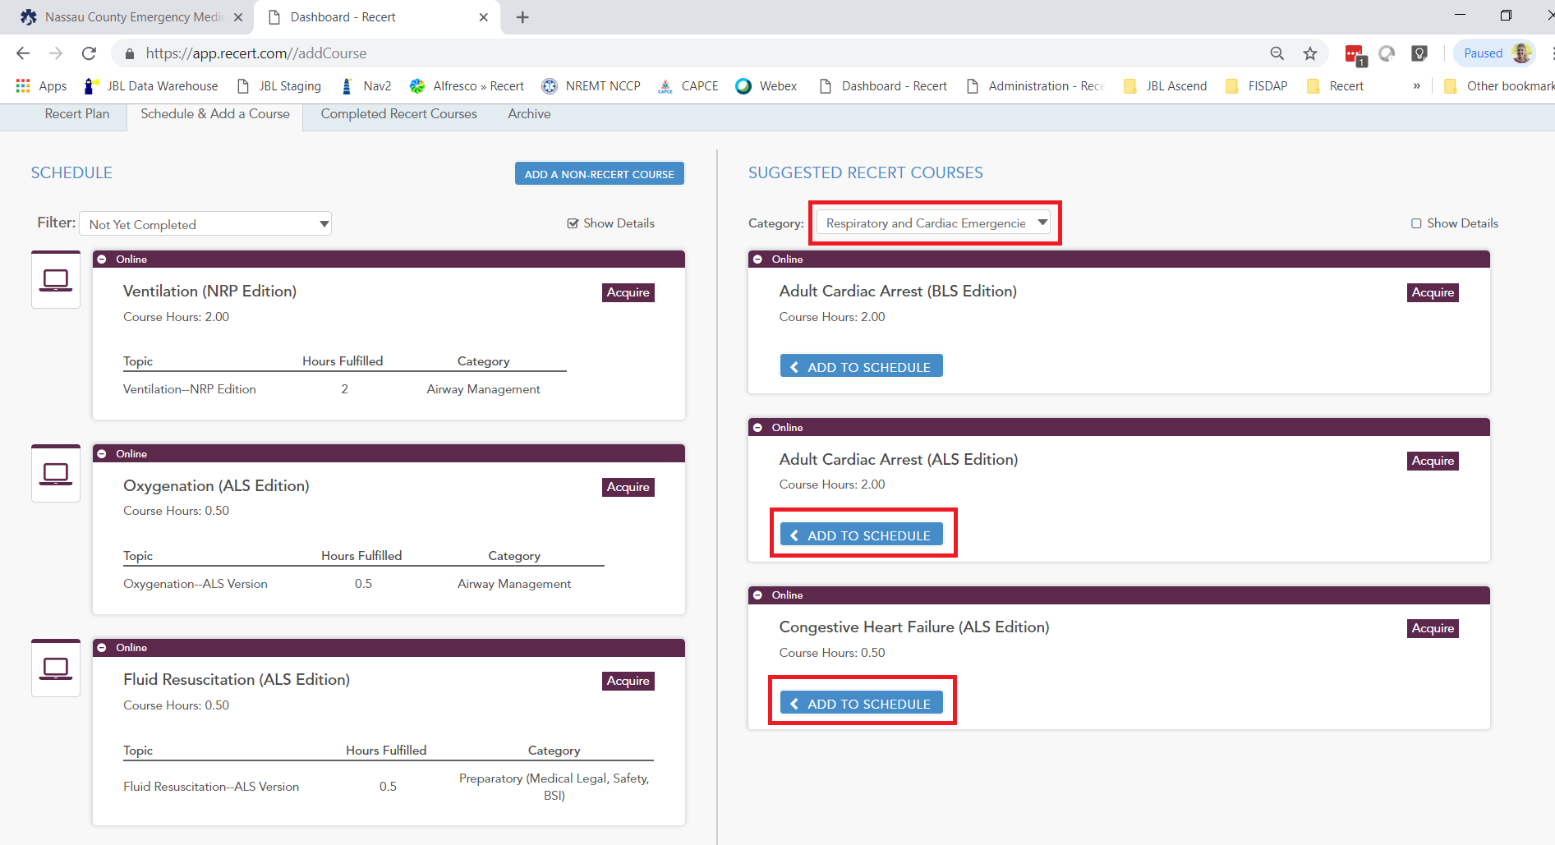

You have now added all required Respiratory and Cardiac Emergencies courses to your Recert schedule.

1. In the Category dropdown menu, select “Environmental / Behavioral Gynecological.” Locate “Endocrine Emergencies: Diabetes and Adrenal Disorders (ALS Edition)” and click “Add to Schedule.” Locate “Psychiatric and Behavior Emergencies (NRP Edition)” and click “Add to Schedule.”

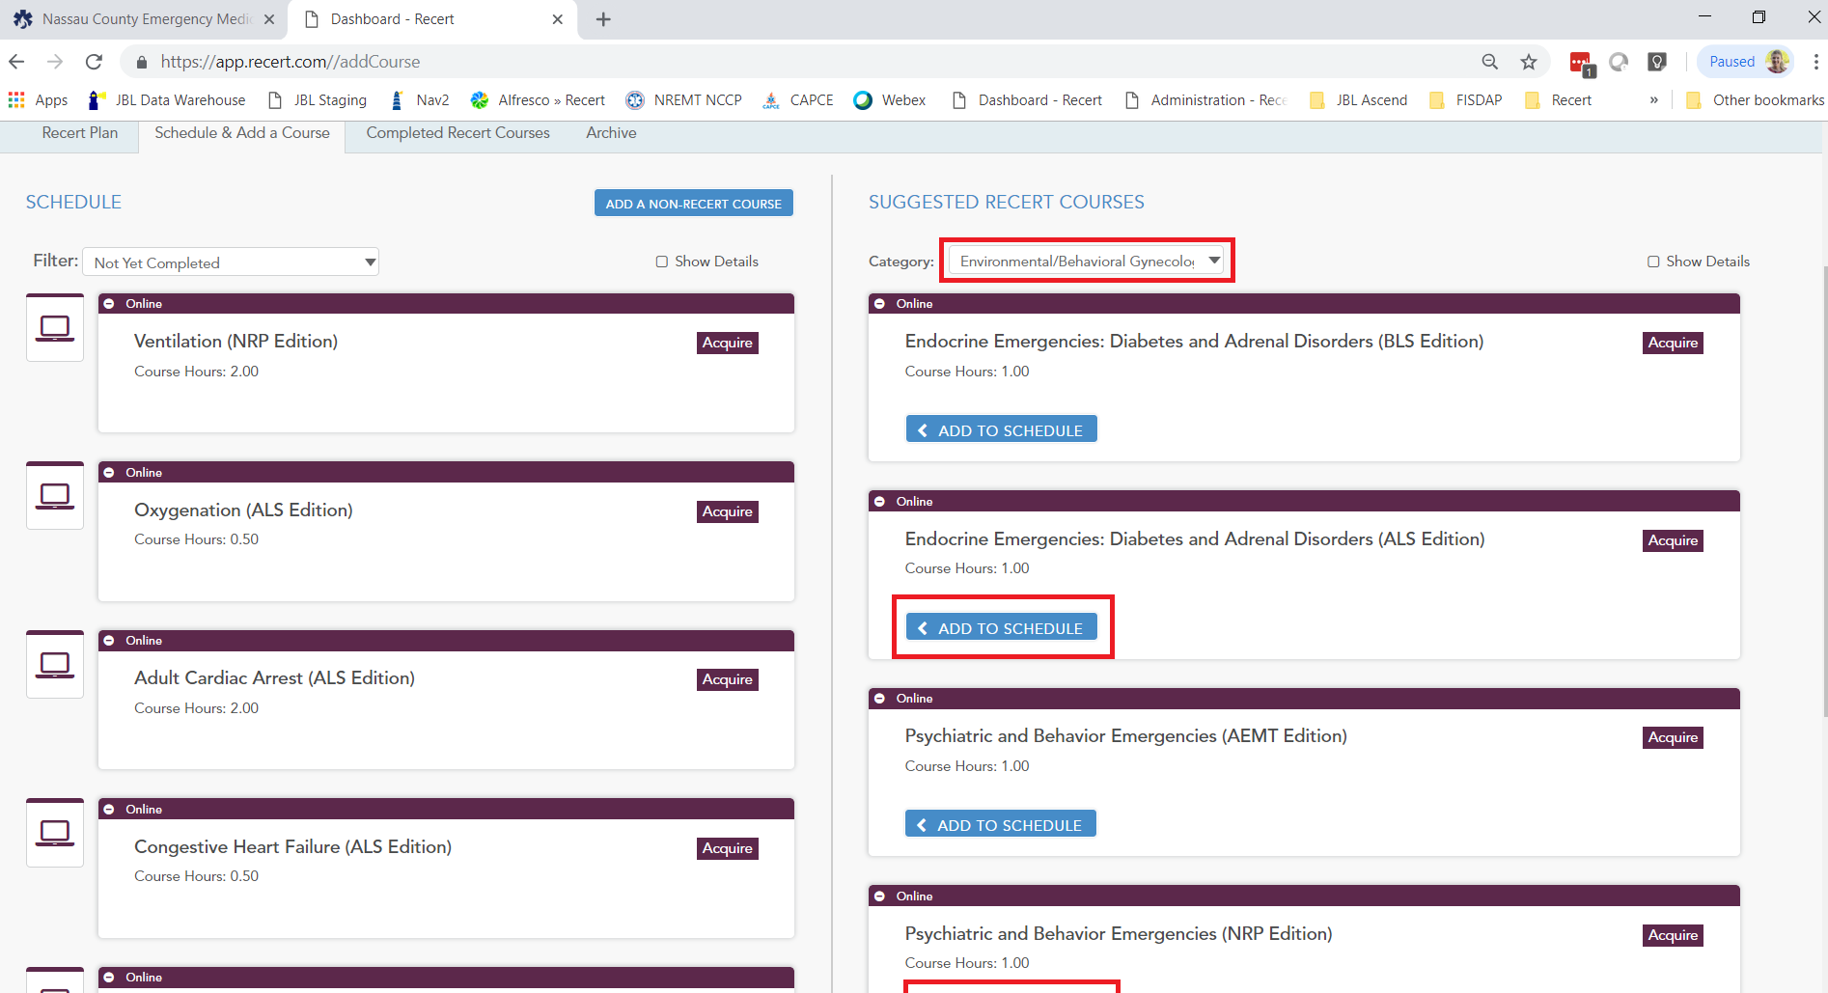

You have now added all required Environmental / Behavioral Gynecological courses to your Recert schedule.

1. In the Category dropdown menu, select “Trauma.” Locate “Circulation, Hemorrhage, and Shock (ALS Edition)” and click “Add to Schedule.”

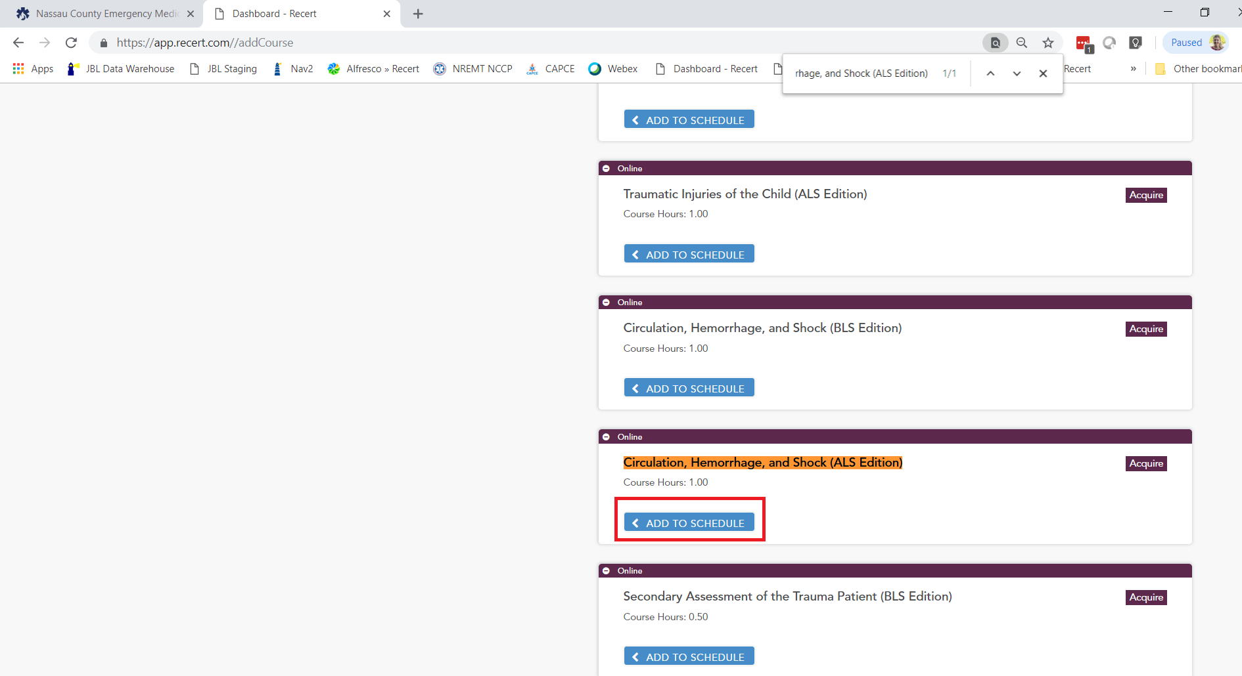

1. Locate “Secondary Assessment of the Trauma Patient (ALS Edition)” and click “Add to Schedule.”

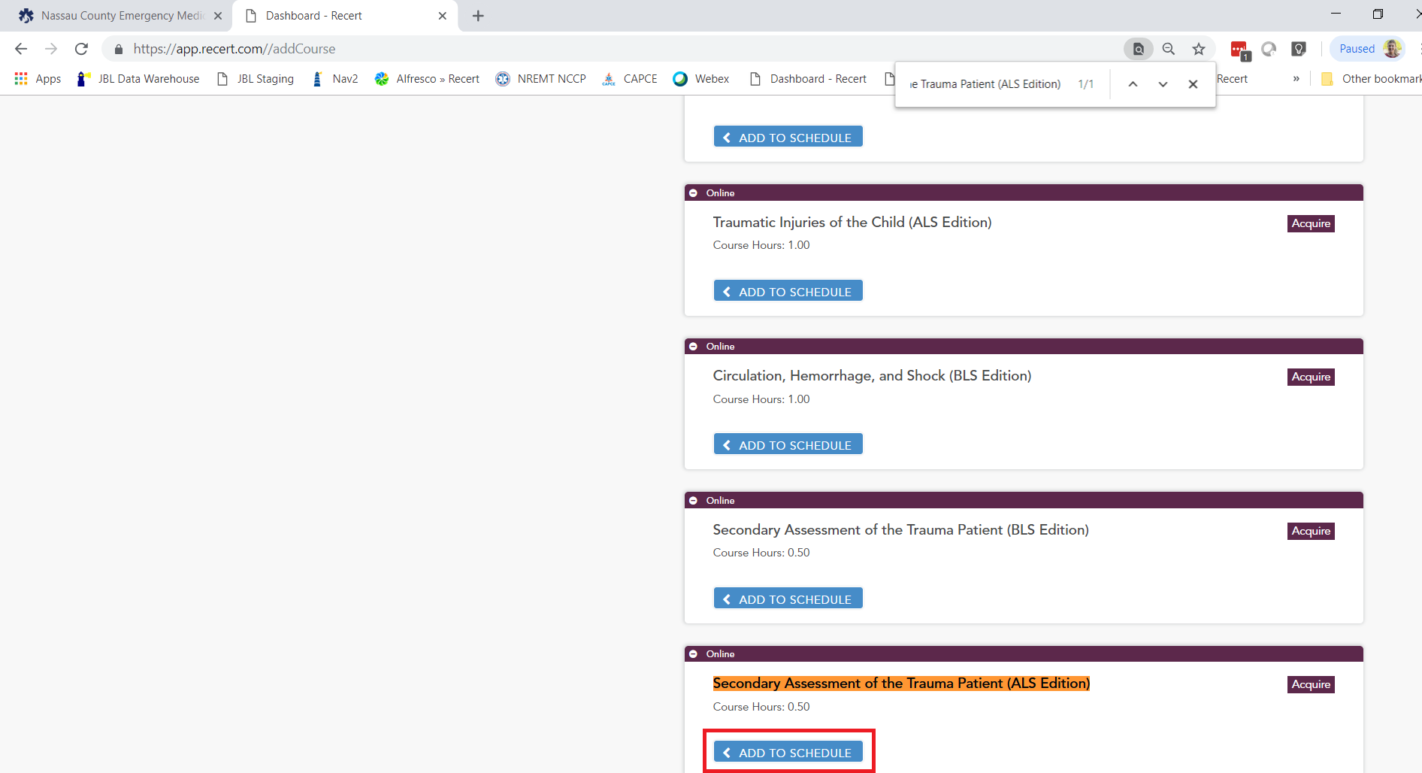

1. Locate “Special Considerations in Trauma (ALS Edition)” and click “Add to Schedule.”

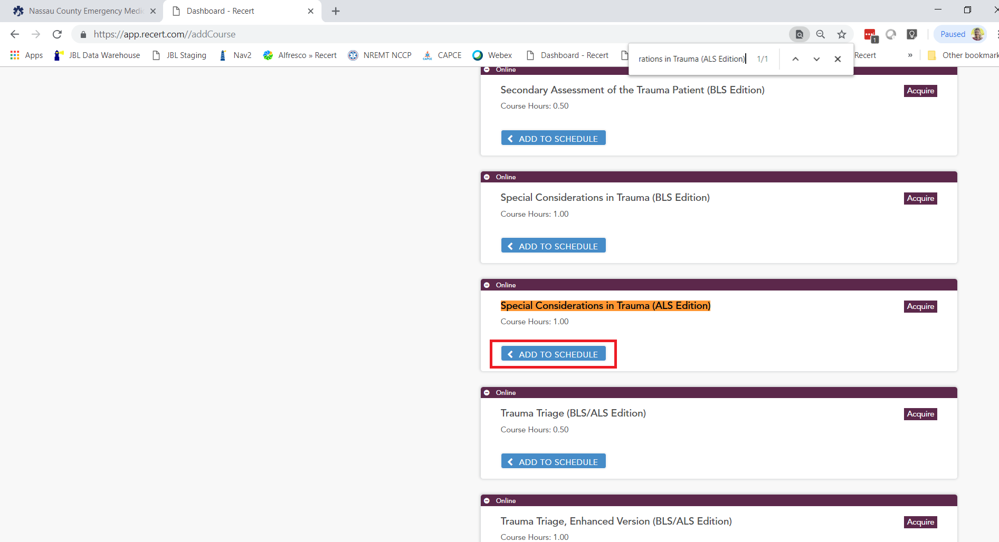

1. Locate “Airway Assessment and Management of the Trauma Patient (ALS Edition)” and click “Add to Schedule.”

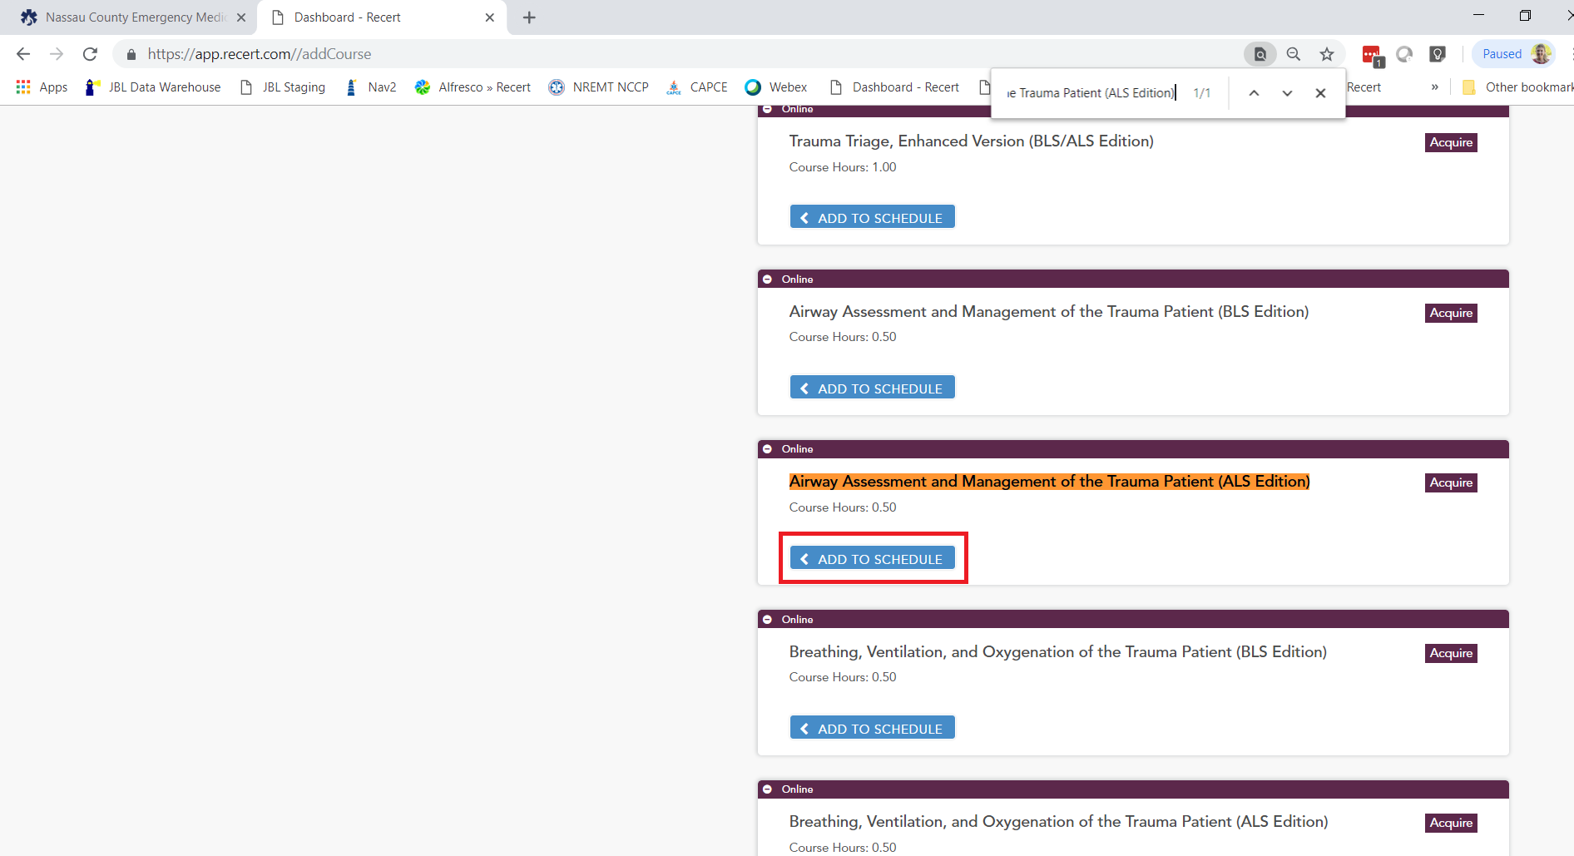

1. Locate “Kinematics of Trauma (BLS/ALS Edition)” and click “Add to Schedule.”

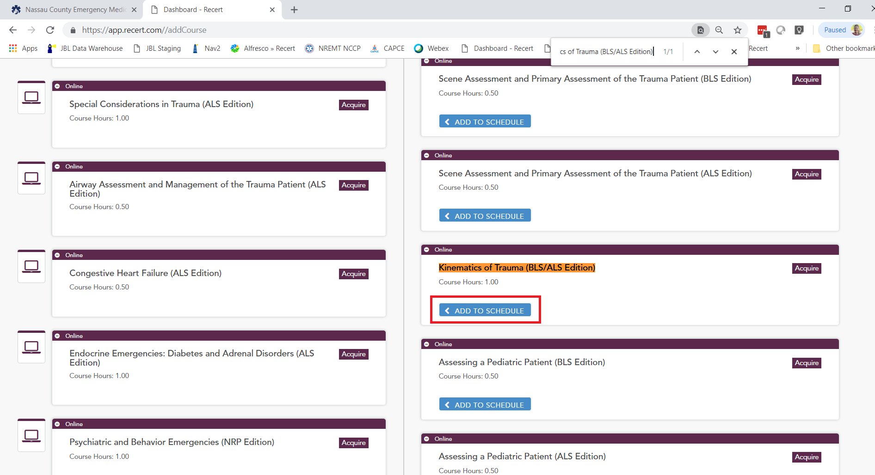

1. Locate “Trauma Triage, Enhanced Version (BLS/ALS Edition)” and click “Add to Schedule.”

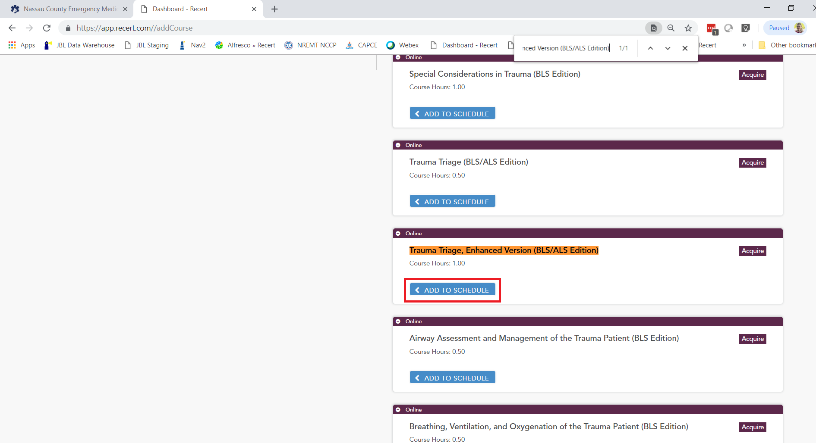

You have now added all required Trauma courses to your Recert schedule.

1. In the Category dropdown menu, select “Obstetric Emergencies.” Locate “Obstetric Emergencies (ALS Edition)” and click “Add to Schedule.”

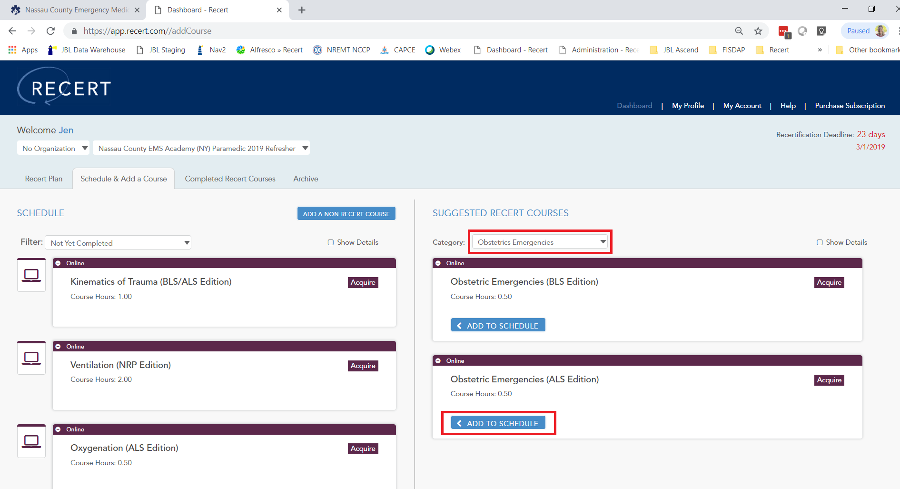

You have now added all required Obstetric Emergencies courses to your Recert schedule.

1. In the Category dropdown menu, select “Pediatric.” Locate “Newborn Resuscitation (ALS Edition)” and click “Add to Schedule.”

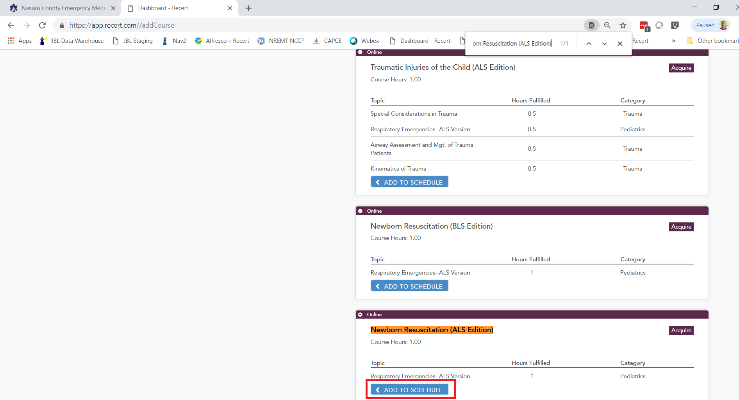

1. Locate “Pediatric Respiratory Emergencies (ALS Edition)” and click “Add to Schedule.”

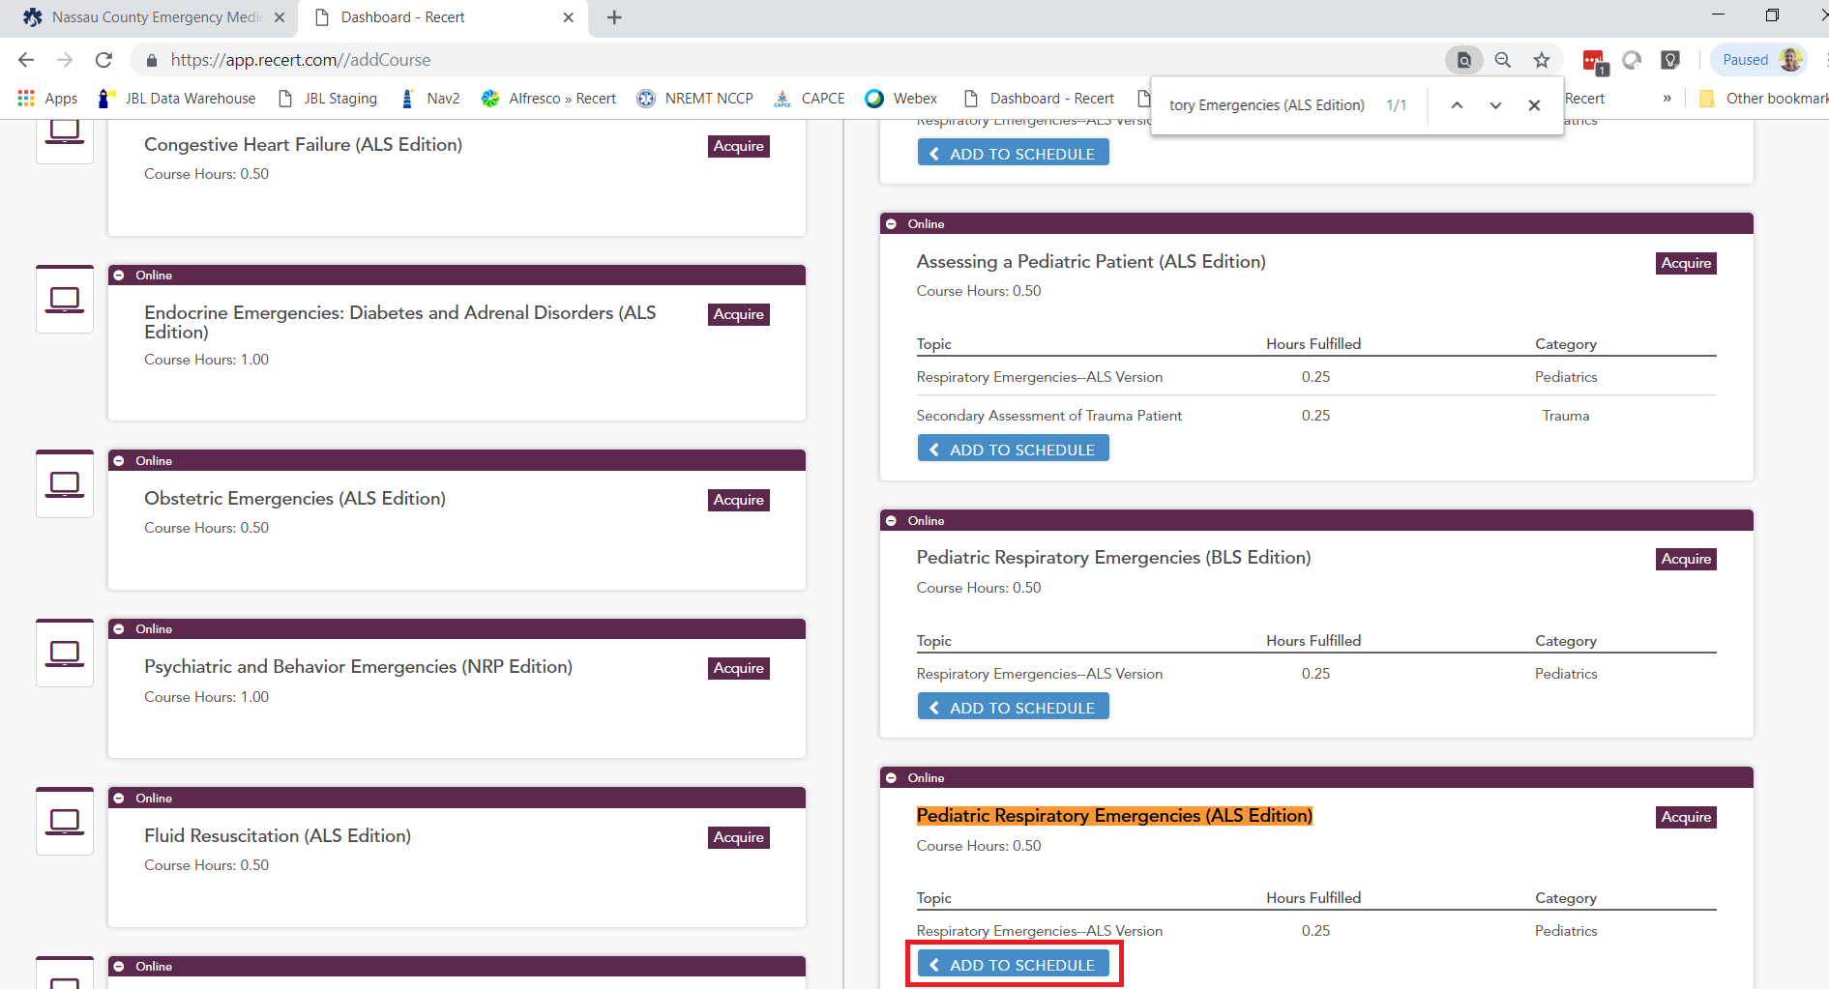

You have now added all required Pediatric courses to your Recert schedule.

1. In the Category dropdown menu, select “EMS Operations.” Locate “Field Triage: Disasters and MCIs, Enhanced Version (BLS/ALS Edition)” and click “Add to Schedule.”

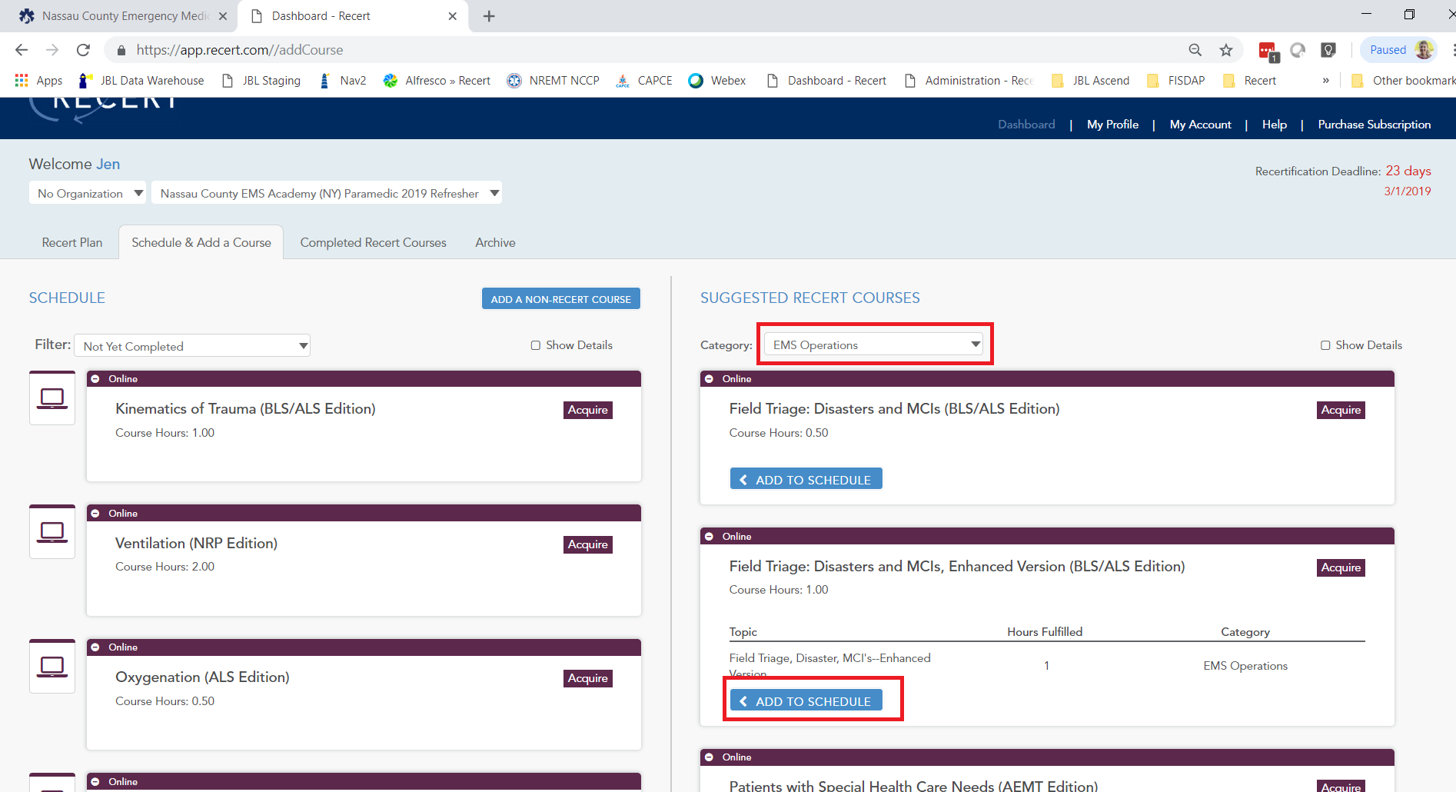

1. Locate “Patients with Special Health Care Needs (NRP Edition)” and click “Add to Schedule.”

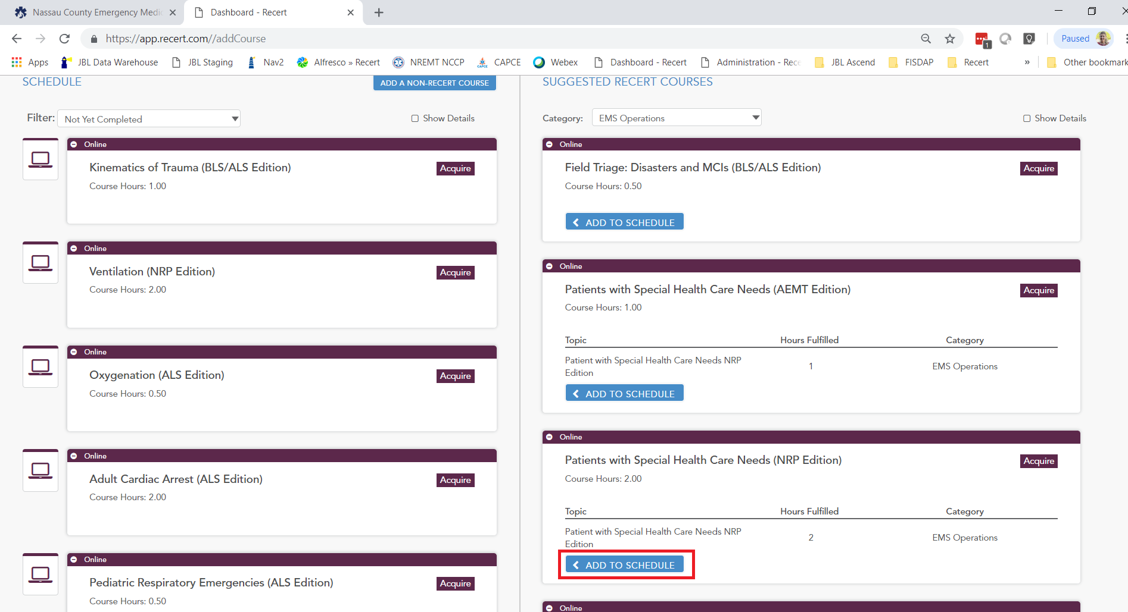

You have now added all required courses to your Recert schedule.

# Taking a Recert Course

Taking a **Recert** course involves three steps:

* Complete the CE activity.
* Submit the Posttest.
* Submit the CAPCE survey.

**Note** Course hours will not display in your dashboard until you complete all three steps. If the **Recert** course satisfies a topic with a skills component, skills verification must be uploaded as well.

1. To launch the course, click the course name on the PRODUCTS tab of the My Account screen, and then click the **LAUNCH** button.

1. Click **Launch** to launch the CE Activity.

1. Click **Launch Module**.

When you have finished reviewing the module, you’ll see a Module Completed screen.

1. Click **Close Module**, and then click **OK** to confirm that you want to close the module. A green checkmark appears next to the CE Activity.

**Note** You can’t launch the Post-Test until you’ve completed the CE Activity.

1. To launch the Post-Test, click **Launch**.

1. Click **Attempt Assessment Now**.

1. Answer the questions, clicking **Next** to move through the test.

1. Click **Submit all and finish**. A green checkmark appears to the right of the Post-Test.

**Note** You can’t launch the CAPCE Survey until you’ve done the Post-Test.

1. Click **Launch** to the right of CAPCE Survey.

1. Click **Answer the questions**.

1. Respond to the questions in the Survey.

1. Click **Continue** to return to the Dashboard and assign your hours.

# Accessing CAPCE Certificates

After completing a course, click on “Completed Recert Courses.” This is the screen that houses your CAPCE certificate, which is required for entry into the in-person portion of the Nassau County EMS Academy refresher course.

Once you have completed a course and uploaded skills verification (if required), you can obtain a certificate indicating that the requirements for that topic have been completed.

1. Click to download a Completion Card, or click to download a CAPCE Certificate.



