HOW DO I GET A LOAN?

MAKE AN APPOINTMENT
If you haven’t already booked an appointment, give us a call on 9738 8801
TIP: Note your appointment time below.

MY APPOINTMENT
Meeting with:

Time:

Date:

APPLICATION
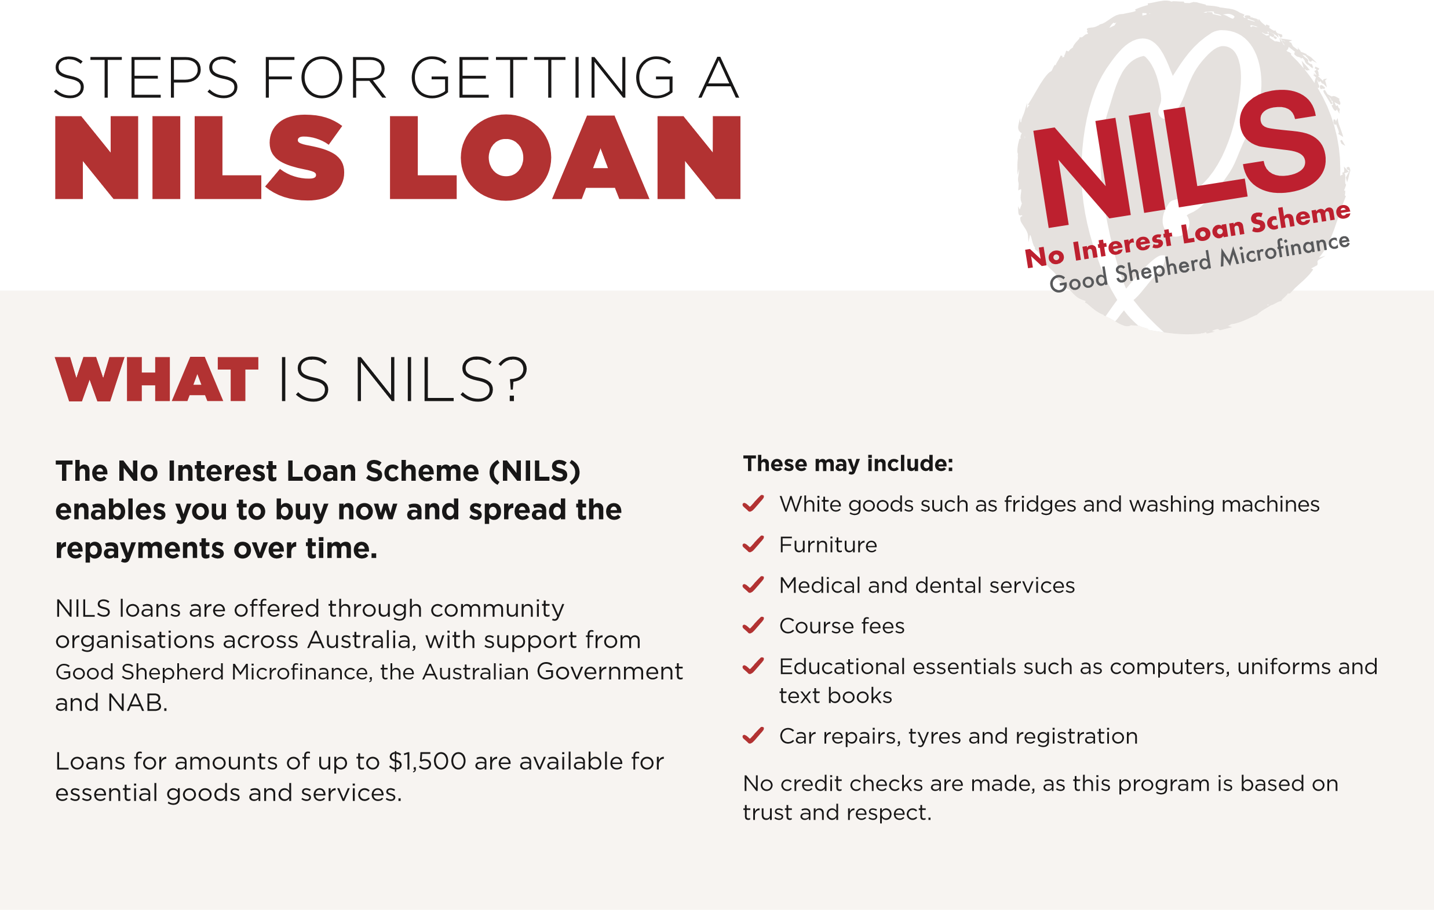
Collect your documents to bring to the appointment
TIP: Use our handy checklist (see back page) to make sure you have everything you need!

QUOTE
Get a quote for the item you need
TIP: We’ll need to know details of the item, including the price and who you will be buying from. So choose the item you want and bring us a quote.

ATTEND YOUR APPOINTMENT
TIP: Don’t forget your paperwork so we can get things
moving for you.

OUTCOME
You will be contacted with the outcome of your loan.

PREPARING
FOR YOUR
APPOINTMENT
Here’s a handy list of documents for your loan application. Avoid delays by bringing these to your appointment.  Your Health Care Card, Pension Card, Low Income Card or Department of Veterans’ Affairs Card.  Bank and credit card statements for the past three months.
 Proof that you have lived in your current home for at least three months. For example if you rent, please provide a lease or a letter from the person you pay rent to. If you own your own home, please bring a local council rates notice or receipt.
 Your latest Centrelink Income Statement. If you trouble accessing this, ask us during your meeting and we can help you.
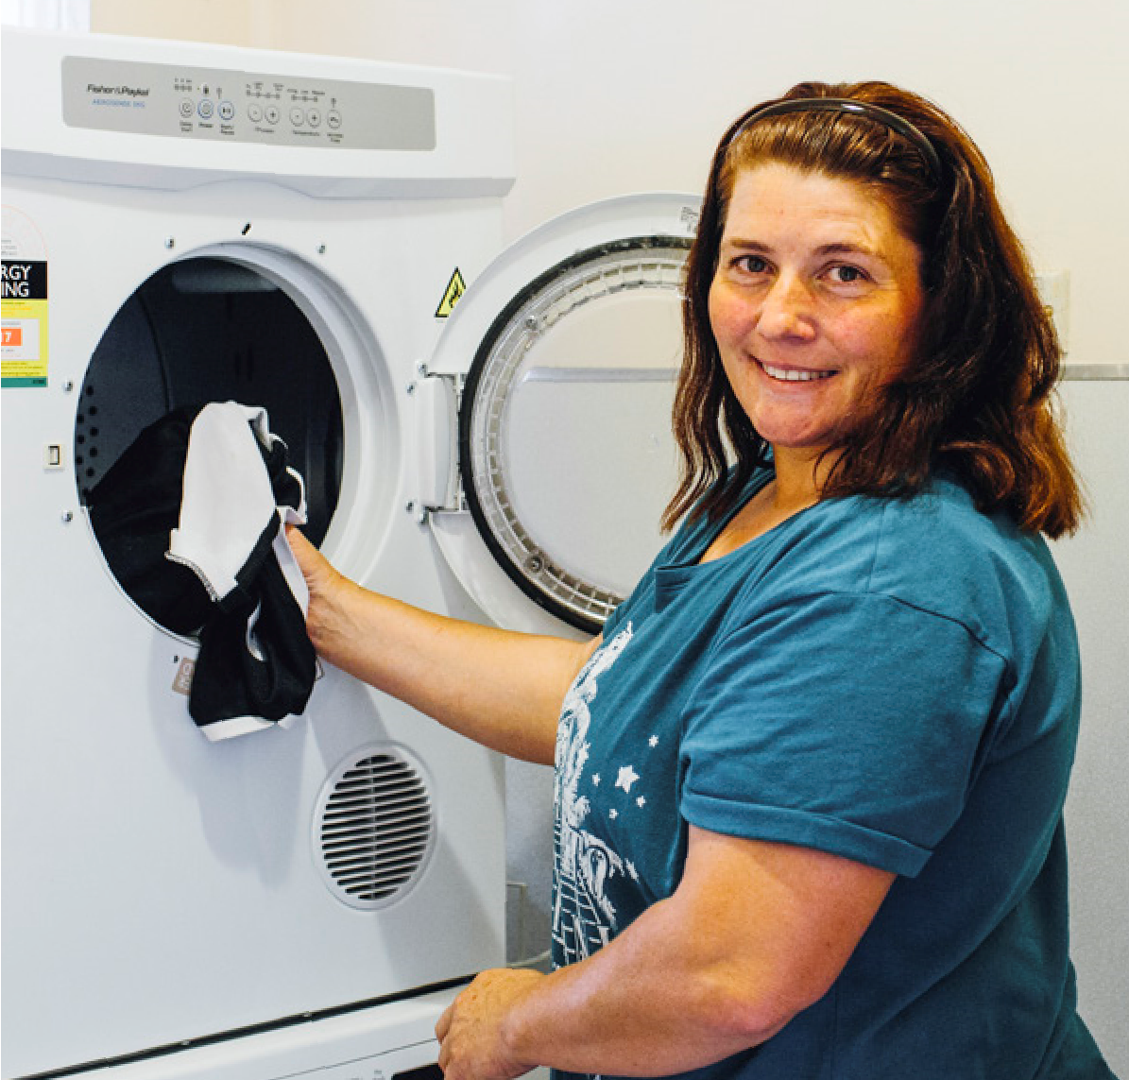
 A copy of your latest electricity or gas bill.  A copy of any other loan or lease agreements or statements. For example do you rent a TV, have a personal loan or are paying off a mortgage?
GETTING A
QUOTE

You’ll need to provide details for the item that you want to
purchase with the loan.
Shop around to get at least two quotes for what you
want. This will help you get the best price for the item or
service you need.
For example if you need car repairs, have mechanic
look at your car and provide you with a quote on their
letterhead or if you need a household appliance, compare
prices online and have the name and address of the
stores and the prices ready for your appointment.
If you’re looking for a new household appliance ask us
about Good2GoNow — a partnership with The Good Guys
Commerical that enables NILS customers to get

a discount.
MORE QUESTIONS?
Please call us for more information and/or make an appointment.
Contact us:
/microfinancegs

DURING YOUR APPOINTMENT
Your appointment is nothing to be nervous about. Think of it more like a friendly chat. A meeting to discuss a loan application usually takes around 45 minutes.
Aim to arrive at least 5–10 minutes early. If you are running late or cannot make it, call us as soon as you can, so that we are able to reschedule.
AFTER YOUR APPOINTMENT
Once you have attended your appointment and submitted an application, you will be contacted about the outcome of your application. If your loan application is successful, the items (or services) are purchased directly from the supplier.
Loan repayments, starting from as low as $20 a fortnight, can be deducted directly from your Centrelink benefit for a 12 month period.

