[Examples] Social Media Posts and Images
Please see below the table for some examples of Social Media Content and Images. Use those as an inspiration to create your own. We will be loading images to this site to support the Social Media posts. You will find them later on today under "Images”.

MESSAGE / COPY | IMAGE
Trimble Agriculture hopes you are doing well during this unprecedented time. We would like to extend a sincere thank you to farmers and many other people who worked tirelessly year-round and especially these past few weeks to keep the world's food supply turning. From farmers to grocers and everybody in between, we all depend on your continued effort. Thank you! #THANKYOUFARMERS | 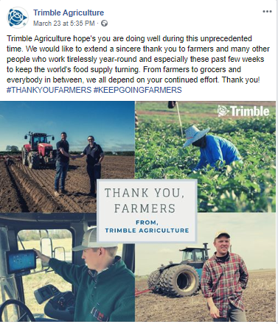  Facebook:  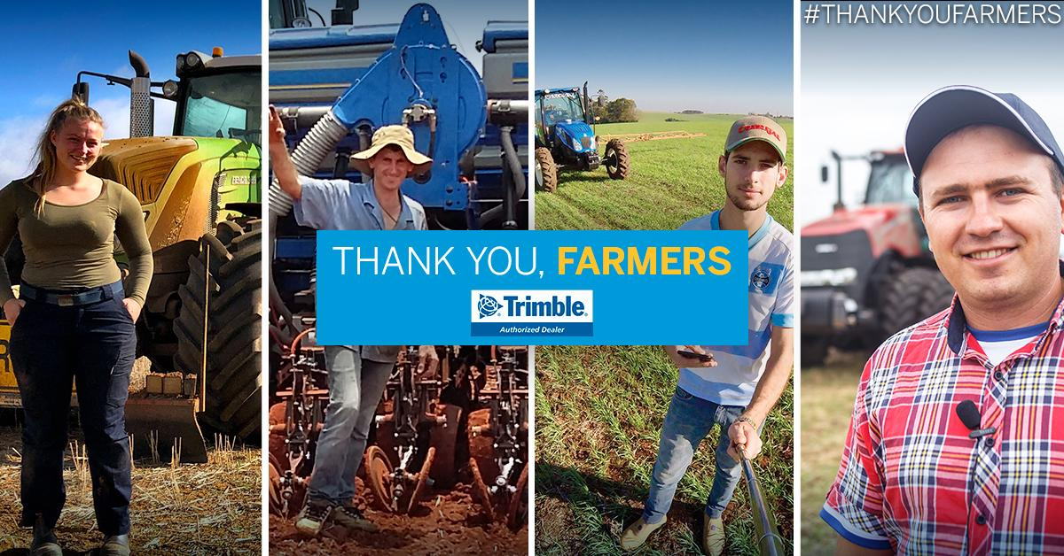  Instagram:  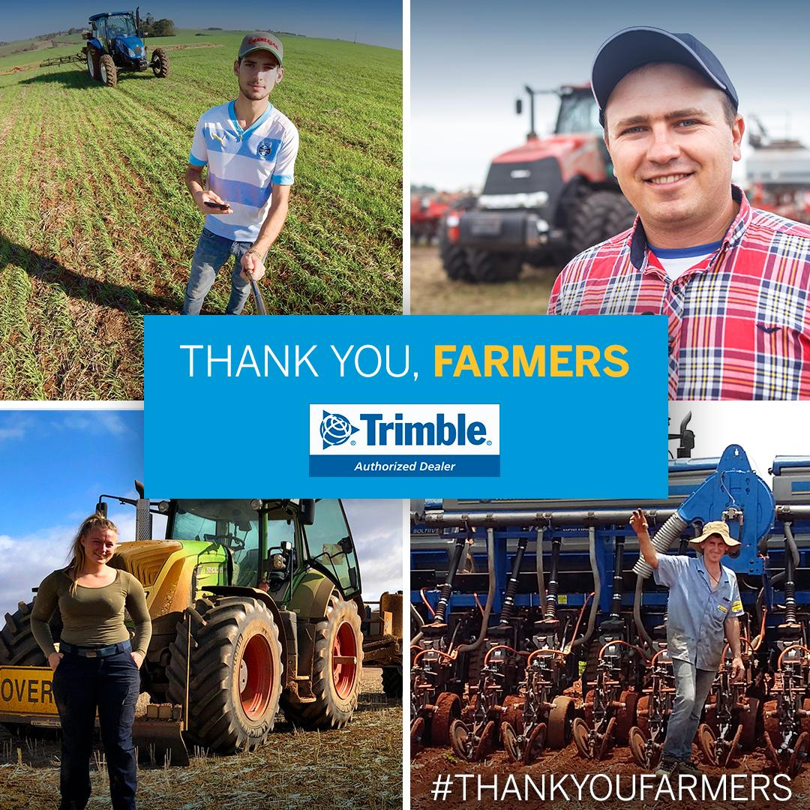  LinkedIn:  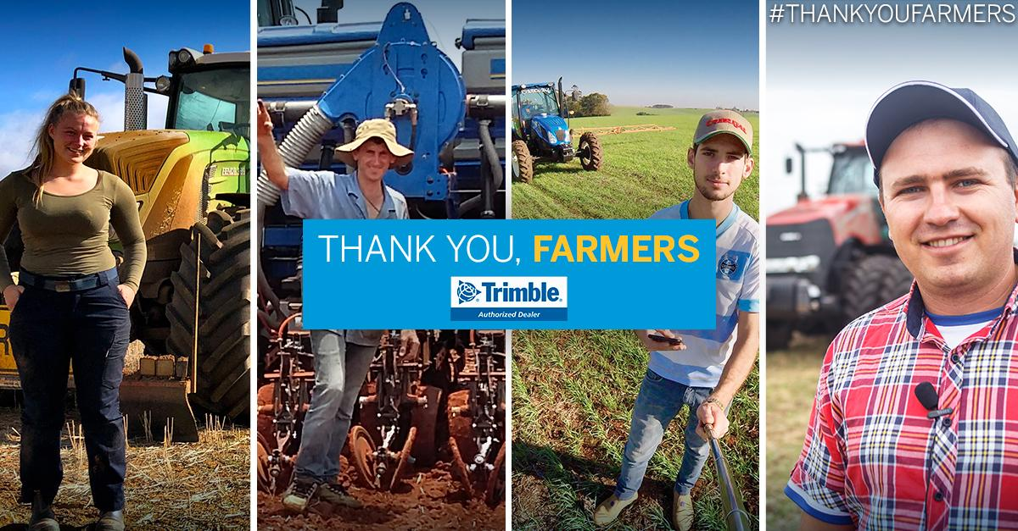  Twitter:  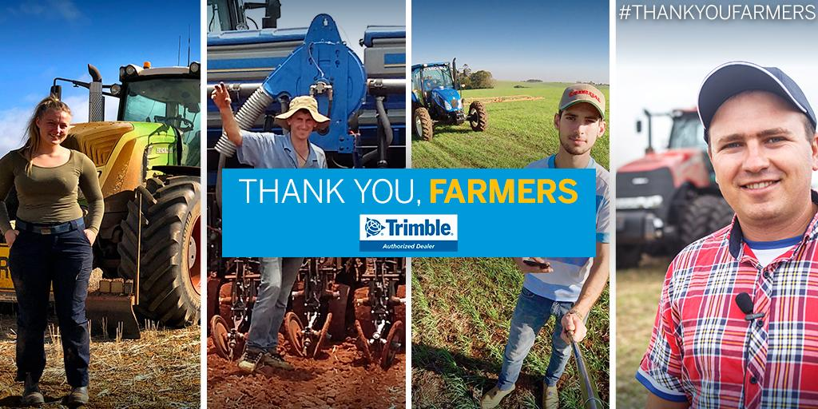  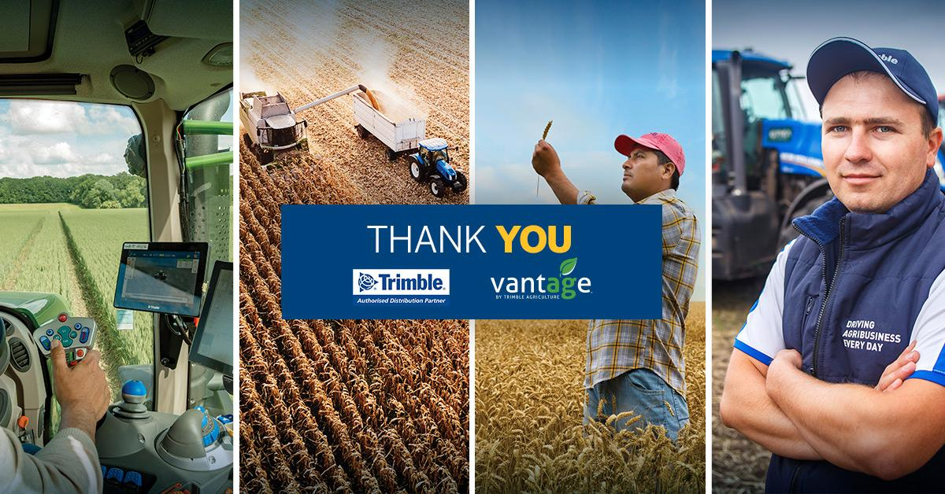
From planting in Brazil to harvests in Australia our farmers never quit - especially when things get tough. A couple of months ago, our team at Trimble Agricultura in Brazil put together a thank you to farmers from the people they feed every day. This message is as true now as it was then. Thank you, farmers! #THANKYOUFARMERS | 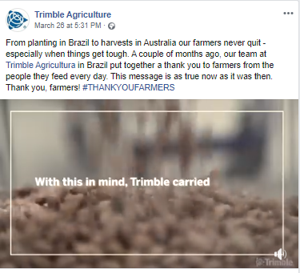
While many of our working situations have changed, the Trimble Agriculture team is devoted to the continued success of everyone in our industry. It is crucial that our customers are supported during the ever-changing Coronavirus Pandemic. We encourage you to read our most recent blog [LINK] on the potential impacts on the Ag industry and how Trimble Agriculture plans to serve you during this time. #THANKYOUFARMERS | 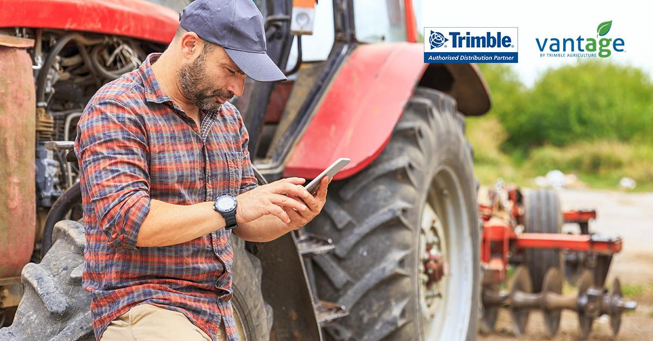
As we continue to monitor and adjust to the ever-changing landscape, Trimble Agriculture would like to say thank you to everyone that continues to work for all of our benefit. To keep up-to-date on how we’re handling and supporting our customers during the Coronavirus Pandemic, click the ‘COVID-19 Response’ link on our homepage, follow our social media pages, or click here: [LINK] #THANKYOUFARMERS | 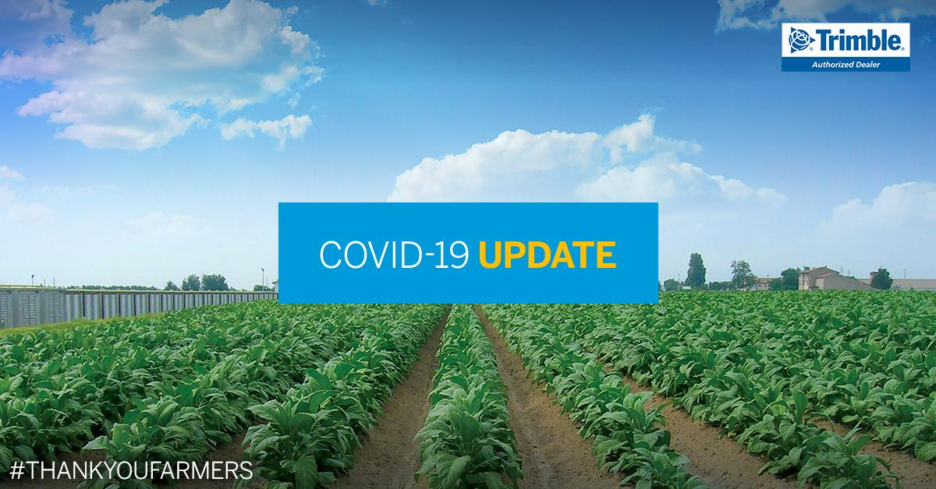  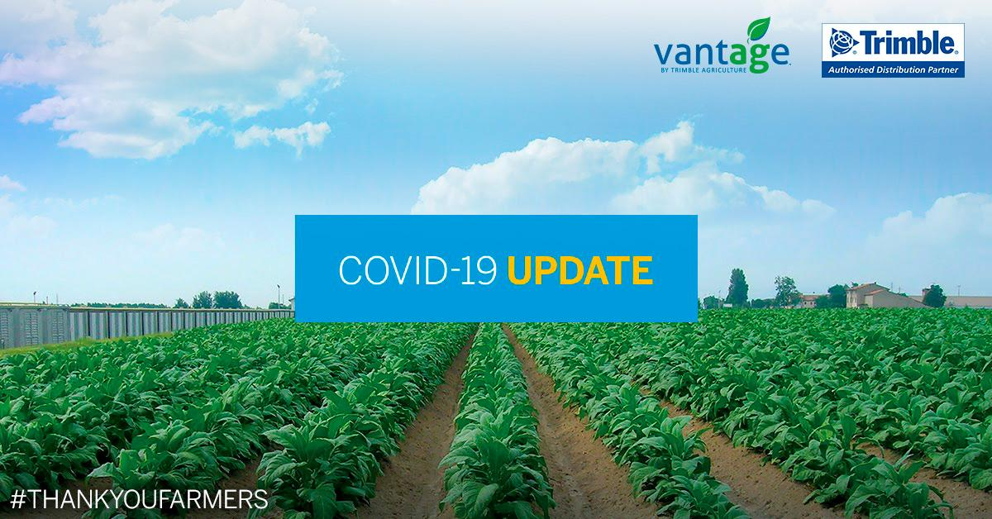
Keep doing your best - with the best support from [Company]. You can reach us throughout these challenging times:  [Contact details]  #WeSupportFarmers | 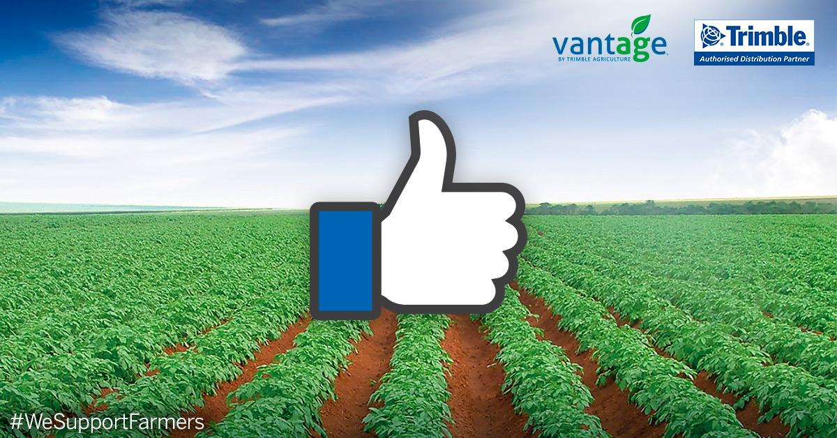
You work, we work too!  [Company] remains open and reachable throughout the coronavirus period. Check this [link] and find all the contact details you need. #FarmingNeverStops  #WeSupportFarmers | 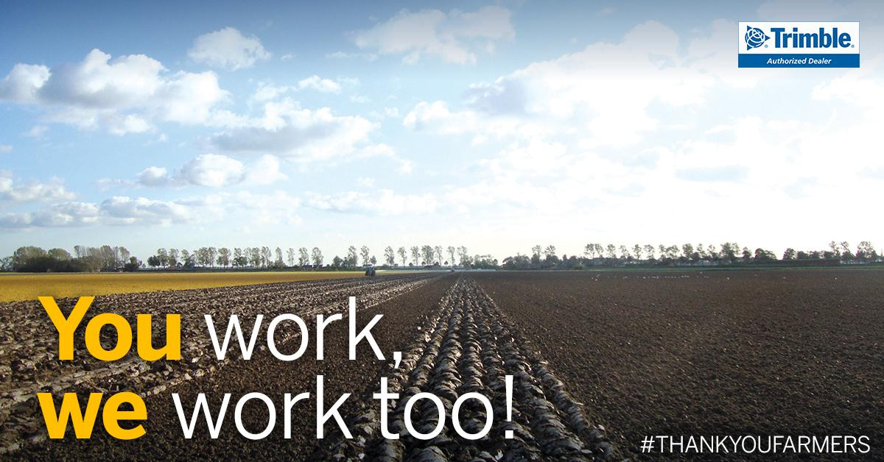  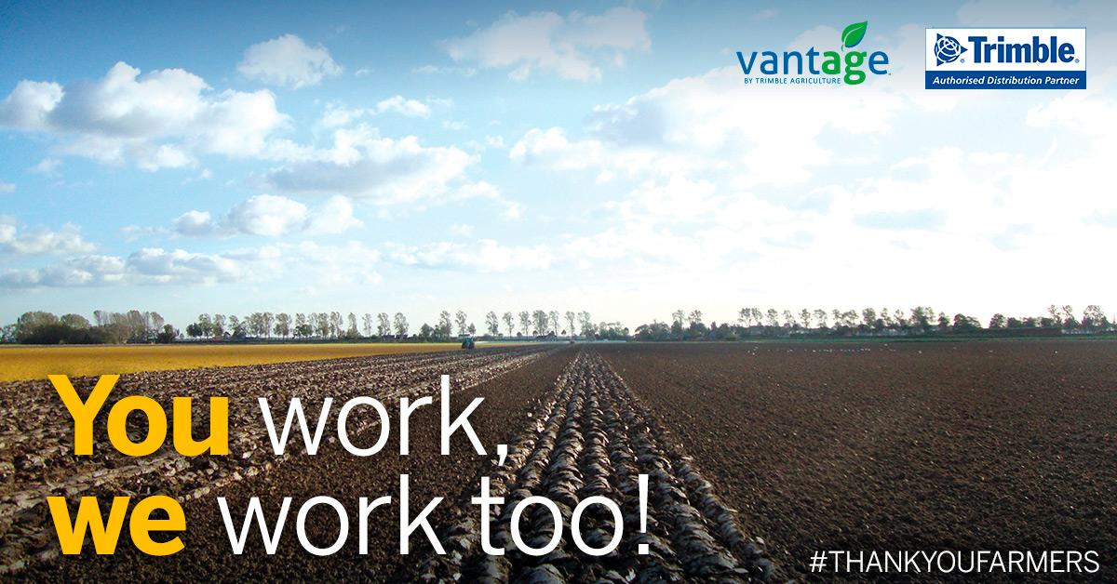
At this crucial time in the farming calendar we will try our best to keep our customers supported during the ever evolving Coronavirus outbreak.  You can reach us:  Tel:  WhatsApp:  E-mail: helpdesk@  #FarmingNeverStops | 