To update the checklist below to fit your needs:

- Select the ‘Developer’ tab from the menu above.
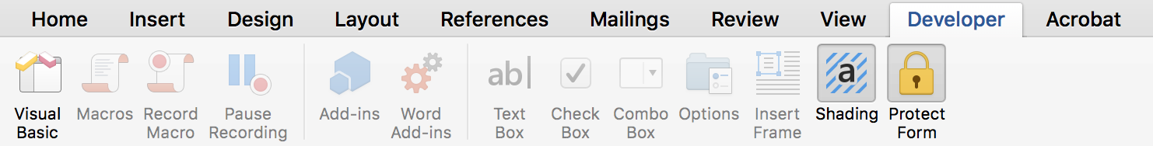

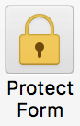

- Select ‘Protect Form’ to unlock the document for editing.

- Edit the footer content by double clicking in the footer space. Include your company name, phone, email and any other contact information you see fit.

- On the final page, include your contact information and place your company logo to personalize your document.

- When you’re finished personalizing, re-select ‘Protect Form’ to lock your information into place. Doing so also enables the checklist capabilities for your customer to proactively fill out the list.

- The form can also be printed and checkboxes can be marked manually.

Implementing the new lease standard is not just a one-time exercise; it requires changes to accounting processes and financial reporting controls. Accounting policy elections and practical expedients will affect the overall process and timeline—so be sure to assess them early. Effective implementations require a thorough evaluation of resources and your organization should identify someone to take the lead for all of this work.
“

10% of Fortune 1000 finance executives expect the level of effort to implement to be ‘extremely painful.” - CRI

The following checklist will help you get started and walk you through key steps in the implementation process.

Identify the entire lease portfolio and gather lease documents
Consider all locations
Review recurring expenses to look for lease payments
Review GL expense accounts with key words that could indicate a lease (e.g. rent, lease, subscription, contractor)
Leases may include office space rental, vehicles, photocopiers, equipment, and embedded leases, which are equipment or other assets included in a service contract.
Be certain to exclude the following contracts that do not fall under the new lease standard:
Leases of 12 months or less, if this is an elected policy
Intangible assets like SAAS software, although IFRS 16 has some scope limitations
Exploration of non-generative resources, e.g., minerals
Biological assets, e.g., crops
Inventory is excluded by ASC 842 but included under IFRS 16
Assets under construction are excluded by ASC 842 but included under IFRS 16
Low-dollar leases, if this is an elected policy under IFRS 16

Review lease data in all lease contracts
Key dates: commencement, termination
Lease term, early termination, and renewal provisions
Asset details: type, description, and location
Payment terms, termination penalties, bargain purchase options, renewal term payments, residual value guarantees
Lease incentives and initial direct costs
Variable lease payments tied to sales or an index receive special treatment:
Variable payments tied to sales are expensed
If payments are tied to an index, organizations following ASC 842 use the index at lease start date or initial application date (whichever is later) to calculate the lease payments. Changes in the index are expensed. Organizations following IFRS 16 will modify their lease liability with every change in the index.
Useful life of the asset to determine amortization period, e.g., right-of-use (ROU) asset life
Other important data to track, such as taxable vs. nontaxable leases

Evaluate existing lease business processes
Who is responsible? Are current resources sufficient?
Are areas other than Accounting involved (Procurement, Legal, Treasury)?
Is lease processing and record retention centralized or decentralized?

Assess current systems and use of technology for lease processing
Are spreadsheets and manual tracking used?
Is separate lease accounting software (not part of ERP, G/L) in place?
Does the accounting software include all of the required general ledger accounts? This includes ROU Assets, Short-Term Lease Liabilities, Long-Term Lease Liabilities, Operating Lease Expense, Variable Lease Expense, Short-Term Lease Expense, and Finance Lease Expenses like Amortization Expense and Interest Expense
Is there a lease module in the ERP, and does it have future capabilities?

Review new accounting and disclosure requirements, including judgment areas
Accounting policy elections and practical expedients, including lease vs. non-lease components, short-term leases, leasehold improvements, and lease accounting during the transition period
Accounting for leases entered into after implementation using the new standard
Process for determining classification criteria, including the fair market value and economic life of the lease asset
Determine how ROU Assets and Lease Liabilities will be disclosed on the financial statements: separately in a footnote, or within the balance sheet and income statement itself; for new disclosures, consider data location and whether it is reliable and auditable
How will discount rates be determined and applied by Accounting? ASC 842 does provide a policy election to use a risk-free rate.

Discuss the new standard with:
Board or owners
Audit committee
Investors
Lenders

Contact us to discuss how the new lease standard will impact your organization—and how we can help.
Place logo here
(xxx) xxx-xxxx | email@companyname.com

