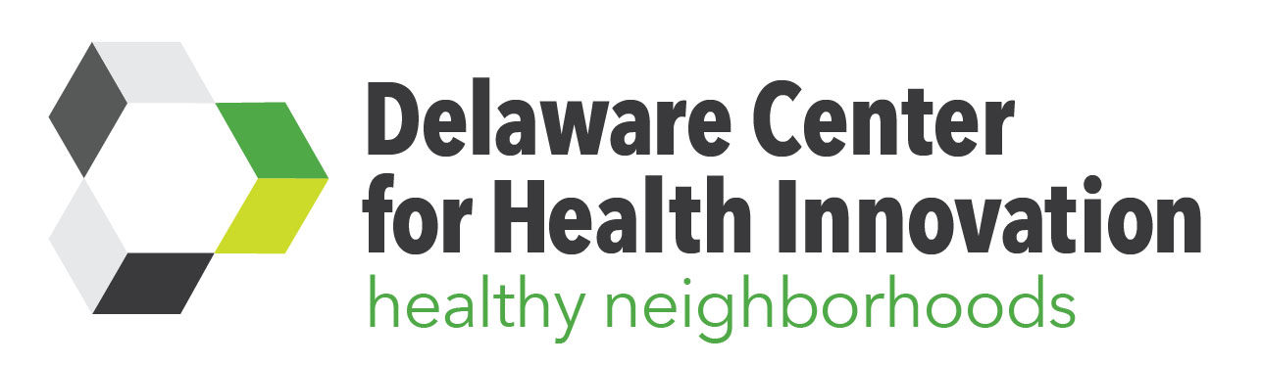
Minutes

Healthy Neighborhoods
Sustainability Committee
Hosted by Christiana Care
Wilmington Annex Campus
1400 N. Washington St.
Conference Room 100
Wilmington, DE 19801
Date | Time 2/3/2017 12:00 PM | Facilitator: Peggy Geisler
The HN Sustainability Committee works to provide recommendations and solutions for sustainability of the Healthy Neighborhoods programs that are established across the state, working to align and unify potential funding streams in targeted neighborhoods, bringing about a more holistic approach, and sharing resources to address population health issues.
Attendees: Stuart Comstock-Gay, David Crimmins, Noel Duckworth, Peggy Geisler, Shebra Hall, Omar Khan, Steve Pequet, Brian Rahmer, Matt Stehl, Matt Swanson
Minutes
Recap
- Chart provided to review DCHI Committee, Council and Task Force structure
- HN Committee and HN Councils- analogy of federal and state
- Efforts differ depending on area: Wilmington efforts focused on coalescing many groups; Dover efforts are emerging as we are building things from the ground up; Sussex efforts are partnerships with a well-organized health coalition established over 10 years ago
- DCHI has a new logo, website and social media accounts (Facebook: DEHealthInnovation; Twitter: @DCHI_SIM) Initial transformation efforts were attached to the marketplace and co-branded w/choosehealth.gov. Felt like it was detracting from our efforts and causing confusion. We have separate branding now but still will be linked and will partner and support each other.
- Feb 1st starts year 3 of 4 year SIM grant

HN Sustainability Plan Process
Short-Term: Structure Goals
- HN Committee growth- Work is moving from visionary to operational via 3 strategic HN subcommittees: Data, Sustainability and CHNA (Community Health Needs Assessments). Each are formed and meeting regularly.
  - Data Committee- Data committee meets monthly directly before Sustainability committee meetings. Committee has been reviewing and analyzing available data on priority health areas. Presentations have been made by State Planning Office on chronic disease/healthy living, by DPH on maternal/child health, and on substance abuse by UD staff overseeing SPF-SIG efforts.
  - CHNA Update- Brings together HCPs to engage in a different way. Comparing and contrasting priorities of hospitals and FQHCs in an effort to align and find shared language.
    - Consensus reached to focus on access to care. Access can be defined by costs, cultural access, physical, etc.
    - Understanding each other’s point of reference- ex that hospital has overutilization of ER and FQHC has underutilization of services
    - Each healthcare systems is working on different timeframes for assessment and implementation plans. Challenges: Community perception doesn’t always match up w/clinical needs. Working collectively in Sussex to address overlap
    - Engaging stakeholders – role of HN Team is to facilitate space between these conversations and find alignment.
Aligning with State Initiatives
- HN Project Director has been reviewing initiatives that are state, federally and locally funded. Discussions underway w/new DHSS Secretary., DSAMH, M/CH, Community Philanthropy, etc.. Rita Landgraf will remain on the DCHI Board and HN Committee in her new role at UD, but DHSS leadership holds a board seat so new Secretary to join as well.
- The Early Childhood Council has formed a new health committee that Leslie is chairing. Council is now looking beyond quality rating system (STARS) to look at total vision of early childhood. With this new lens of convergence, they are going to need a space to operationalize that and HN may be the right fit.
- Workforce Development and Education are high priorities for state

Mid-Term Goals: Grant Funding
- Committee reviewed several RFPs recently issued by federal agencies (CDC, OMH) and foundations. Discussion evolved into the committee’s broader funding and grant strategy approach, and whether primary focus should be on the statewide infrastructure, building the capacity for DCHI to deliver programming, and/or directing individual councils to funding sources while building their capacity to pursue and manage such funding.
- Identified 2 categories: 1) capacity-building at a higher level; and, 2) helping funding become more distributed by fostering cooperation and helping community entities be more successful at raising their own money and not competing
- What portfolio of opportunities should we consider? Committee further explored a collective impact model where DCHI would serve as a backbone agency and the “hub” for capacity work of the councils. In this capacity, DCHI would do more than provide TA and training, but also serve as a convener of multiple groups part of a comprehensive plan. DCHI’s role could be to manage data and provider administrative oversight. DCHI also has capacity to serve as fiscal agent.
- What is the gold standard? DCHI was purposefully built and constructed around CMMI’s mission. If this work is going to continue to sit at the Governor’s office or DHHC -if the Triple Aim is still the agenda - then we have to make sure there’s an organization like DCHI that can deliver the capacity to do that.
- Pros: Could translate to more programmatic funds, would provide an opportunity to create a common way for applying for grants, evaluation measures could match up w/score cards, tools could be provided to do evaluation in a more performance driven way, and everyone could benefit from branding.
- Cons: Could present a liability if it became too distributed. Balance needed for backbone to distribute enough w/out sacrificing discipline in the process.
- Lessons learned from Blueprint Communities: Light fire at local level- those closest to community understand it; act in a way that doesn’t reinforce activities from other parties that aren’t sanctioned by us but works to get them coordinated; develop and fully integrate core values and philosophy. Council Coordinator needs to understand landscape in region, including who should be invited to participate in a more formal way. Acknowledge value in relationships and value in resources. Some groups have never come due to trust issues.
Long-Term Goals: Social Impact Bond
- DCHI’s work may be well suited for a “pay for success” funding structure. Pay for Success, also referred to as Social Impact Bonds, is a public-private partnership that drives government resources toward social programs that deliver proven results to those in need. This innovative funding model connects high-quality service providers with impact investors, who provide up-front funding for programs, and government, who agrees to repay that investment if, and only if, the program achieves predetermined goals of improving lives.
- Although there is not even legislation to allow it yet, there may be interest locally, and constructs do exist in other states (ex. Prevention & Wellness Trust fund in Mass). In these efforts, regardless of CMMI grants, and with some regulatory work done, there has been commitment secured by hospital systems, large employers and others. Volunteer effort for hospital system to give 20% of community benefits dollars to these efforts. In DE, this total is approx. $20 mil (20%=$5 mil) . However, an estimated $6.3 mil is needed consistently across a 10-year period to make an impact, so would need to garner an additional $1.3 mil to meet that demand. Efforts right now can be focused on what kind of contribution hospitals can make (sister partnership with eBrightHealth?), and generating a standard commitment for HN collective impact
- Hospital Community Benefits funds: Hospitals have to spend CB $ and most have been spending them in ways that don’t match up. As eBright creates a more coordinated population health agenda, there should be a similar effort on the population health front that should be funded by the hospitals. If we can work toward goal of monetartizing the value of $ spent in reduction of care costs, this is the model of sustainability.
- Opportunities:
  - How well can we account for a ROI that isn’t a theoretical model of pop health? And, if CB $ has historically gone to writing off Medicaid or Medicare payments, is there a chance of that happening again due to potential ACA repeal? It may, but prior to ACA, $28 billion of community benefit was accumulated (per 990 forms)- and only 2% was going to community improvement initiatives.
  - Identify emerging interest in social impact bonds in DE (i.e. workforce development, economic development) and look for linkages. DCHI’s efforts around Community-based Healthcare Workers could be presented as a social impact on health outcomes and/or as part of a broader impact on workforce development. DCHI should take position that CHWs would be creating good paying jobs in communities w/greatest health need while impacting social determinants of health. Likewise, people w/good paying jobs have health insurance, navigation of social services helps eliminate barriers to be insured, and navigation work is supporting other workforce development strategies.
  - HN trust fund- how to increase resources via: 1) clinical 2) gov’t to drive policy to earmark across agencies
- Next Steps: Committee to develop and propose a sustainability structure to hospital systems.
Update on SIM Funding Application
- Stakeholder funding provided to DCHI was being used to support PMGConsulting contract for Project Director of HN. However, CMMI has now approved that contract as an allowable cost in SIM grant, and so unrestricted funds will be freed up for HN infrastructure and programming. More details on this at next meeting.

Next Steps & 2017 Meeting Schedule
- Next Steps:
  - Develop strategic 1-5 year plan for grant strategy
  - Develop and propose a sustainability structure to hospital systems
  - Continued discussion of emerging funding:
- HN CMMI Funds- re-configuration
- Plan 4 Health statewide
- RWJ Grant discussion
- Social Impact Fund- workforce
- ACCEL Support
- RWJF- Grant- Brian- Coordinating hospitals.

Next meeting: 3/3 at 12 pm at Wilm Annex (LUNCH WILL BE PROVIDED). Committee will meet monthly every first Friday at Noon. A recurring invite for the next 6 months will be sent.

