Speaker Biography:
David Hultstrom
President, Financial Architects LLC
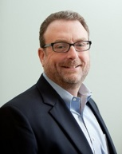
For over a decade Mr. Hultstrom has served as president of Financial Architects, a registered investment advisory firm that provides personal financial planning and wealth management services for private clients.
He began his career as a Financial Advisor at a small firm in Florida. Realizing his clients’ need for more comprehensive financial advice, he worked for several years in the tax field while earning his MBA and was subsequently a Vice President at Wheat First Butcher Singer (now Wells Fargo Advisors) where he was responsible for teaching financial advisors the nuances of various financial planning and investment techniques as well as the latest technology tools.
Mr. Hultstrom then joined Financeware as the Director of Training where again he instructed financial advisors in the proper methods of performing sophisticated modeling of financial plans and constructing appropriate investment portfolios. Subsequently, he founded Financial Architects, LLC to help individuals more directly.

