NAIFA-Nebraska
Speaker: David McKnight
10/10/2019
12:00 – 1:00 PM CENTRAL TIME
“NAIFA LIVE Webinar October 2019 – The Power of Zero”

Course Description: The following course is designed to educate financial advisors on how to advise their clients on accumulating dollars for retirement in a rising tax rate environment. It makes the case that certain types of investments should be contributed to only in carefully prescribed ways with an eye towards how those investments may be taxed in the future. It discusses many of the unintended consequences of having too much money in retirement accounts like 401(k)s and IRAs, namely the impact of Social Security taxation. Finally, we conclude with a case study that discusses various strategies as it relates tax-advantaged retirement planning, including the incorporation of cash value life insurance as one of multiple options in a well-balanced approach to tax-advantaged retirement planning.

Learning Objectives:
Increase participant’s knowledge and understanding of:
- Retirement planning in a rising tax rate environment
- Social Security Taxation
- The pros and cons of Roth IRAs
- The importance of utilizing a Life Insurance Retirement Plan
- Taxable and tax-deferred investments

Presentation Timed outline:
- Taxable Investments (5 min.)
  - Taxable bucket
  - 1099
  - Emergency fund
- Tax-Deferred Investments (5 min.)
  - Tax-deferred bucket
  - Generally, the contributions made to these accounts qualify as tax deduction
  - These accounts are taxed the same way upon distribution
  - Good place for retirement income?
- Deductions in Retirement (5 min.)
  - Many deductions during working years aren’t eligible during retirement
- Standard Deductions (5 min)
  - Standard deduction ($24,000) is typical in retirement
- The Catch-22 of Tax-Deferred Investing (15 min.)
  - Catch-22 story, caught between a rock and a hard place”
  - 401(k) can present as a “Catch-22) if not utilized in a correct way
  - Rock = Required Minimum Distributions
  - Hard place = Social Security
  - Social Security Taxation
- The American Tax System– (5 min.)
  - Brief overview American tax system and how IRS taxes individuals
  - Income tax compared to graduated cylinder; income taxed at graduated rates
- Social Security Taxation Case Study– (5 min.)
  - Looking at an example of a married couple and how their Social Security is taxed
- Tax-Free Investments– (5 min.)
  - Tax-advantaged bucket
  - Withdrawals can’t be taxed under any circumstances
  - Withdrawals cannot count towards Social Security threshold
  - Tax-advantaged retirement planning
  - Roth IRA
- Life Insurance as a Tax-Free Investment– (5 min.)
  - Under right circumstances, life insurance can be an alternative way to build money in the tax-advantaged bucket
  - Cash Value contributions
  - Policy distributions
- Case Study– (5 min.)
  - How do all of these concepts apply to a real life situation?

Total time = 60 minutes
Speaker Biography:
David McKnight
Best-Selling Author
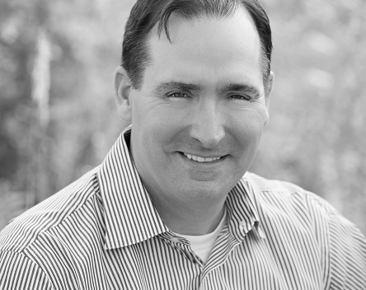
David McKnight graduated from Brigham Young University with Honors in 1997. Over the past 20 years David has helped put thousands of Americans on the road to the zero percent tax bracket. He has been featured in Forbes, USA Today, The New York Times, Fox Business, Bloomberg Radio, MarketWatch, CBS Radio, CNBC, Yahoo Finance, Nasdaq.com, Reuters, Investor’s Business Daily and numerous other national publications. David was a Focus Speaker at the worldwide annual meeting of MDRT in Toronto, Canada and is a multiple Top of the Table qualifier. His bestselling book The Power of Zero has sold over 185,000 copies and the updated and revised version was published by Penguin Random House. When it was launched in September of 2018, it finished the week as the #2 most-sold business book in the world. In 2019 The Power of Zero was ranked as the #9 best financial resource in the country by Forbes Magazine. This book was recently made into a full-length documentary film, also entitled The Power of Zero. As the President of David McKnight & Company, he mentors hundreds of financial advisors from across the country who specialize in The Power of Zero retirement approach. He and his wife Felice have seven children.

