*(right click and save logo as picture)*

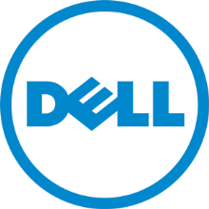

Dell is offering A+ savings with 2-30% off. Sign in to your member site and save!