(right click and save logo as picture)
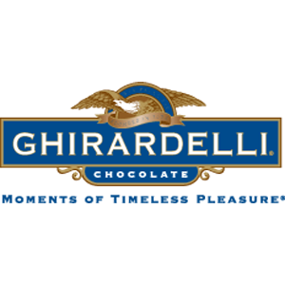
Enjoy holiday treats from Ghirardelli for less with 20% off $100. Sign in to your member site and save!

