(right click and save logo as picture)
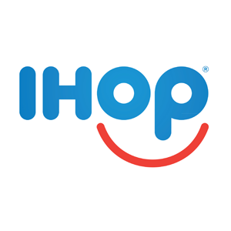
If you’re a pancake lover, then take advantage of 10% off a gift card purchase from IHOP. Sign in to your member site and save!

