(right click and save logo as picture)
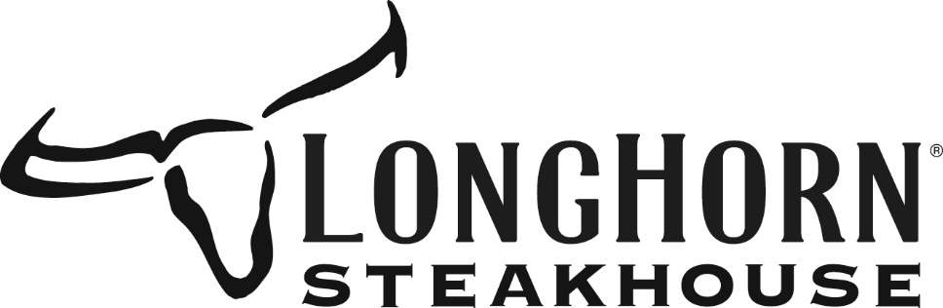

Save $5 off your $50 eGift card purchase from LongHorn Steakhouse. Sign in to your member site and save!

