(right click and save logo as picture)
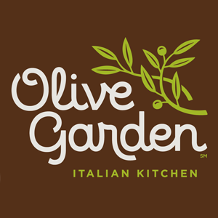
Olive Garden has never tasted better with $5 off your $50 eGift card purchase. Sign in to your member site and save!

