(right click and save logo as picture)
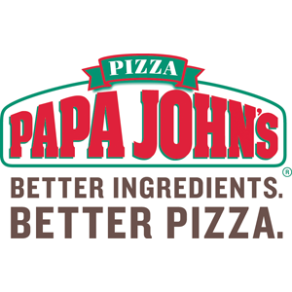
Quick, easy and delicious – save 30% on regular menu price orders from Papa John’s. Sign in to your member site and save!

