(right click and save logo as picture)
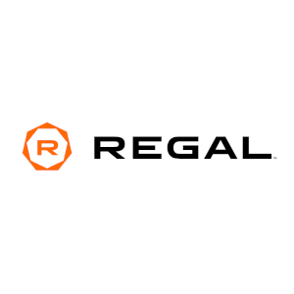
You can enjoy your favorite films for less at Regal Entertainment Group and save up to 25% on premiere movie tickets. Sign in to your member site and save!

