(right click and save logo as picture)
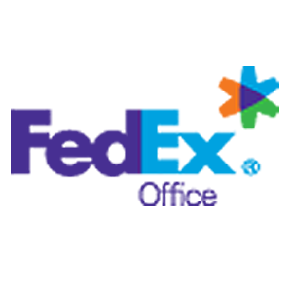
FedEx is ringing in the New Year with 15% off any print order. Sign in to your member site and save!

