(right click and save logo as picture)
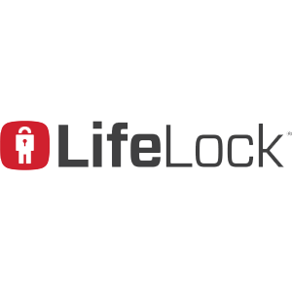
You’ll find peace-of-mind with 25% off your first year with LifeLock. Sign in to your member site and save!

