(right click and save logo as picture)
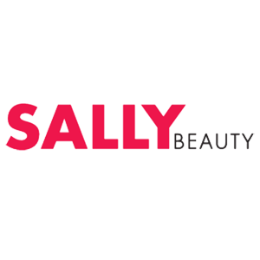
Look your best this year with $5 off $25 from Sally Beauty. Sign in to your member site and save!

