(right click and save logo as picture)
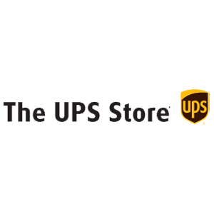
You’ll enjoy 10% off selected products and services from The UPS Store. Sign in to your member site and save!

