(right click and save logo as picture)
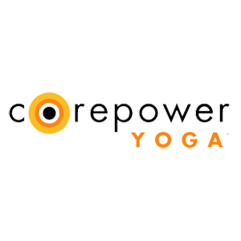
Center yourself in 2020 with 20% off regional rates on a 10 class pack or Black Tag unlimited membership from CorePower Yoga. Sign in to your member site and save!

