(right click and save logo as picture)
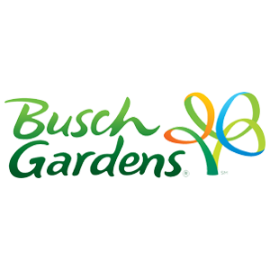
Busch Gardens is offering you up to 25% off single day tickets. Sign in to your member site and save!

