(right click and save logo as picture)
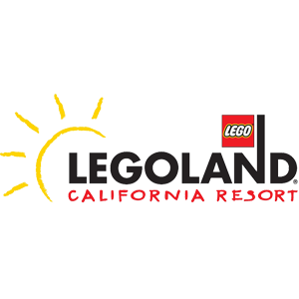
Rides and thrills await you with up to 50% off at LEGOLAND® California. Sign in to your member site and save!

