(right click and save logo as picture)
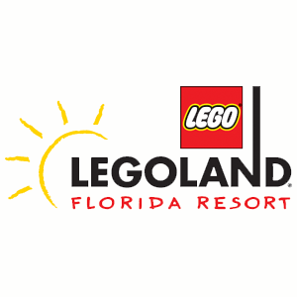
LEGOLAND® Florida is begging you to have fun with up to 40% off admission. Sign in to your member site and save!

