(right click and save logo as picture)
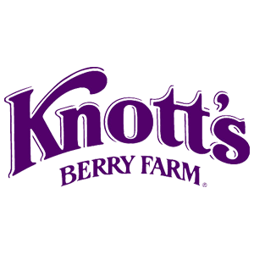
Knott’s Berry Farm is making your day better with up to 47% off on single day admission. Sign in to your member site and save!

