(right click and save logo as picture)
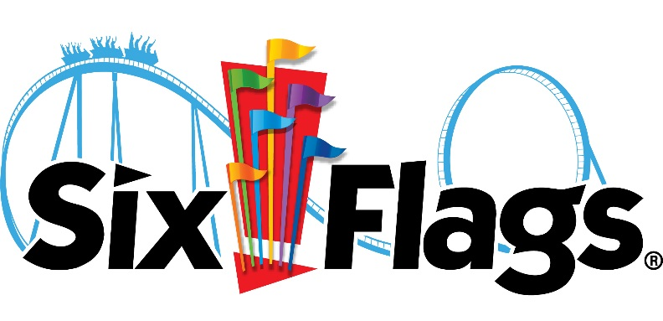
You’ll have a blast on your next visit to Six Flags and save up to $30 on tickets. Sign in to your member site and save!

