(right click and save logo as picture)

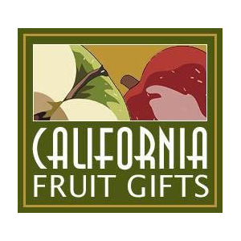
You can order tasty treats from California Fruit Gifts and save 15%. Sign in to your member site and save!

