(right click and save logo as picture)
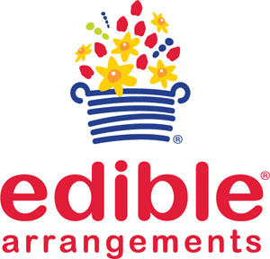
Edible Arrangements makes great goodies at 10% off your purchase of $50 or more. Sign in to your member site and save!

