(right click and save logo as picture)
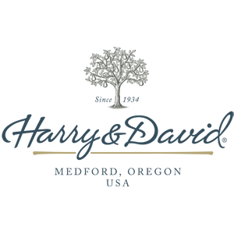
Harry & David brings you gourmet gifts for 20% off this holiday season. Sign in to your member site and save!

