(right click and save logo as picture)
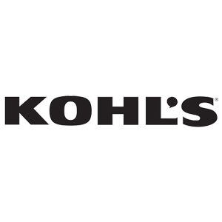
Getting your home ready for the holidays? Shop Kohl’s and take advantage of 15% off $100 or more. Sign in to your member site and save!

