(right click and save logo as picture)
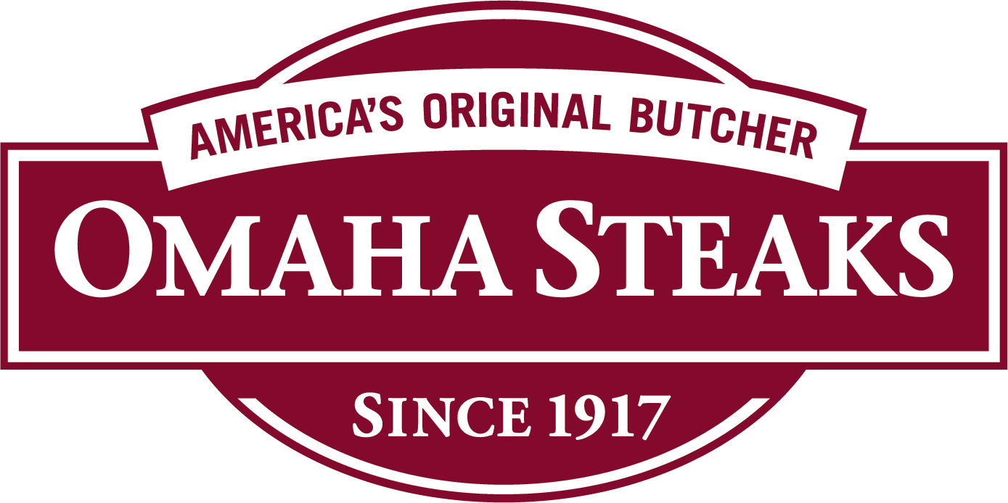

Enjoy 4 free Omaha Steaks burgers with your purchase of $40 or more. Sign in to your member site and save!

