(right click and save logo as picture)
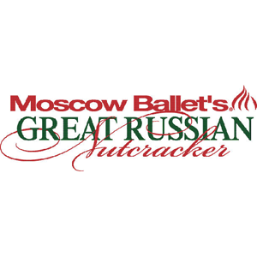
A night out at the ballet is even better with up to 20% off tickets from Moscow Ballet. Sign in to your member site and save!

