(right click and save logo as picture)
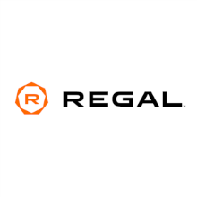
Take a trip to the movies with up to 25% off Premiere movie tickets from Regal Entertainment Group. Sign in to your member site and save!

