(right click and save logo as picture)
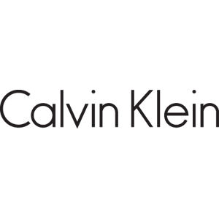
You can keep your fashion game on point with $15 off $100 from Calvin Klein. Sign in to your member site and save!

