(right click and save logo as picture)
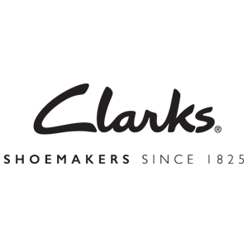
You’ll find fall footwear at $10 off $100 from Clarks when you shop online. Sign in to your member site and save!

