*(right click and save logo as picture)*

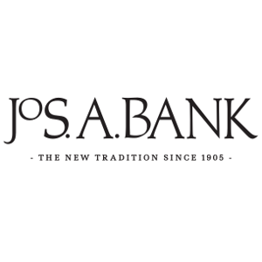

Staying stylish is a cinch with 40% off from Jos. A. Bank. Sign in to your member site and save!